Certification Details 2

Controller Manager 10

Kube Scheduler 15

Kubelet 17

Kube-proxy 18

Replica Set 21

Deployment 31

Namespace 34

Imperative commands 42

Scheduler – no pod 43

Labels 47

Taits and tolerations 55

NodeSelector 60

Node Affinity 61

Resousece limits 68

Daemon set 72

Static Pods 75

Multiple Schedulers 82

Logging monitoring 87

Checking logs 89

Rollout & versioning 90

Configure Applications 96

Commands and arguments 102

Environment variables 104

ConfigMap 106

Secrets 110

MultiContainer Pod 120

InitContainers 124

OS upgrades 126

Kubernetes Releases 128

Cluster upgrades 130

Backup 151

Kubernetes

## Certification Details

Certified Kubernetes Administrator: <https://www.cncf.io/certification/cka/>

Exam Curriculum (Topics): <https://github.com/cncf/curriculum>

Candidate Handbook: <https://www.cncf.io/certification/candidate-handbook>

Exam Tips: [http://training.linuxfoundation.org/go//Important-Tips-CKA-CKAD](http://training.linuxfoundation.org/go/Important-Tips-CKA-CKAD)

<https://kodekloud.slack.com/join/shared_invite/enQtNzU2Mjk4MTI5NDkwLTdjYzc0ZmI5MjU1NGUzMzgxMWFhNDgyNjZhZGVjNjRhYjc2NTgzZTcyN2FiODkyZWQ5NGQ4MzY3NWU2NzAwMjU>

Cluster Architecture

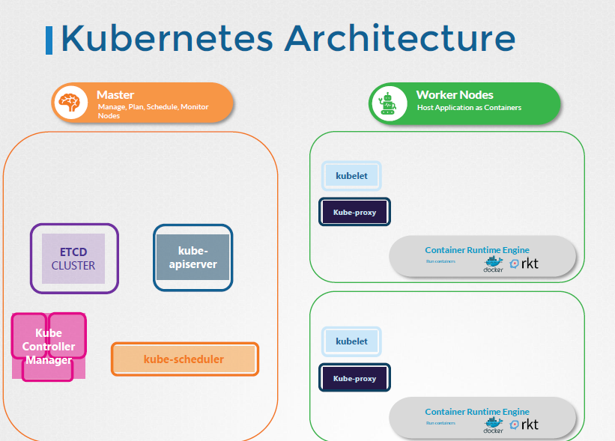

worker node = cargo ships that carry containers

Control Node= load the containers on the cargo ship, plan how to load, identify the right ships, monitor and track the location of the containers on the ships, monitor, manage the loading process

Etcd=maintain information about different ships, containers that are running, what time it was loaded

=highly available key value store, database

Scheduler= craines identify the containers to be placed on ships, identifies the right ship based on its capacity, the number of containers already on the ship and other conditions (destination of the ship, type of containers it is allowed to carry etc.)

!! identifies the right node to place a container based on the C resource requirement, worker capacity, or any other policy or constraint (node affinity rules,

NodeController = takes care of nodes (cargo ships), onboarding new nodes to the cluster, handling situations where nodes become unavailable, gets destroyed,

Replication controller = desired number of containers are running all times in your replication

There are different offices in the dock that are assigned to special tasks or departments.

For example the operations team takes care of ship handling traffic control etc. they deal with issues

related to damages, the routes the different ship state etc. The cargo team takes care of containers

when continuous are damaged or destroyed.

They make sure new containers are made available.

You have these services office that takes care of the I.T. and communications between different ships.

The kube-apiserver is the primary management component of kubernetes. The kube-api server is responsible for

orchestrating all operations within the cluster.

It exposes the Kubernetes API which is used by externals users to perform management operations on

the cluster as well as the various controllers to monitor the state of the cluster and make the necessary

changes as required and by the worker nodes to communicate with the server.

A kubelet is an agent that runs on

each node in a cluster.

It listens for instructions from the kube-api server and deploys or destroys containers on the nodes

Worker

The captain is responsible for liaising with the master ships starting with letting the master ship

know that they are interested in joining the group receiving information about the containers to be

loaded on the ship and loading the appropriate containers as required sending reports back to the master

about the status of this ship and the status of the containers on the ship etc

Now the captain of the ship is the kubelet in Kubernetes. A kubelet is an agent that runs on

each node in a cluster.

It listens for instructions from the kube-api server and deploys or destroys containers on the nodes

as required.

The kube-api server periodically fetches status reports from the kubelet to monitor the state of nodes

and containers on them.

Communication between worker nodes are enabled by another component that runs on the worker node known

as the Kube-proxy service. The Kube-proxy service ensures that the necessary rules are in place on the

worker nodes to allow the containers running on them to reach each other.

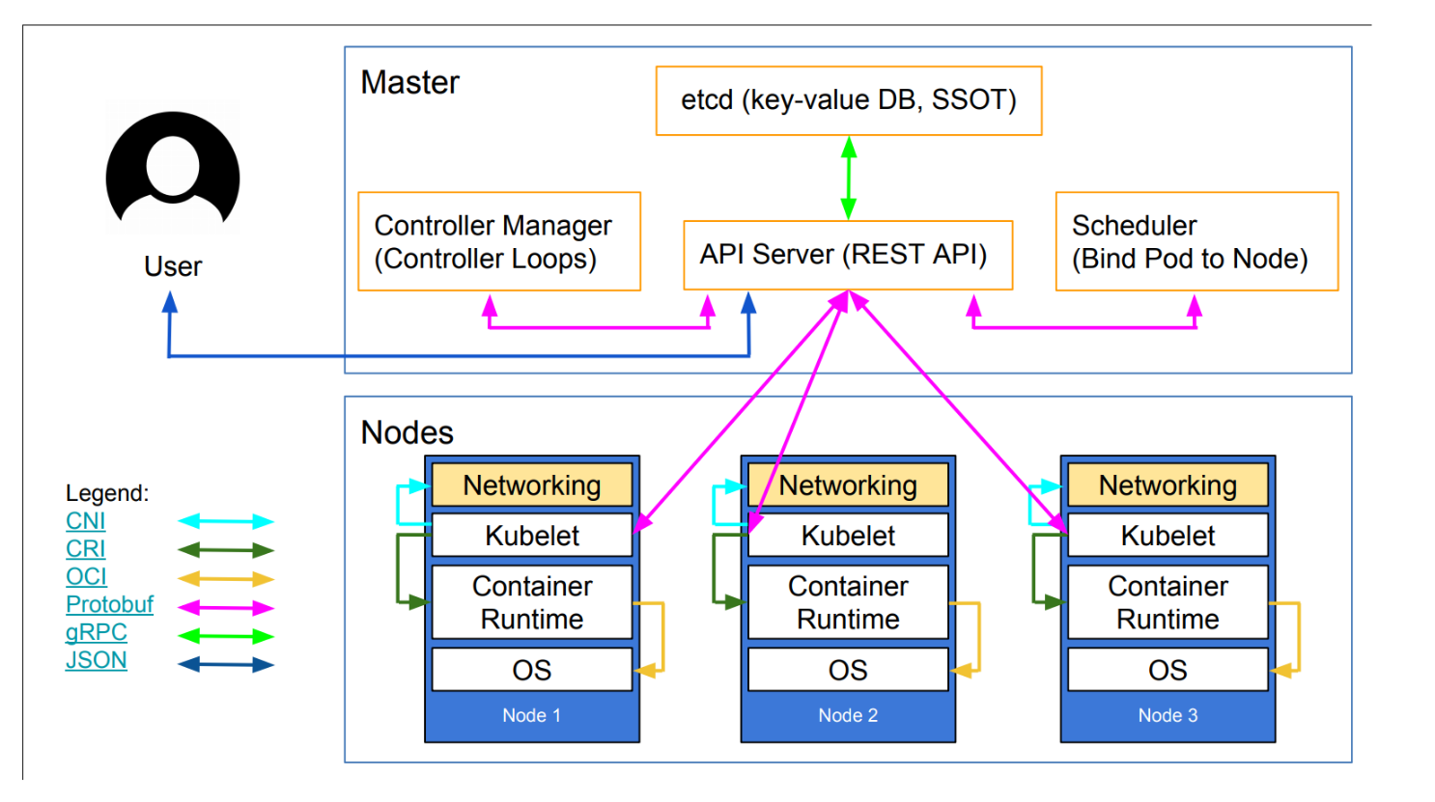

API server

Earlier we discussed that the Kube-api server is the primary management component in kubernetes. When

you run a kubectl command, the kubectl utility is infact reaching to the kube-apiserver.

The kube-api server first authenticates the request and validates it. It then retrieves the data from the

ETCD cluster and responds back with the requested information.

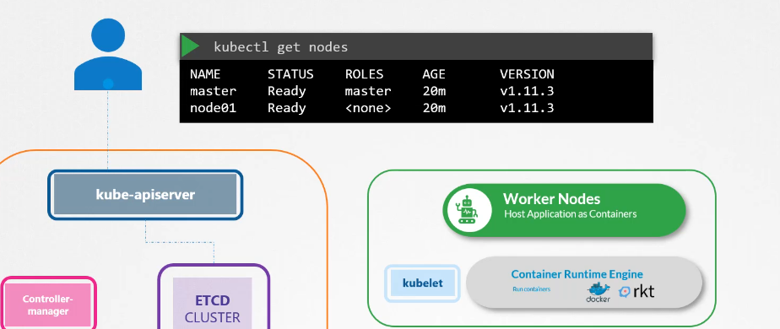

You don’t really need to use the kubectl command line.

Instead, you could also invoke the API directly by sending a post request like this let's look at an

example of creating a pod when you do that as before the request is authenticated first and then validated.



In this case, the API server creates a POD object without assigning it to a node, updates the information in the ETCD. server updates the user that the POD has been created.

The scheduler continuously monitors the API server and realizes that there is a new pod with no node

assigned the scheduler identifies the right node to place the new POD on and communicates that back

to the kube-apiserver.

The API server then updates the information in the ETCD cluster. The API server then passes that information

to the kubelet in appropriate worker node.

The kubelet then creates the POD on the node and instructs the container runtime engine to deploy the

application image.

Once done, the kubelet updates the status back to the API server and the API server then updates the

data back in the ETCD cluster. A similar pattern is followed every time a change is requested.

The kube-apiserver is at the center of all the different tasks that needs to be performed to make a

change in the cluster.

To summarize, the kube-api server is responsible for Authenticating and validating requests, retrieving

and updating data in ETCD data store,

in fact, kube-api server is the only component that interacts directly with the etcd datastore.

The other components such as the scheduler, kube-controller-manager & kubelet

uses the API server to perform updates in the cluster in their respective areas.

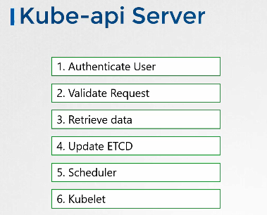

If you bootstrapped your cluster using kubeadm tool then you don't need to know this but if you are setting up the hard way, then kube-apiserver is available as a binary in the kubernetes release

page. Download it and configure it to run as a service on your kubernetes master node.

The kube-api server is run with a lot of parameters as you can see here. Throughout this section

we are going to take a peak at how to install and configure these individual components of the kubernetes architecture.

You don't have to understand all of the options right now but I think having a high level understanding on some of these now will make it easier later when we configure the whole cluster and all of its components from scratch.

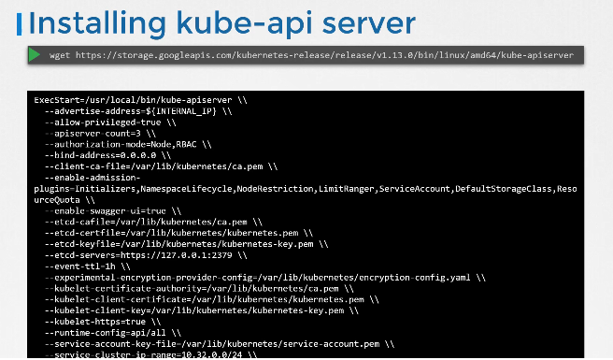

The kubernetes architecture consists of a lot of different components working with each other, talking to each other in many different ways so they all need to know where the other components are.

There are different modes of authentication, authorization, encryption and security. And that’s why you have so many options when we go through the relevant section in the course we will pull up this file and look at the relevant options.

For now we will look at a few important ones.

A lot of them are certificates that are used to secure the connectivity between different components.

We look at these certificates in more detail when we go through the SSL/TLS certificates lecture later

in this course.

There is a whole section just for it. So we will get rid of them for now.

But just remember all of the various components we are going to look at in this section will have certificates

associated with them. The option ETCD-servers is where you specify the location of the ETCD servers.

This is how the kube-api server connects to the etcd servers.

So how do you view the kube-api server options in an existing cluster

It depends on how you set up your cluster.

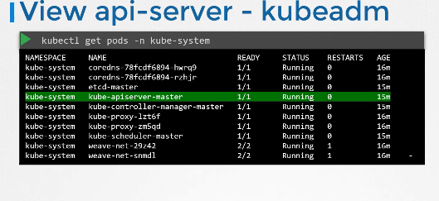

If you set it up with kubeadm tool, kubeadm deploys the kube-api server as a pod in the kube-

system namespace on the master node you can see the options within the pod definition file located at etc kubernetes manifests folder. etc kubernetes manifests folder.

kube-apiserver service located at /etc/systemd/system/kube-apiserver.service.You can also see

the running process and the effective options by listing the process on the master node and searching for kube-apiserver.

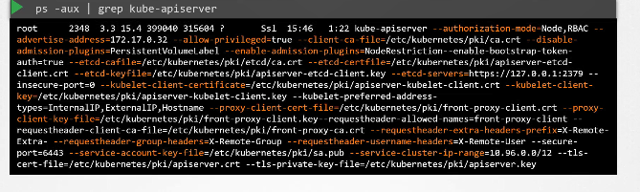

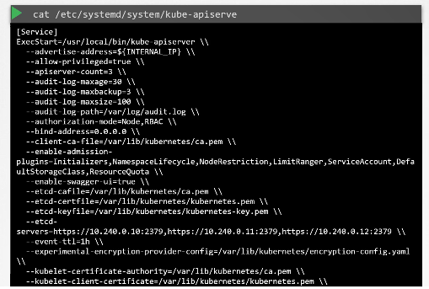

## Controller Manager

As we discussed earlier, the kube controller manager manages

various controllers in Kubernetes. A controller is like an office or department within the master ship

that have their own set of responsibilities. Such as an office for the Ships would be responsible for

monitoring and taking necessary actions about the ships.

Whenever a new ship arrives or when a ship leaves or gets destroyed another office could be one that

manages the containers on the ships they take care of containers that are damaged or full of ships.

So these officers are number 1, continuously on the lookout for the status of the ships and 2, take

necessary actions to remediate the situation. In the kubernetes terms

a controller is a process that continuously monitors the state of various components within the system

and works towards bringing the whole system to the desired functioning state.

For example the node controller is responsible for monitoring the status of the nodes and taking necessary

actions to keep the application running.

It does that through the kube-api server.

The node controller checks the status of the nodes every 5 seconds.

That way the node controller can monitor the health of the nodes if it stops receiving heartbeat from

a node the node is marked as unreachable but it waits for 40 seconds before marking it unreachable after

a node is marked unreachable it gives it five minutes to come back up if it doesn’t, it removes the

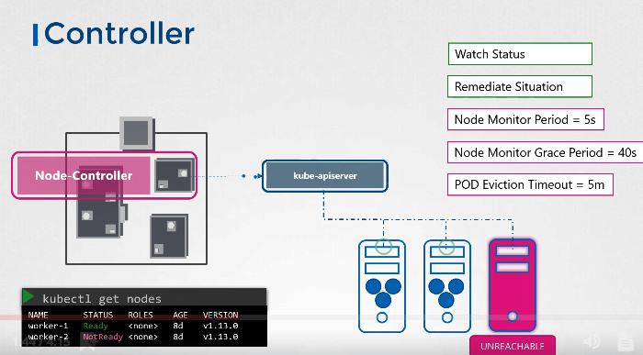

PODs assigned to that node and provisions them on the healthy ones.

If the PODs are part of a replica set the next controller is the replication controller.

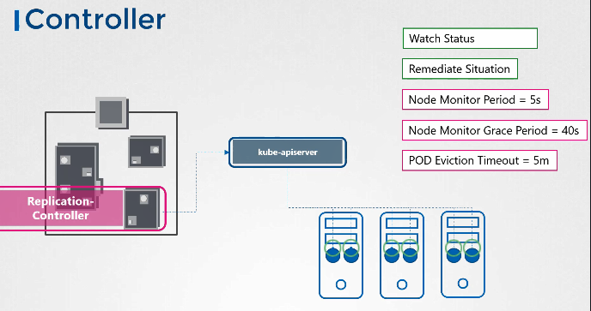

It is responsible for monitoring the status of replica sets and ensuring that the desired number of PODs are available at all times within the set.

If a pod dies it creates another one.

Now those were just two examples of controllers.

There are many more such controllers available within kubernetes.

Whatever concepts we have seen so far in kubernetes such as deployments, Services, namespaces, persistent volumes and whatever intelligence is built into these constructs it is implemented through

these various controllers.

As you can imagine this is kind of the brain behind a lot of things in kubernetes.

Now how do you see these controllers and where are they located in your cluster.

They're all packaged into a single process known as kubernetes controller manager.

When you install the kubernetes controller manager the different controllers get installed as well.

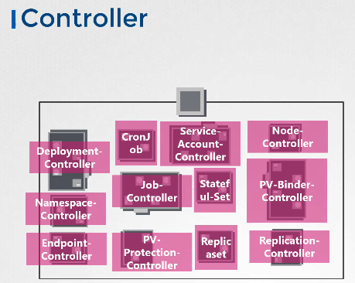

So how do you install and view the kubernetes

Controller manager download the kube-controller-manager from the kubernetes release page. Extract it and run it as a service.

When you run it as you can see there are a list of options provided this is where you provide additional options to customize your controller.

Remember some of the default settings for node controller we discussed earlier such as the node monitor period the grace period and the eviction timeout.

These go in here as options.

There is an additional option called controllers that you can use to specify which controllers to enable.

By default all of them are enabled but you can choose to enable a select few.

So in case any of your controllers don't seem to work or exist this would be a good starting point to look at.

So how do you view the Kube-controller-manager server options?

Again it depends on how you set up your cluster.

If you set it up with kubeadm tool, kubeadm deploys the kube-controller-manager as a pod in the kube-system namespace on the master node. You can see the options within the pod definition file located

at /etc/kubernetes manifests folder.

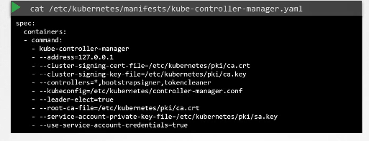

In a non-kubeadm setup, you can inspect the options by viewing

the kube-controller-manager service located at the services directory.

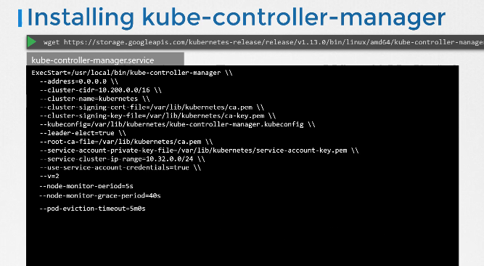

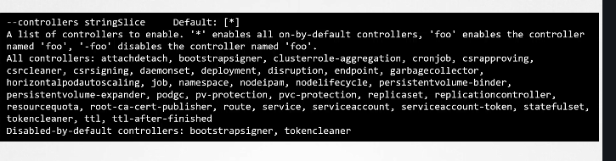

You can also see the running process and the effective options by listing the process on the master

node and searching for kube-controller-manager.

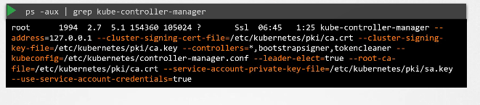

## Kube Scheduler

Earlier we discussed that the kubernetes scheduler is responsible for scheduling pods on nodes.

Now don't let the graphic mislead you.

remember the scheduler is only responsible for deciding which pod goes on which node. It doesn’t actually

place the pod on the nodes.

That’s the job of the kubelet. The kubelet or the captain on the ship is who creates the pod on the

ships.

The scheduler only decides which pod goes where.

Let's look at how the scheduler does that in a bit more detail.

First of all why do you need a scheduler? When there are many ships and many containers,

You want to make sure that the right container ends up on the right ship.

For example there could be different sizes of ships and containers.

You want to make sure the ship has sufficient capacity to accommodate those containers different ships

maybe going to different destinations.

You want to make sure your containers are placed on the right ships so they end up in the right destination

In kubernetes, the scheduler decides which nodes the pods are placed on

depending on certain criteria. You may have PODs with different resource requirements,

You can have nodes in the cluster dedicated to certain applications.

So how does the scheduler assign these PODs? The scheduler looks at each POD and tries to find the

best node for it.

For example, let’s take one of these PODs.

The big blue one. It has a set of CPU and Memory requirements.

The scheduler goes through two phases to identify the best node for the pod in the first phase.

The scheduler tries to filter out the nodes that do not fit the profile for this pod.

For example, the nodes that do not have sufficient CPU and memory resources requested by the pod.

So the first two small nodes are filtered out. So we are now left with two nodes on which the POD

can be placed.

Now how does the scheduler pick one from the two the scheduler ranks the node to identify the best fit

for the pod.

It uses a priority function to assign a score to the nodes on a scale of 0 to 10.

For example the scheduler calculates the amount of resources that would be free on the nodes after placing

the pod on them.

In this case, the one on the right would have 6 CPUs free if the pod was placed on it which is 4 more

than the other one so it gets a better rank.

And so it wins.

So that's how a scheduler works at a high level.

And of course these can be customized and you can write your own scheduler as well.

There are many more topics to look at such as resource requirements, limits, taints and tolerations,

node selectors, affinity rules etc. Which is why we have an entire section dedicated to scheduling coming

up in this course where we will discuss each of these in much more detail.

For now we will continue to focus on the scheduler as a process at a high level.

So how do you install the kube-scheduler?

Download the kube-scheduler from the kubernetes release page. Extract it and run it as a service.

when you run it as a service.

You specify the scheduler configuration file.

So how do you view the kube-scheduler server options?

Again, if you set it up with kubeadm tool, kubeadm deploys the kube-scheduler as a pod

in the kube-system namespace

on the master node. You can see the options within the pod definition file located at etc

kubernetes manifests folder.

You can also see the running process and the effective options by listing the process on the master

node and searching for kube-scheduler.

Well that's it for this lecture.

I will see you in the next.

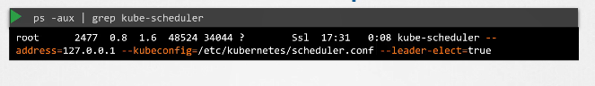

## Kubelet

Hello and welcome to this lecture. In this lecture

we will look at kubelet.

Earlier we discussed that the kubelet is like the captain on the ship. They lead all activities on

a ship.

They're the ones responsible for doing all the paperwork necessary to become part of the cluster,

They're the sole point of contact from the master ship.

They load or unload containers on the ship as instructed by the scheduler on the master.

They also send back reports at regular intervals on the status of the ship and the containers on them.

The kubelet in the kubernetes worker node, registers the node with the kubernetes cluster.

When it receives instructions to load a container or a POD on the node, it requests the container run time

engine, which may be Docker, to pull the required image and run an instance.

The kubelet then continues to monitor the state of the POD and the containers in it and reports to the kube-api

server on a timely basis.

So how do you install the kubelet? If you use kubeadm tool to deploy your cluster, it does not

automatically deploy the kubelet.

Now that's the difference from the other components.

You must always manually install the kubelet on your worker nodes. Download the installer, extract

it and run it as a service.

You can view the running kubelet process and the effective options by listing the process on the worker

node and searching for kubelet.

We will look more into kubelets, how to configure kubelets, generate certificates, and finally how

to TLS bootstrap kubelets later in this course.

That's it for now.

Will see you in the next lecture.

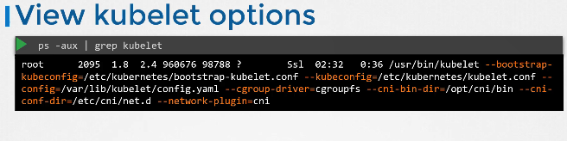

## Kube-proxy

Hello and welcome to this lecture. In this lecture, we will talk about Kube Proxy. Within a kubernetes

cluster every pod can reach every other pod.

This is accomplished by deploying a POD networking solution to the cluster. A POD network is an internal virtual network that spans across all the nodes in the cluster to which all the PODs connect to. Through this network are able to communicate with each other.

There are many solutions available for deploying such a network.

In this case I have a web application deployed on the first node and a database application deployed on the second.

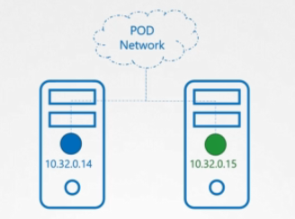

The web app can reach the database, simply by using the IP of the database POD.

But there is no guarantee that the IP of the database part will always remain the same.

If you've gone through the lecture on services as discussed in the beginners course you must know that

a better way for the web application to access the database is using a service. So we create a service to expose the database application across the cluster.

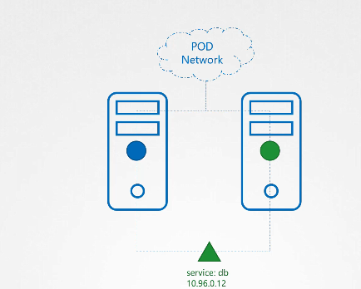

The web application can now access the database using the name of the service db.

The service also gets an IP address assigned to it whenever a pod tries to reach the service using its IP or name it forwards the traffic to the back end pod.

In this case the database.

But what is this service and how does it get an IP?

Does the service join the same POD Network?

The service cannot join the pod network because the service is not an actual thing.

It is not a container like pod so it doesn't have any interfaces or an actively listening process.

It is a virtual component that only lives in the cabinet as memory.

But then we also said that the service should be accessible across the cluster from any not.

So how is that achieved?

That’s where kube-proxy comes in.

Kube-proxy is a process that runs on each node in the kubernetes cluster.

Its job is to look for new services and every time a new service is created it creates the appropriate

rules on each node to forward traffic to those services to the backend pods.

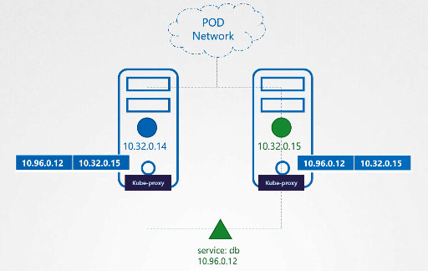

One way it does this is using IPTABLES rules.

In this case it creates an IP tables rule on each node in the cluster to forward traffic heading to the IP of the service which is 10.96.0.12 to the IP of the actual pod which is

10.32.0.15. So how kube-proxy configure the service

We discuss a lot more about networking and services kube-proxy and POD networking.

Later in this course again we have a large section just for networking.

This is a high level overview for now.

We will now see how to install kube-proxy.

Download the kube-proxy binary from the kubernetes release page. Extract it and run it as a service. The

kubeadm tool deploys kube-proxy as PODs on each node.

In fact it is deployed as a daemon set, so a single POD is always deployed on each node in the cluster.

Well if you don't know about daemon set yet don't worry we have a lecture on that coming up in this course.

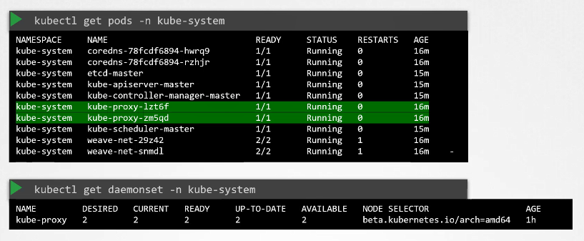

We have now covered a high-level overview of the various components in the kubernetes control plane.

As mentioned we will look at some of these in much more detail at various sections in this course.

Well that's it for this lecture.

## Replica Set

So what is a replica And why do we need a replication controller?

Let's go back to our first scenario where we had a single pod running our application.

What if for some reason our application crashes and the pod fails?

Users will no longer be able to access our application to prevent users from losing access to our application.

We would like to have more than one instance or pod running at the same time.

That way if one fails we still have our application running on the other one. The replication controller

helps us run multiple instances of a single POD in the kubernetes cluster

thus providing High Availability.

So does that mean you can't use a replication controller if you plan to have a single pod?

No.

Even if you have a single pod the replication controller can help by automatically bringing up a new

pod when the existing one fails.

Thus the replication controller ensures that the specified number of PODs are running at all times.

even if it's just 1 or 100. Another reason we need a replication controller is to create multiple PODs

to share the load across them.

For example in this simple scenario we have a single pod serving a set of users. When the number of users

increase

we deploy additional pod to balance the load across the two pods. If the demand further increases and

if we were to run out of resources on the first node we could deploy additional PODs across the other

nodes in the cluster.

As you can see the replication controller spans across multiple nodes in the cluster.

It helps us balance the load across multiple pods on different nodes as well as scale our application

when the demand increases. It's important to note that there are two similar terms replication controller

and Replica Set.

Both have the same purpose but they're not the same. Replication controller is the older technology that

is being replaced by Replica Set. Replica set is the new recommended way to setup replication.

However whatever we discussed in the previous few slides remain applicable to both these technologies.

There are minor differences in the way each works and we will look at that in a bit.

As such we will try to stick to Replica sets in all of our demos and implementations going forward.

Let us now look at how we create a replication controller.

As with the previous lecture we start by creating a replication controller definition file. We will name

name it rc-definition.yml. As with any kubernetes definition file,

We have four sections. The apiVersion, kind,

Metadata and spec the apiVersion is specific to what we are creating.

In this case replication controller is supported in kubernetes apiVersion v1.

So we will write it as v1. The kind as we know is ReplicationController. Under metadata,

we will add a name and we will call it myapp-rc. And we will also add a few labels, app and type

and assign values to them.

So far, it has been very similar to how we created a POD in the previous section.

The next is the most crucial part of the definition file and that is the specification written as spec.

For any kubernetes definition file, the spec section defines what’s inside the object we are creating.

In this case we know that the replication controller creates multiple instances of a POD. But what POD?

We create a template section under spec to provide a POD template to be used by the replication controller

to create replicas.

Now how do we define the POD template?

It's not that hard because we have already done that in the previous exercise.

Remember we created a pod-definition file in the previous exercise.

We could reuse the contents of the file to populate the template section. Move all the contents of the

pod definition file into the template section of the replication controller except for the first few

lines which are apiVersion and kind remember whatever we move must be under the template section. Meaning

this should be intended to the right and have more spaces before them

than the template line itself. They should be children of the template section. Looking at our file

now we now have two metadata sections.

One is for the Replication Controller and another for the POD

And we have two spec sections one for each.

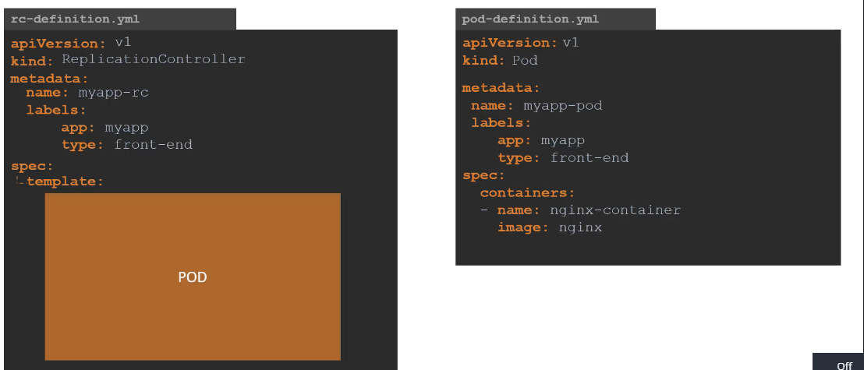

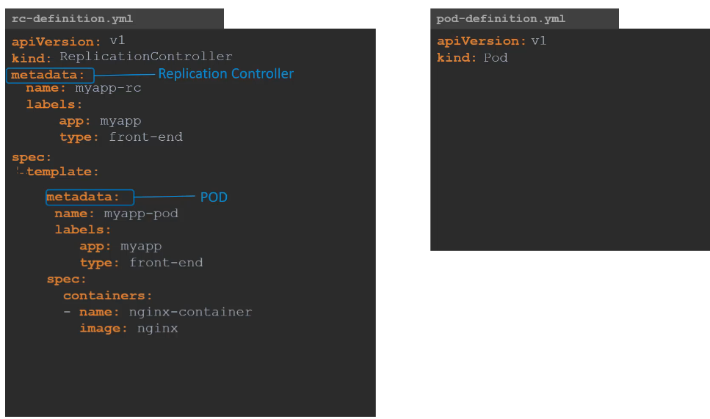

We have nested two definition files together.

The replication controller being the parent and the pod definition being the child. Now there is something

still missing.

We haven't mentioned how many replicas we need in the replication controller. For that,

add another property to the spec called replicas and input the number of replicas you need under it.

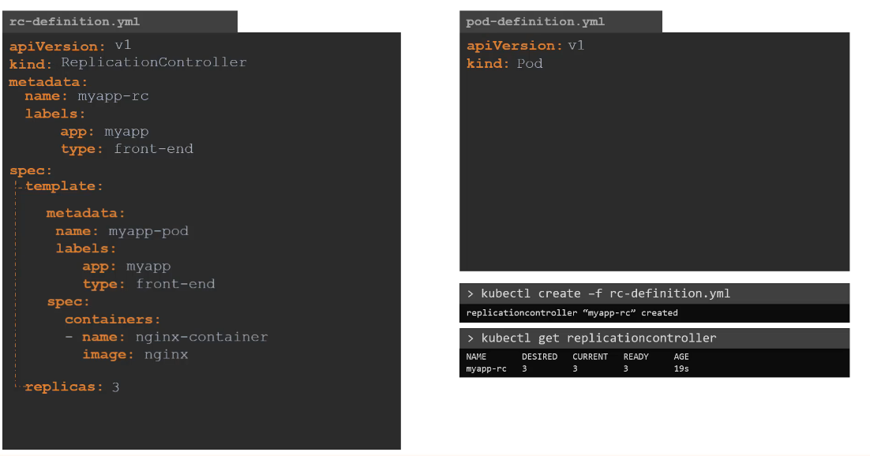

Remember that the template and replicas are direct children of spec sections. So they are siblings and

must be on the same vertical line which means having equal number of spaces before them. Once the file

is ready run the kubectl create command and input the file using the -f parameter. The replication

controller is created. When the replication controller is created it first creates the PODs using the

pod-definition template as many as required, which is 3

in this case. To view the list of created replication controllers run the kubectl get replication controller

command and you will see the replication controller listed.

We can also see the desired number of replicas or pods,

the current number of replicas and how many of them are ready in the output.

If you would like to see the pods that were created by the replication controller, run the kubectl

get pods command and you will see three pods running.

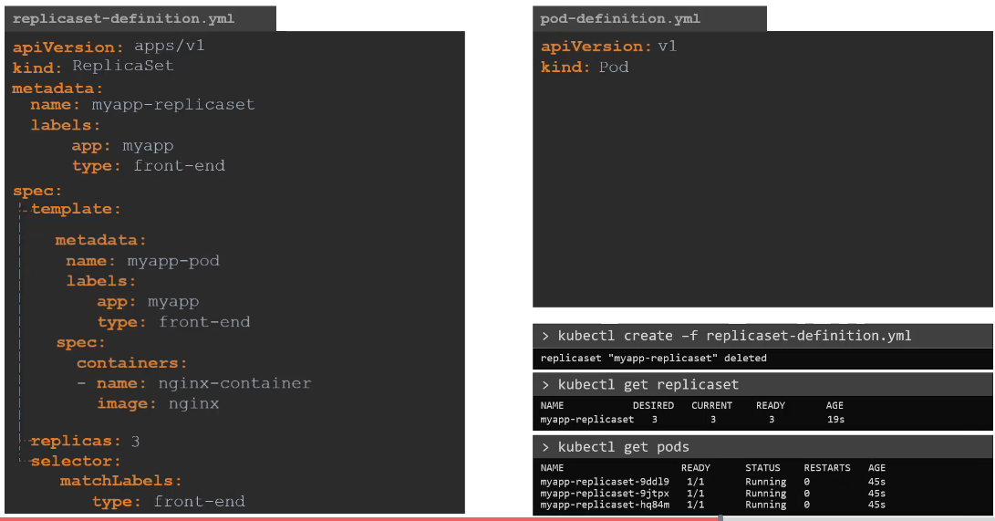

Note that all of them are starting with the name of the replication controller which is myapp-rc

indicating that they are all created automatically by the replication controller.

What we just saw was the Replication Controller.

Let us now look at replica set.

It is very similar to replication controller. As usual,

first we have apiVersion, kind,

metadata and spec. The apiVersion though is a bit different.

It is apps/v1 which is different from what we had before for replication controller which

was just V1.

If you get this wrong you are likely to get an error that looks like this.

It would say no match for a kind replica set because the specified kubernetes API version has no support

for replica set. The kind would be replica set and we add name and labels in the metadata.

The specification section looks very similar to replication controller.

It has a template section where we provide part definition as before.

So I am going to copy contents over from pod-definition file. And we have number of replicas which

is set to 3.

However there is one major difference between replication controller and replica set.

Replica set requires a selector definition. The selector section helps the replicaset identify what

pods fall under it. But why would you have to specify what PODs fall under it,

if you have provided the contents of the pod-definition file itself in the template? It’s because, replica

set can also manage parts that were not created as part of the public asset creation.

Say for example, there were pods created before the creation of the ReplicaSet that match the labels specified

in the selector.

The replica set will also take those pods into consideration when creating the replicas.

I will elaborate this in the next slide. But before we get into that I would like to mention that the

selector is one of the major differences between replication controller and replica set. The selector

is not a required field in case of a replication controller but it is still available. When you skip

it, as we did in the previous slide it assumes it to be the same as the labels provided in the pod definition

file. In case of replica said a user input is required for this property and it has to be written in

the form of match labels as shown here.

The match labeles selector simply matches the labels specified under it to the labels on the PODs.

The replica set selector also provides many other options for matching labels that were not available

in a replication controller.

And as always to create a replica set

run the kubectl create command providing the definition file as input and to see the created replicasets

run the kubectl get replicaset command. To get list of pods, simply run the kubectl get pods

command.

So what is the deal with labels and selectors.

Why do we label our PODs and objects in kubernetes?

Let us look at a simple scenario.

Say we deployed 3 instances of our frontend web application as 3 PODs.

We would like to create a replication controller or replica set to ensure that we have three active

PODs at anytime.

And yes that is one of the use case of replica sets.

You can use it to monitor existing parts if you have them already created.

As it is in this example in case they were not created the replica set will create them for you.

The role of the replicaset is to monitor the pods and if any of them were to fail, deploy new ones.

The replica set is in fact a process that monitors the parts.

Now how does the replica set know what pods to monitor.

There could be 100s of other PODs in the cluster running different application.

This is where labelling our pods during creation comes in handy.

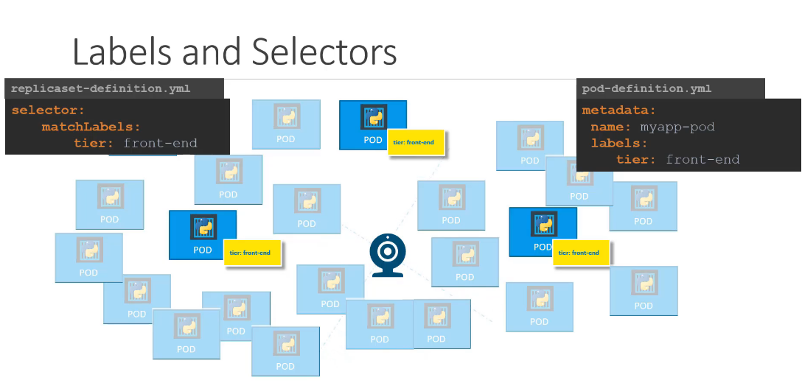

We could now provide these labels as a filter for replica set. Under the selector section we use to match

labels filter and provide the same label that we used while creating the pods.

This way the replica set knows which pods to monitor. The same concept of labels and selectors is used

in many other places throughout kubernetes.

Now let me ask you a question along the same lines. In the replicaset specification section

we learned that there are 3 sections: Template, replicas and the selector.

We need three replicas and we have updated our selector based on our discussion in the previous slide.

Say for instance we have the same scenario as in the previous slide were we have three existing pods

that were created already and we need to create a replica set to monitor the pods to ensure there are

a minimum of three running at all times.

When the replication controller is created it is not going to deploy a new instance of pods as three

of them with matching labels are already created.

In that case do we really need to provide a template section in the replica set specification.

since we are not expecting the replicaset to create a new POD on deployment? Yes we do because in case

one of the PODs were to fail in the future, the replicaset needs to create a new one to maintain the

desired number of PODs. And for the replica set to create a new POD,

The template definition section is required. Let’s look at how we scale the replicaset.

Say we started with three replicas and

In the future we decided to scale to six.

How do we update our replica set to scale to six replicas.

Well there are multiple ways to do it.

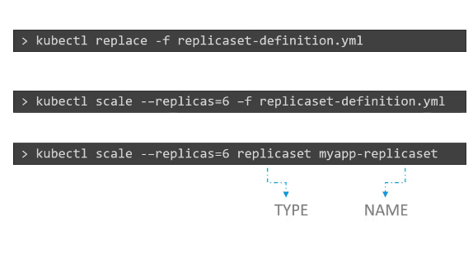

kubectl scale --replicas=2 replicaset new-replica-set

The first, is to update the number of replicas in the definition file to 6.

Then run the kubectl replace command specifying the same file using the –f parameter and that

will update the replica set to have six replicas.

The second way to do it is to run the kubectl scale command.

Use the replicas parameter to provide the new number of replicas and specify the same file as input.

You may either input the definition file or provide the replicaset name in the type Name format. However,

Remember that using the file name as input will not result in the number of replicas being updated

automatically in the file.

In otherwords, the number of replicas in the replicaset-definition file will still be 3 even

though you scaled your replicaset to have 6 replicas using the kubectl scale command and the

file as input.

There are also options available for automatically scaling the replica set based on load but that is

an advanced topic and we will discuss it at a later time. Let us now review the commands real quick. The

kubectl create command, as we know, is used to create a replca set or basically any object in Kubernetes

depending on the file we are providing as input.

You must provide the input file using the –f parameter. Use the kubectl get command to see

list of replicasets created. Use the kubectl delete replicaset command followed by the name of

the replica set to delete the replicaset. And then we have the kubectl replace command to replace

or update replicaset and also the kubectl scale command to scale the replicas simply from the

command line without having to modify the file. That's it for this lecture.

## Deployment

For a minute, let us forget about PODs and replicasets and other kubernetes concepts and talk about how you might want to deploy your application in a production environment.

Say for example you have a web server that needs to be deployed in a production environment.

You need not one but many such instances of the web server running for obvious reasons.

Secondly whenever newer versions of application builds become available on the docker registry you would like to upgrade your Docker instances seamlessly.

However when you upgrade your instances you do not want to upgrade all of them at once

as we just did. This may impact users accessing our applications, so you might want to upgrade them one after the other.

And that kind of upgrade is known as rolling updates.

Suppose one of the upgrades you performed resulted in an unexpected error and you're asked to undo the

recent change you would like to be able to roll back the changes that were recently carried out. Finally,

say for example you would like to make multiple changes to your environment such as upgrading the underlying

WebServer versions, as well as scaling your environment and also modifying the resource allocations etc.

WebServer versions, as well as scaling your environment and also modifying the resource allocations etc.

You do not want to apply each change immediately after the command is run instead you would like to

apply a pause to your environment, make the changes and then resume so that all changes are rolled-out together. All of these capabilities are available with the kubernetes Deployments. So far in this course

we discussed about PODs, which deploy single instances of our application such as the web application

in this case. Each container is encapsulated in PODs. Multiple such PODs are deployed using Replication Controllers or Replica Sets. And then comes Deployment which is a kubernetes object that comes higher in the hierarchy.

The deployment provides us with the capability to upgrade the underlying instances seamlessly using

rolling updates, undo changes, and pause and resume changes as required.

So how do we create a deployment. As with the previous components,

We first create a deployment definition file. The contents of the deployment definition file are exactly

similar to the replica set definition file, except for the kind, which is now going to be deployment. If

we walk through the contents of the file

it has an apiVersion which is apps/v1, metadata which has name and labels and a spec that

has template, replicas and selector.

The template has a pod definition inside it. Once the file is ready run the kubectl create command

and specify the deployment definition file. Then run the kubectl get deployments command to see

the newly created deployment. The deployment automatically creates a replica set.

So if you run the kubectl get replcaset command

You will be able to see a new replica set in the name of the deployment.

The replicasets ultimately create pods,

so if you run the kubectl get pods command

you will be able to see the pods with the name of the deployment and the replicaset.

So far there hasn't been much of a difference between replica set and deployments except for the fact that deployments created a new kubernetes object called deployments.

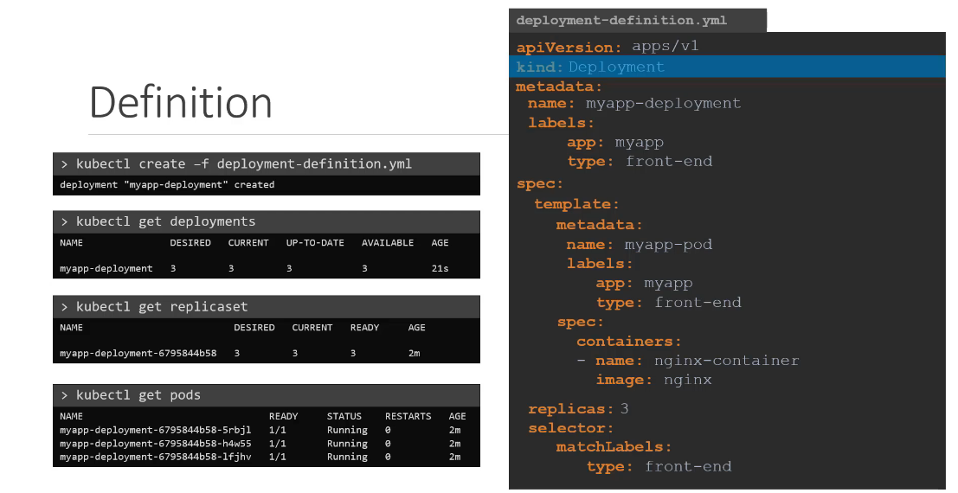

We will see how to take advantage of the deployment using the use cases we discussed in the previous

slide in the upcoming lectures and one more note before we end this lecture.

To see all the created objects at once run the kubectl get all command and in this case we can see that the deployment was created and then we have the replica set followed by three pods that were created as part of the deployment.

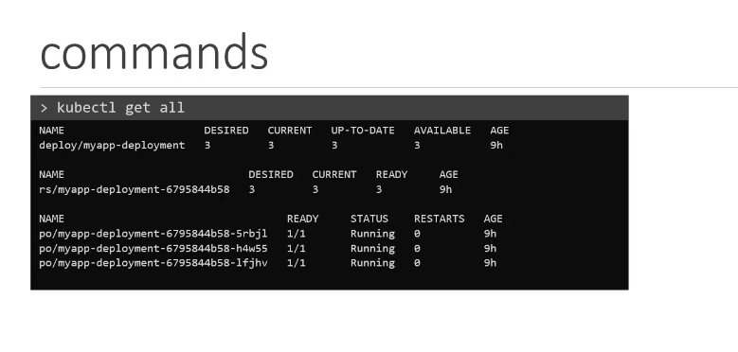

Exp

apiVersion: apps/v1

kind: Deployment

metadata:

name: http-frontend

spec:

replicas: 3

selector:

matchLabels:

name: http-frontend

template:

metadata:

labels:

name: http-frontend

spec:

containers:

- name: http-frontend

image: httpd:2.4-alpine

## Namespace

There are two boys named Mark to differentiate them from each other.

We call them by their last names.

Smith and Williams they come from different houses.

Of course the Smiths and the Williams There are other members in the house.

The individuals within the house address each other simply by their first names.

For example the father addresses Mark simply as Mark.

However if the father wishes to address the mark in the other house he would use the full name someone

outside of these houses would also use the full name to refer to the boys or anyone within these houses.

Each of these houses have their own set of rules that defines who does what each of these houses have

their own set of resources that they can consume.

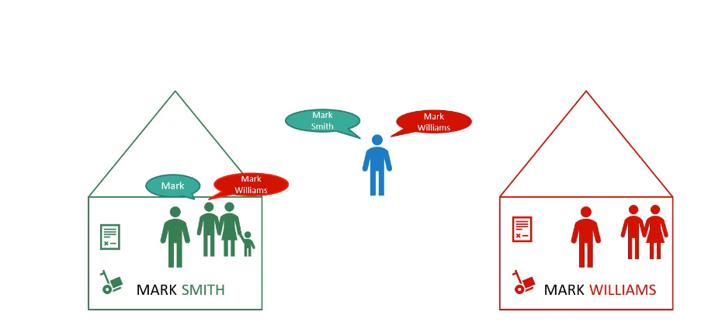

Now let's get back to kubernetes these houses correspond to namespaces in kubernetes.

So far in this course we've created objects such as pods deployments and services in our cluster.

Whatever we have been doing we have been doing within a namespace.

We were inside a house all this while this namespace is known as the default namespace and it is created

automatically kubernetes,

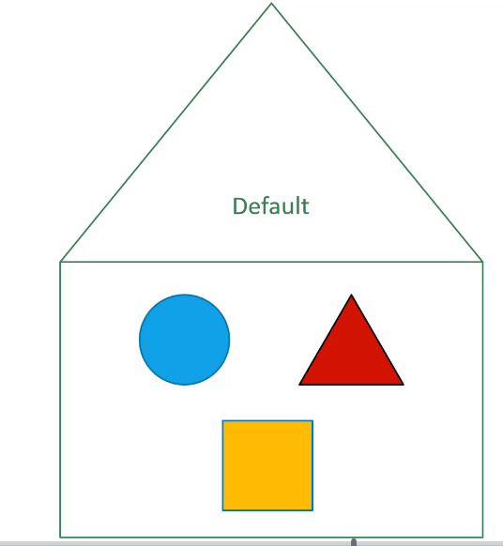

when the cluster is first set up kubernetes, creates a set of pods

and services for its internal purpose such as those required by the networking solution.

The DNS service etc. to isolate these from the user and to prevent you from accidentally deleting or modifying these services kubernetes creates them under another namespace created at cluster startup named Kube system a third namespace created by Coburn that is automatically is called kube public.

This is where resources that should be made available to all users are created.

If your environment is small or your learning and playing around with a small cluster you shouldn't

really have to worry about namespaces you could continue to work in the default namespace.

However as and when you grow and use a kubernetes cluster for enterprise or production purposes you may want to consider the use of namespace as you can create your own namespaces as well.

For example, if you wanted to use the same cluster for both dev and production environment but at the same time isolate the resources between them you can create a different namespace for each of them.

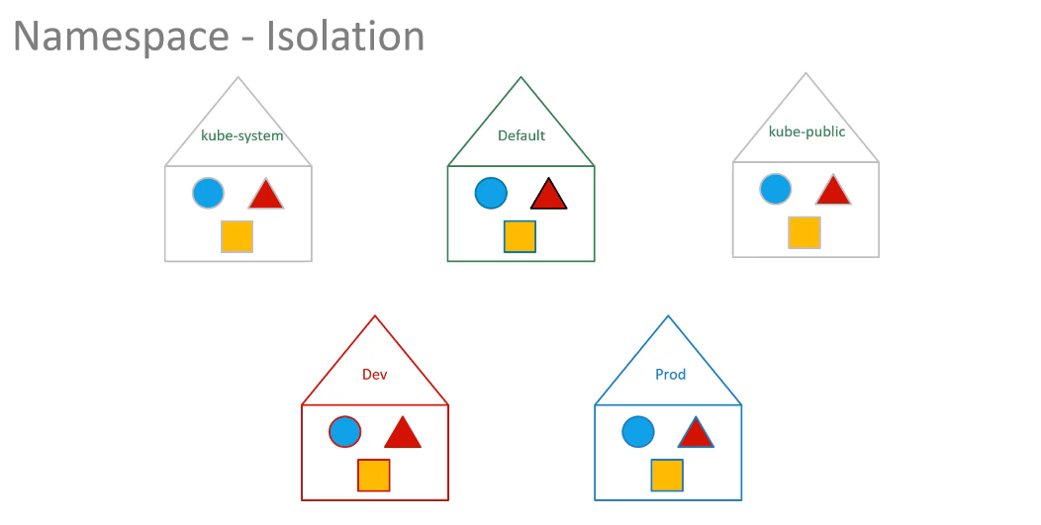

That way while working in the dev environment you don't accidentally modify a resources in production.

Each of these namespace can have its own set of policies that define who can do what.

You can also assign quota of resources to each of these named spaces that we each namespace is guaranteed

a certain amount and does not use more than it's allowed.

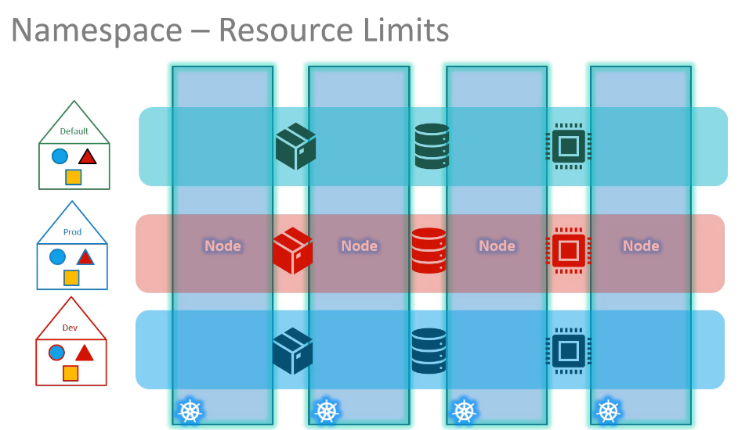

Limit going back to the default namespace that we have been working on just like how the members within

the House refer to each other by their first names.

The resources within a namespace can refer to each other simply by their names.

In this case the web app part can reach the db service simply using the hostname db service if required.

The Web app Pod can reach a service in another namespace as well.

For this you must append the name of the namespace to the name of the service.

For example for the web pod in the default namespace to connect to the database in the dev environment or namespace.

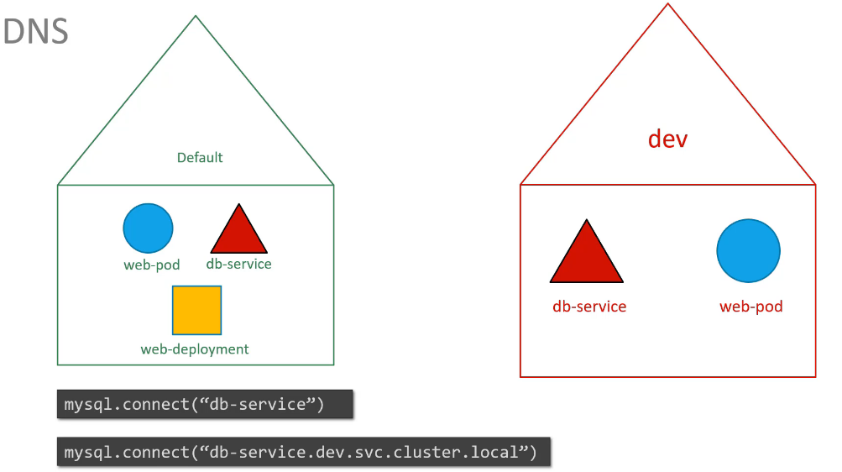

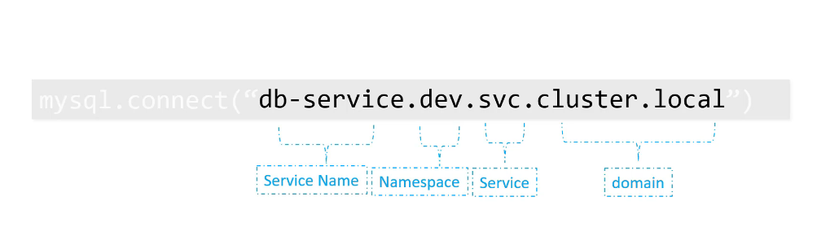

Use the servicename.namespace.svc.cluste.local format that would be db service.

Dev.SVC.cluster.local you're able to do this because when the service is created a DNS entry is added automatically in this format looking closely at the DNS name of the service.

The last part Cluster.local is the default domain name of the kubernetes cluster SVC is the subdomain for service followed by the namespace and then the name of the service itself.

Let us now look at some of the operational aspects of namespace.

Let's start with a Kube control commands.

For example, this command is used to list all the pods but it only lists the pods in the default namespace

to list pods in another namespace.

Use the namespace option in the command along with the name of the namespace.

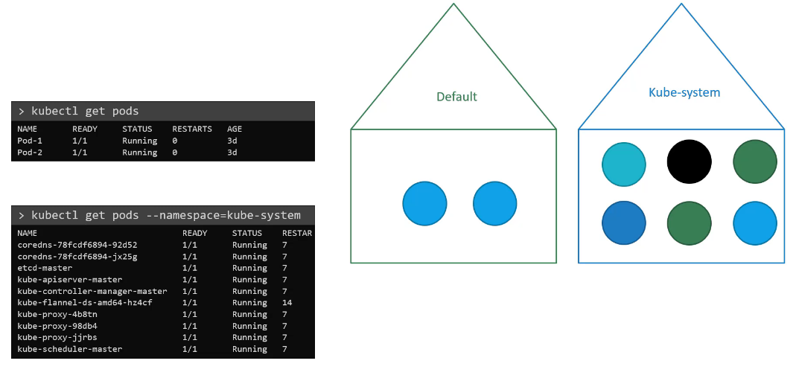

In this case Kube system here I have a pod definition file when you create a pod using this file.

The pod is created in the default namespace to create a pod in another namespace.

Use the namespace option if you want to make sure that this board gets created in the dev environment all the time.

Even if you don't specify the namespace in the command line you can move the namespace definition into the pod definition file like this under the metadata section.

This is a good way to ensure your resources are always created in the same namespace.

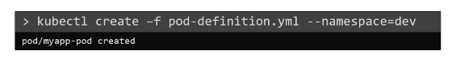

or

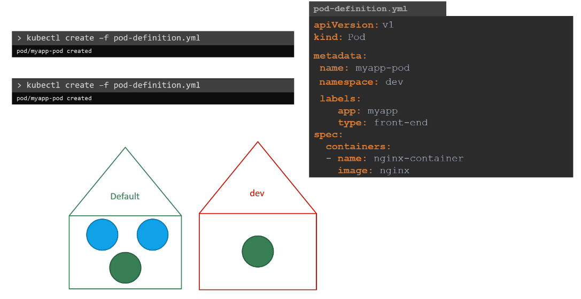

So how do you create a new namespace like any other object.

Use an namespace definition file the API version is V1 kind is namespace and under metadata specify

the name.

In this case.

Dev run the Kube control create command to create the namespace.

Another way to create a namespace is by simply running the command Kube control.

Create namespace followed by the name of the namespace now say we're working in three namespaces.

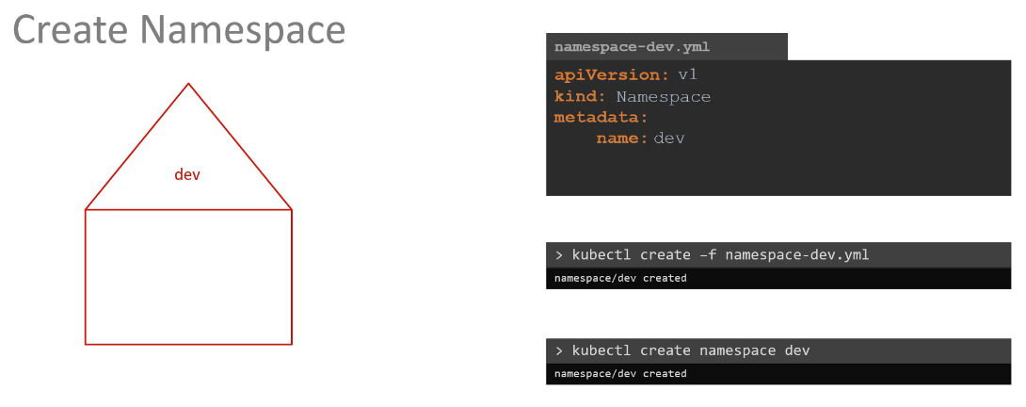

As we discussed before by default we are in the default namespace which is why we can see the resources

inside the default namespace using the kube control get pods command and to view those in the dev namespace.

We have to use the namespace option but what if we want to switch to the dev namespace permanently so

that we don't have to specify the namespace option anymore.

Well, in that case, use the Kube control config command to set the namespace in the current context.

Dev you can then simply run the Kube control get pods command without the namespace option to list pods

in the dev environment but you will need to specify the option for other environments such as default

or prod similarly you can switch to the prod namespace the same way.

Finally to view pods in all namespace use the all namespace option in the command.

This will list all the pods in all of the namespace is taking a closer look at the command.

This command first identifies the current context and then sets the namespace to the desired one for

that current context.

Well contexts are used to manage multiple clusters in multiple environments from the same management

system.

It is a totally separate topic to discuss and requires its own lecture so we will discuss context in

another lecture to limit resources in a namespace.

Create a resource quota to create one.

Start with a definition file for resource quota specify the namespace for which you want to create the

quota and then under spec provide your limits such as 10 pods 10 CPU units 10 GB byte of memory

etc..

Well that's it for this lecture.

Head over to the coding exercise and section and practice working with namespaces and I will see you

in the next lecture.

## Imperative commands

**Create an NGINX Pod**

kubectl run --generator=run-pod/v1 nginx --image=nginx

**Generate POD Manifest YAML file (-o yaml). Don't create it(--dry-run)**

kubectl run --generator=run-pod/v1 nginx --image=nginx --dry-run -o yaml

**Create a deployment**

kubectl run --generator=deployment/v1beta1 nginx --image=nginx

**Generate Deployment YAML file (-o yaml). Don't create it(--dry-run)**

kubectl run --generator=deployment/v1beta1 nginx --image=nginx --dry-run -o yaml

**Generate Deployment YAML file (-o yaml). Don't create it(--dry-run) with 4 Replicas (--replicas=4)**

kubectl run --generator=deployment/v1beta1 nginx --image=nginx --dry-run --replicas=4 -o yaml

**Save it to a file - (If you need to modify or add some other details before actually creating it)**

kubectl run --generator=deployment/v1beta1 nginx --image=nginx --dry-run --replicas=4 -o yaml > nginx-deployment.yaml

|  |
| --- |
| * all  * certificatesigningrequests (aka 'csr')  * clusterrolebindings  * clusterroles  * componentstatuses (aka 'cs')  * configmaps (aka 'cm')  * controllerrevisions  * cronjobs  * customresourcedefinition (aka 'crd')  * daemonsets (aka 'ds')  * deployments (aka 'deploy')  * endpoints (aka 'ep')  * events (aka 'ev')  * horizontalpodautoscalers (aka 'hpa')  * ingresses (aka 'ing')  * jobs  * limitranges (aka 'limits')  * namespaces (aka 'ns')  * networkpolicies (aka 'netpol')  * nodes (aka 'no')  * persistentvolumeclaims (aka 'pvc')  * persistentvolumes (aka 'pv')  * poddisruptionbudgets (aka 'pdb')  * podpreset  * pods (aka 'po')  * podsecuritypolicies (aka 'psp')  * podtemplates  * replicasets (aka 'rs')  * replicationcontrollers (aka 'rc')  * resourcequotas (aka 'quota')  * rolebindings  * roles  * secrets  * serviceaccounts (aka 'sa')  * services (aka 'svc')  * statefulsets (aka 'sts')  * storageclasses (aka 'sc') |

Top of Form

Bottom of Form

## Scheduler – no pod

What do you do when you do not have a scheduler in your cluster?

You, probably do not want to rely on the built in scheduler and instead want to schedule the PODs yourself.

So how exactly does a scheduler work in the backend.

Let's start with a simple pod definition file.

Every POD has a field called NodeName that, by default, is not set.

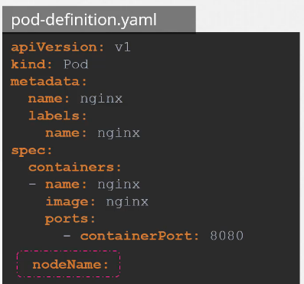

You don’t typically specify this field when you create the manifest file, Kubernetes adds it automtically.

The scheduler goes through all the pods and looks for those that do not have this property set.

Those are the candidates for scheduling.

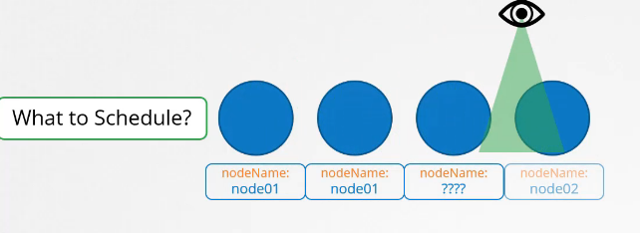

It then identifies the right node for the POD, by running the scheduling algorithm.

Once identified it schedules the POD on the Node by setting the node Name property to the name of the node by creating a binding object.

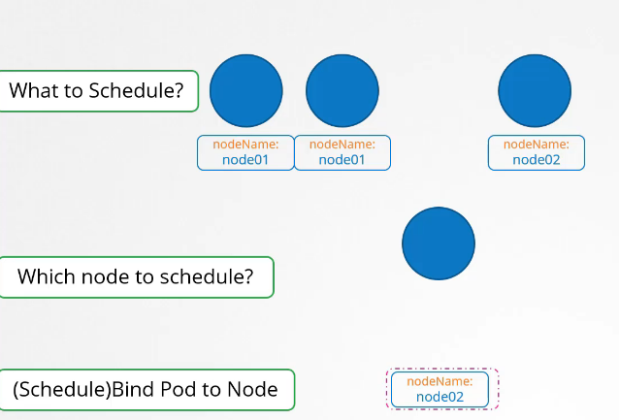

So if there is no scheduler to monitor and schedule nodes what happens?

The pods continue to be in a pending state.

So what can you do about it.

You can manually assign pods to node yourself. Well without a scheduler,

the easiest way to schedule a pod is to simply set the node name field to the name of the node in your pod specification while creating the POD.

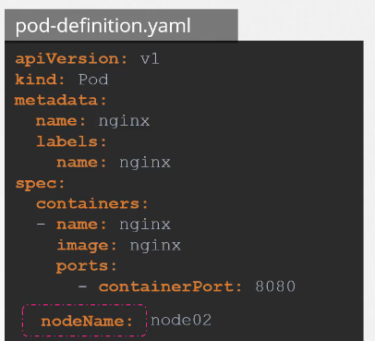

The pod then gets assigned to the specified node. You can only specify the node name at creation time.

What if the pod is already created and you want to assign the pod to a node? Kubernetes won’t allow you to modify the node Name property of a pod.

So another way to assign a note to an existing pod is to create a binding object and send a post request

to the pod binding API thus mimicking what the actual scheduler does. In the binding object you specify

a target node with the name of the node. Then send a post request to the pods binding API with the data set to the binding object in a JSON format.

So you must convert the YAML file into its equivalent JSON format.

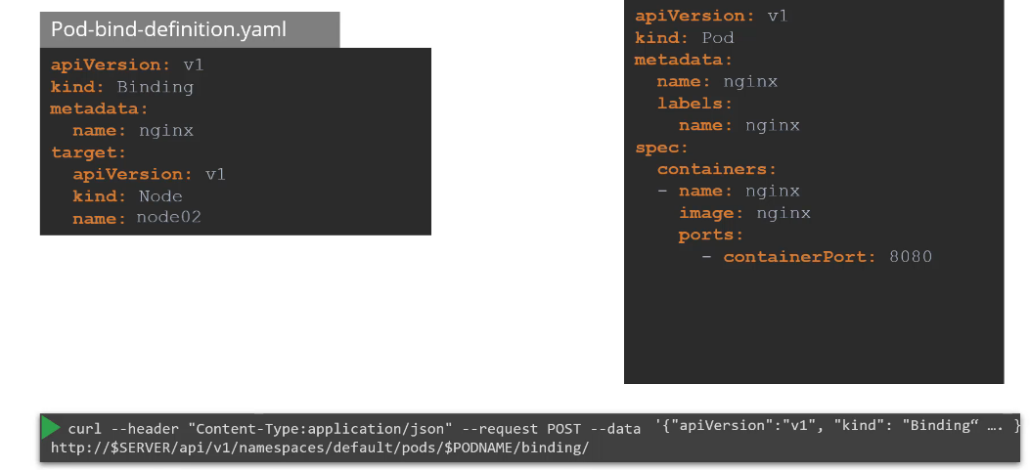

## Labels

Say you have a set of different species.

A user wants to be able to filter them based on different criteria such as based on their class or kind if they are domestic or wild or see by their color and not just group.

You want to be able to filter them based on a criteria such as all green animals or with multiple criteria such as everything green.

That is also a bird. Whatever that classification may be you need the ability to group things together and filter them based on your needs and the best way to do that is with labels. Labels or properties attached to each item.

So you add properties to each item for their class, kind and color selectors help you filter these items.

For example when you say class equals mammal we get a list of mammals and when you say color equals green we get the green mammals we see labels and selectors used everywhere such as the keywords you

tag to YouTube videos or blogs that help users filter and find the right content we see labels added

to items in an online store that help you add different kinds of filters to view your products.

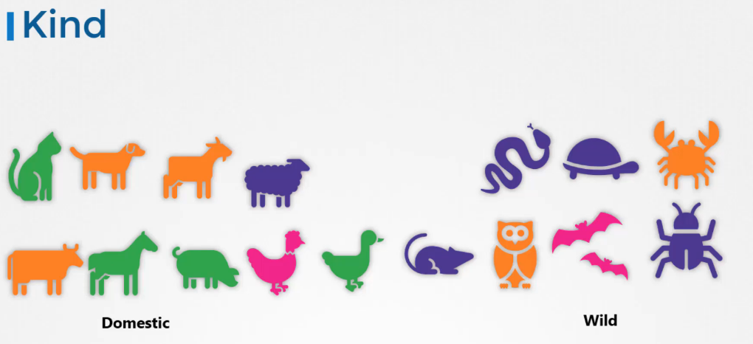

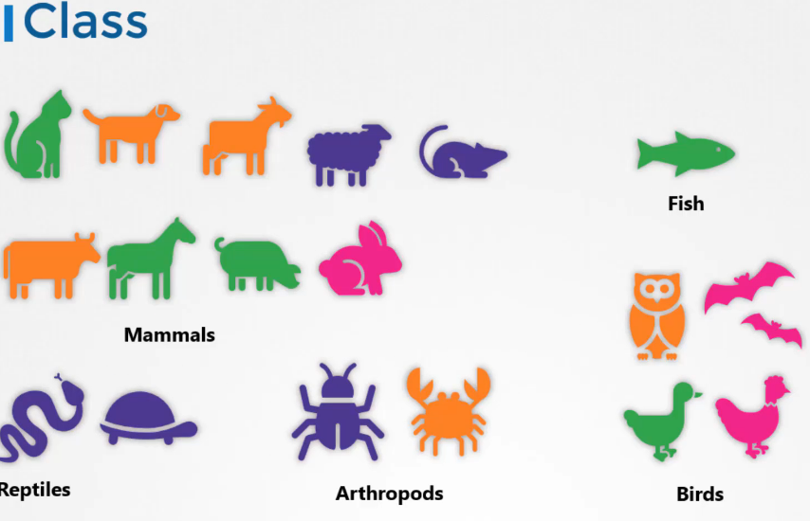

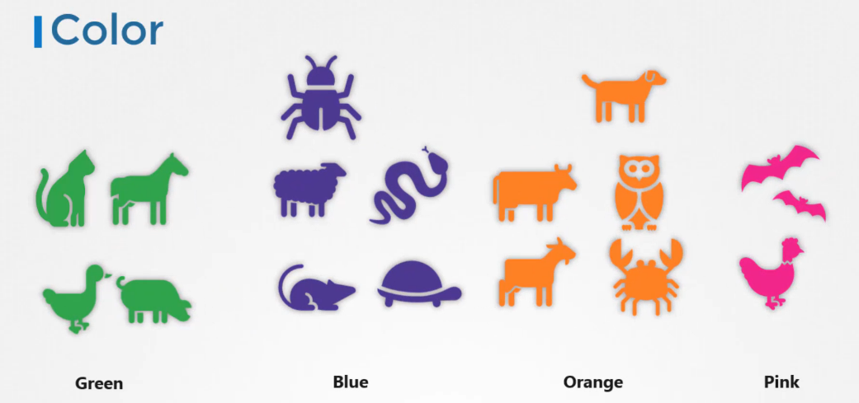

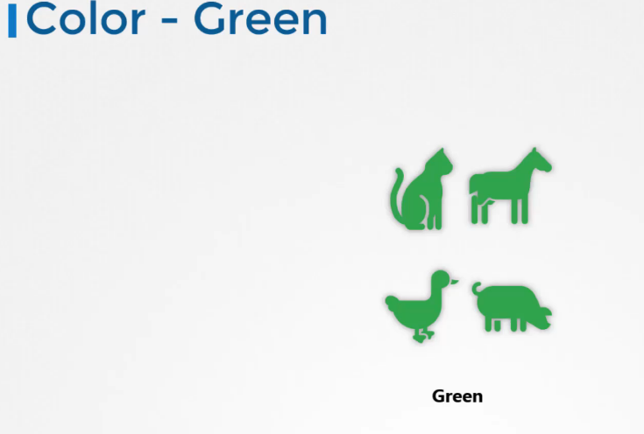

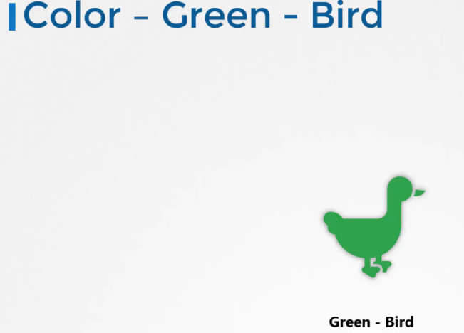

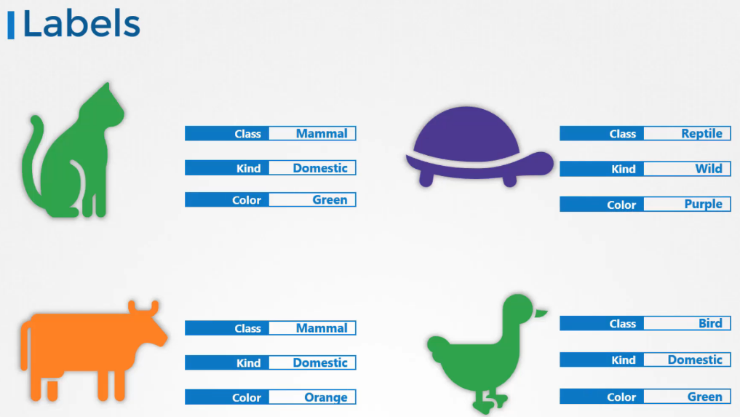

So how are labels and selectors used in Kubernetes?

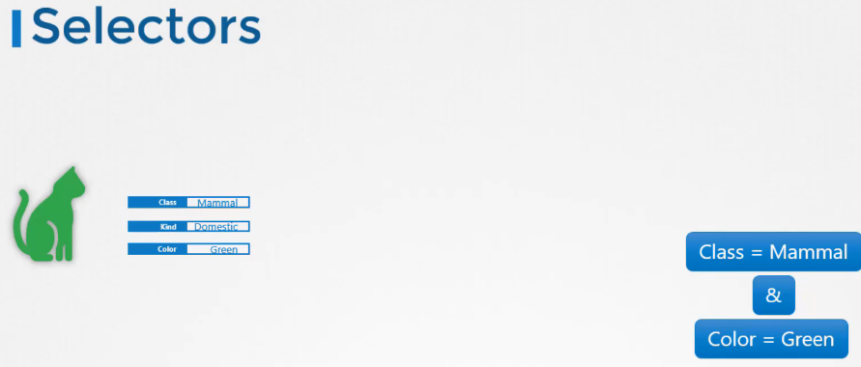

We have created a lot of different types of Objects in Kuberentes. Pods, Services, ReplicaSets and Deployments.

etc. For Kubernetes, all of these are different objects.

Over time you may end up having hundreds or thousands of these objects in your cluster.

Then you will need a way to filter and view different objects by different categories such as to group objects by their type or view objects by application or by their functionality whatever it may be.

You can group and select objects using labels and selectors for each object attach labels as per your needs, like app, function etc.

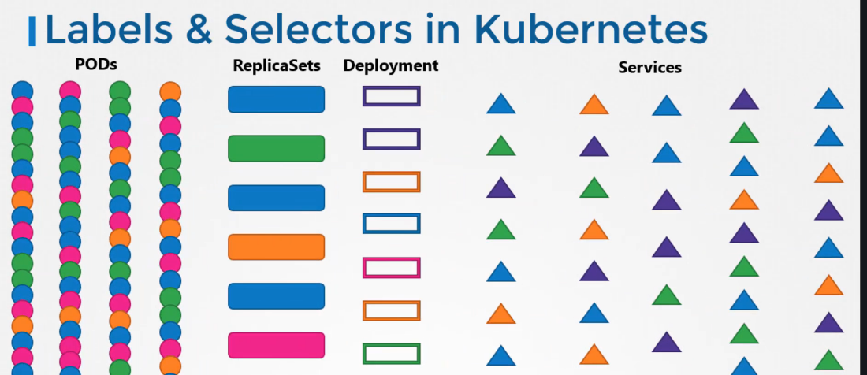

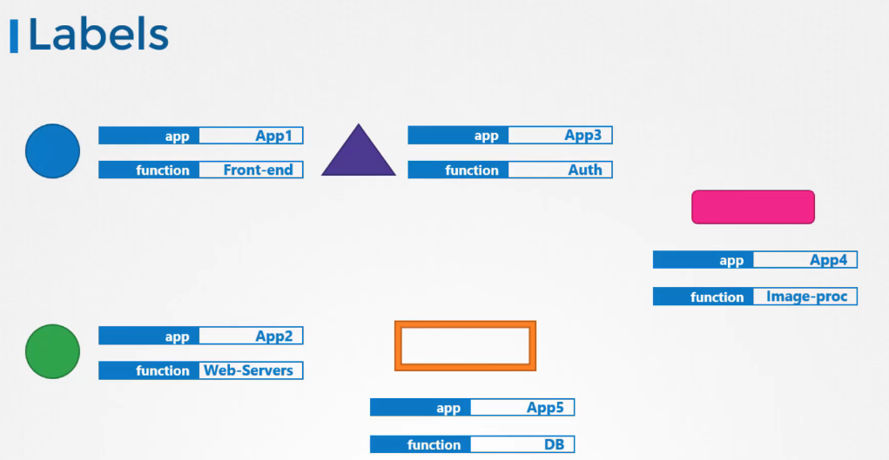

Then while selecting specify a condition to filter specific objects.

For example app == App1. So how exactly do you specify labels in kubernetes.

In a pod-definition file, under metadata,

create a section called labels. Under that add the labels in a key value format like this.

You can add as many labels as you like.

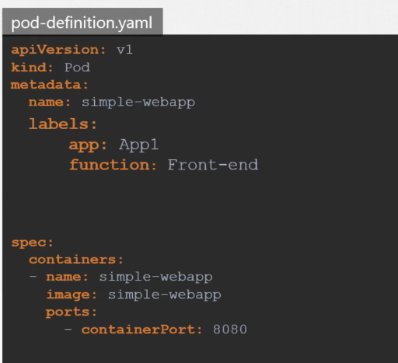

Once the pod is created, to select the pod with the labels

use the kubectl get pods command along with the selector option, and specify the condition like app=App1.

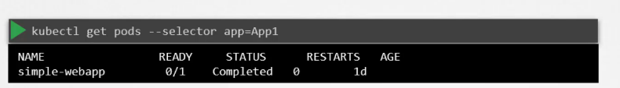

Now this is one use case of labels and selectors. Kubernetes objects use labels and selectors internally to connect different objects together.

For example to create a replicaset consisting of 3 different

pods, we first label the pod definition and use selector in a replicaset to group the pods .

In the replica-set set definition file.

You will see labels defined in two places.

Note that this is an area where beginners attempt to make a mistake.

The labels defined under the template section are the labels configured on the pods. The labels you see at the top are the labels of the replicas set itself.

We're not really concerned about the labels of the replica set for now because we are trying to get the replica set to discover the pods.

The labels on the replica set will be used if you were to configure some other object to discover the replica set in order to connect the replica set to the pod we configure the selector field under the replica set specification to match the labels defined on the pod a single label will do if it matches correctly.

However if you feel there could be other pods with the same label but with a different function then you could specify both the labels to ensure that the right pods are discovered by the replica set on creation.

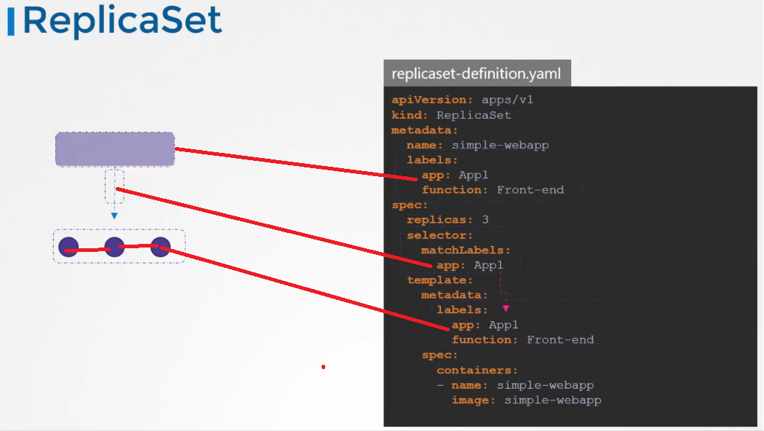

If the labels match the replica set is created successfully it works the same for other objects like

a service when a service is created it uses the selector defined in the service definition file to match

the labels set on the pods in the replica set definition file.

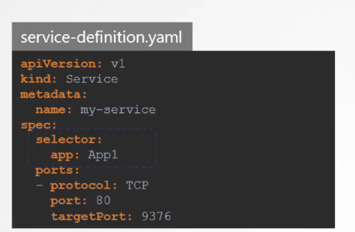

Finally let’s look at annotations. While labels and selectors are used to group and select objects, annotations are used to record other details for inflammatory purpose.

For example tool details like name, version build information etc or contact details, phone numbers, email

ids etc, that may be used for some kind of integration purpose.

master $ kubectl get pods --selector env=dev

NAME READY STATUS RESTARTS AGE

app-1-5nvbn 1/1 Running 0 1m

app-1-dkzg8 1/1 Running 0 1m

app-1-wn6xk 1/1 Running 0 1m

db-1-bb72k 1/1 Running 0 1m

db-1-nphv5 1/1 Running 0 1m

db-1-q2r64 1/1 Running 0 1m

db-1-sgwlq 1/1 Running 0 1m

master $ kubectl get pods --selector env=dev

NAME READY STATUS RESTARTS AGE

app-1-5nvbn 1/1 Running 0 1m

app-1-dkzg8 1/1 Running 0 1m

app-1-wn6xk 1/1 Running 0 1m

db-1-bb72k 1/1 Running 0 1m

db-1-nphv5 1/1 Running 0 1m

db-1-q2r64 1/1 Running 0 1m

db-1-sgwlq 1/1 Running 0 1m

## Taits and tolerations

.In this lecture we will discuss about the part to note relationship and how you can restrict what parts are placed on what notes the concept of taints and toleration can be a bit confusing for beginners.

So we will try to understand what they are using an analogy of a bug approaching a person.

Now my apologies in advance but this is the best I could come up with to prevent the bug from landing on the person.

We spray the person with a repellent(insecticide) spray or attained as we will call it.

In this lecture the book is intolerant to the smell.

So on approaching the person detained applied on the person throws the bug off however there could be

other books that are tolerant to the smell and so the taint doesn't really affect them.

And so they end up landing on the person.

So there are two things that decide if a bug can land on a person.

First the taint on the person.

And second the bugs toleration level to that particular taint

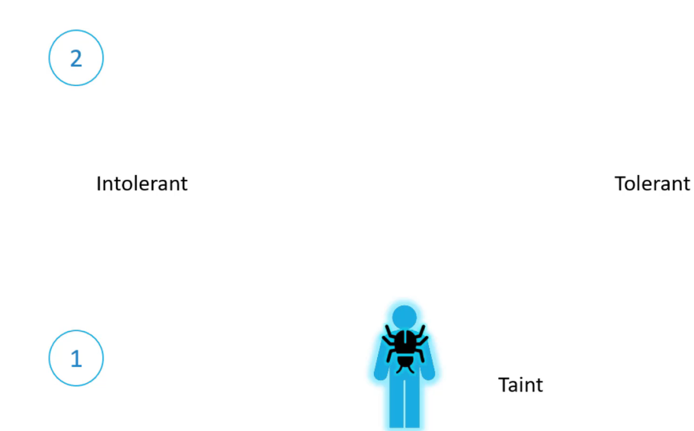

Getting back to Kube NET is the person is a node and the bugs are pods.

Now teens and toleration have nothing to do with security or intrusion on the Cluster.

Teens and toleration are used to set restrictions on what parts can be scheduled.

On a note let us start with a simple cluster with three worker notes the notes are named one two and

three.

We also have a set of paths that are to be deployed on these notes.

Let's call them A B C and D.

When the parts are created common it is scheduler tries to place these parts on the available worker

nodes.

As of now there are no restrictions are limitations and as such the scheduler places the parts across

all of the nodes to balance them out equally.

Now let us assume that we have dedicated resources on Node 1 for a particular use case or application

so we would like only those parts that belong to this application to be placed on Node 1.

First we prevent all parts from being placed on the Node by placing a taint on the Node.

Let's call it blue by default.

Paths have no toleration which means unless specified otherwise none of the parts can tolerate any taint.

So in this case none of the parts can be placed on Node 1 as none of them can tolerate the team.

Blue this solves half of our requirement no unwanted parts are going to be placed on this note.

The other half is to enable certain parts to be placed on this note.

For this we must specify which parts are tolerant to this particular attempt.

In our case we would like to allow only Part D to be placed on this note so we add a toleration to Part

D.

Part D is now tolerant to blue so when the scheduler tries to place this part on Node 1 it goes through

Node 1 can now only accept parts that can tolerate the taint. Blue so with all the teens and toleration is in place. This is how the parts would be scheduled. The scheduler tries to place part a on not one but due to the team it is thrown off and it goes to note to the scheduler then tries to place part B on not one but again due to the taint it is thrown off and

is placed on Node 3 which happens to be the next free node.

The scheduler then tries to place part c to the Node 1 it is thrown off again and ends up on Node 2. Finally the scheduler tries to place part D on Node 1 since the part is tolerant to Node 1. It goes through so remember trains are set on nodes and toleration are set on pods.

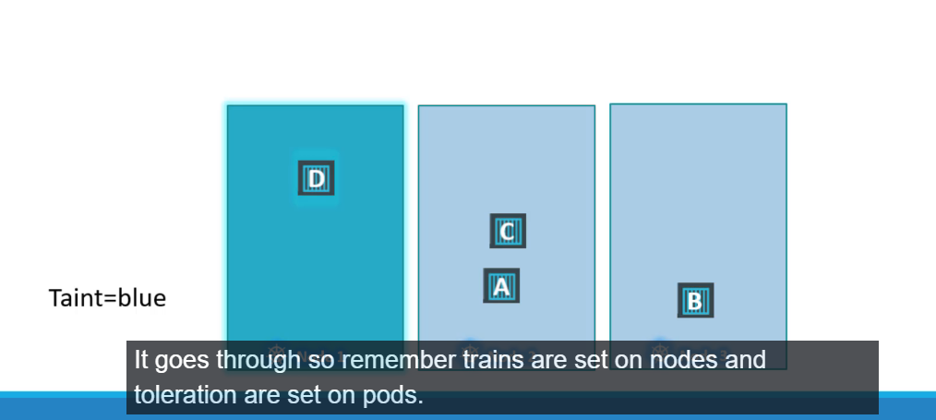

So how do you do this.

Use the cube control taint nodes command to taint in node specify the name of the node to train followed by the train itself which is a key value pair.



Key=value exp app=blue

For example if you would like to dedicate the Node 2 parts in application blue then the key value pair

would be app=blue the taint effect defines what would happen to the pods.

If they do not tolerate the taint there are three taint effects no schedule which means the pod will not be scheduled on the node which is what we have been discussing.

Prefer No schedule which means the system will try to avoid placing a pod on the node but that is not guaranteed.

And third is no execute.

Which means that new pods will not be scheduled on the node and existing parts on the node if any will be evicted if they do not tolerate the taint.

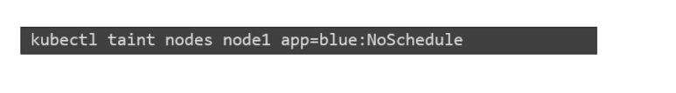

These parts may have been scheduled on Node before the 10th was applied to the node.

An example command would be detained Node node one with the key value pair app equals blue and an effect

of no schedule toleration is are added to parts to add a toleration to a pod.

First pull up the pod definition file in the spec section of the pod definition file had a section called

toleration move the same values used to while creating the taint under this section.

The key is app operator is equal value is blue and the effect is no should you.

And remember all of these values need to be encoded in double codes.

When the pods are now created or updated with the new toleration they are either not scheduled on nodes

or evicted from the existing nodes depending on the effect set let us try to understand the No.

Execute takes effect in a bit more depth.

In this example we have three nodes running some workload.

We do not have any teens or toleration at this point so they are scheduled this way.

We then decided to dedicate Node 1 for a special application and as such we obtained the node with the

application name and add a toleration to the part that belongs to the application which happens to be

part D.

In this case while tending the node we set the taint effect to no execute and as such.

Once detained on the Node takes effect it evokes Part C from the node which simply means that the part

is killed.

The Part D continues to run on the node as it has a toleration to the change.

Now going back to our original scenario where we have teens and toleration is configured.

Remember teens and toleration are only meant to restrict nodes from accepting certain parts.

In this case no one can only accept Part D but it does not guarantee that Part D will always be placed

on Node 1.

Since there are no teens or restrictions applied on the other two nodes Part D may very well be placed

on any of the other two nodes so remember teens and toleration does not tell the part to go to a particular

node.

Instead it tells the node to only accept parts with certain toleration.

If your requirement is to restrict a part to certain nodes it is achieved through another concept called

Ask node affinity which we will discuss in the next lecture finally.

While we're on this topic let us also take a look at an interesting fact.

So far we have only been referring to the worker nodes.

But we also have master nodes in the cluster which is technically just another note that has all the

capabilities of hosting a part.

Plus it runs all the management software.

Now I'm not sure if you noticed the scheduler does not schedule any part on the master node.

Why is that when the covenant is cluster is first setup.

It teams is set on the master node automatically that prevents any parts from being schedule on this

note.

You can see this as well as modified his behavior if required.

However a best practice is to not deploy application workloads on a master server to see this taint

run a cube.

Control described node command with Cube master as the node name and look for the tail section.

You will see a taint set to not schedule any parts on the master node.

## NodeSelector

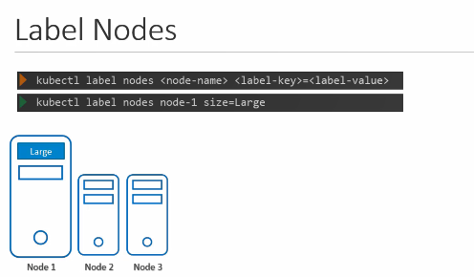

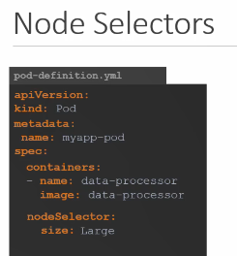

## Node Affinity

The primary purpose of node affinity feature is to ensure that pods are hosted on particular nodes.

In this case to ensure the large data processing pod ends up on no one in the previous lecture we did

this easily using notes selectors we discussed that you cannot provide advanced expressions like or

or not with node selectors the node affinity feature provides us with advanced capabilities to limit

pod placement on specific nodes with great power comes great complexity.

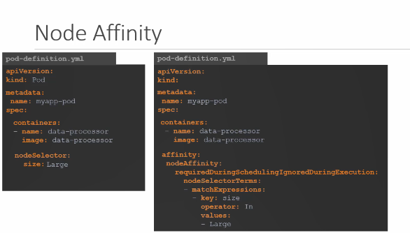

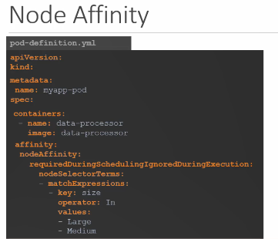

Operator : In, NotIn, Exists (only check that label exists)

So the simple node selector specification will now look like this with node affinity although both does

exactly the same thing plays the pod on the large node let us look at it a bit closer under spec you

have affinity and then node affinity under that and then you have a property that looks like a sentence

called required during scheduling ignored during execution no description needed for that and then you

have the node selector terms that is an array and that is where you will specify the key and value pairs

the key value pairs are in the form key operator and value where the operator is in the operator ensures

that the pod will be placed on a node whose label size has any value in the list of values specified

here in this case it is just one called large.

If you think your part could be placed on a large or a medium node you could simply add the value to

the list of values like this you could use the not in operator to say something like size not in small

where node affinity will match the node with a size not set to small.

We know that we have only set the labels size too large and medium nodes the smaller nodes don't even

have the labels set.

So we don't really have to even check the value of the label as long as we are sure we don't set a label

size to the smaller nodes using the exists operator will give us the same result.

The exists the operator will simply check if the label size exists on the notes and you don't need the

values section for that as it does not compare the values.

There are a number of other operators as well.

Check the documentation for specific details.

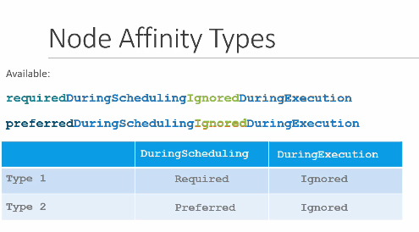

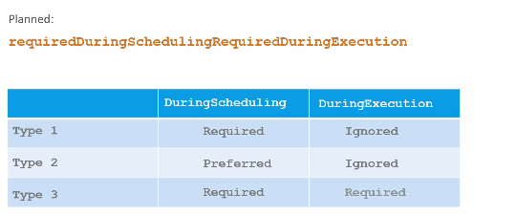

Now we understand all of this and we're comfortable with creating a pod with specific affinity rules

when the pods are created.

These rules are considered and the pods are placed onto the right nodes.

But what if node affinity could not match a node with a given expression.

In this case what if there are no nodes with a label called size say we had the labels and the pods

are scheduled.

What if someone changes the label on the node at a future point in time.

Will the pod continue to stay on the Node.

All of this is answered by the long sentence like property under node affinity which happens to be the

type of node affinity the type of node affinity defines the behaviour of the scheduler with respect to

node affinity and the stages in the lifecycle of the pod.

There are currently two types of node affinity available required during scheduling ignored during execution

and preferred during scheduling ignored during execution and there are additional types of node affinity

planed.

As of this recording required during scheduling required during execution we will now break this down

to understand further.

We will start by looking at the two available affinity types.

There are two states in the lifecycle of a pod when considering node affinity during scheduling and

during execution during scheduling.

Is the state where a pod does not exist and is created for the first time.

We have no doubt that when a pod is first created the affinity rules specified are considered to place

the pods on the right note.

Now what if the nodes with matching labels are not available.

For example we forgot to label the node as large.

That is where the type of node affinity used comes into play.

If you select the required type which is the first one the scheduler will mandate that the pod be placed

on a node with a given affinity.

Rules if it cannot find one the pod will not be scheduled.

This type will be used in cases where the placement of the pod is crucial.

If a matching node does not exist the pod will not be scheduled.

But let's say the pod placement is less important than running the workload itself.

In that case you could set it to preferred and in cases where a matching node is not found.

The scheduler will simply ignore node affinity rules and place the card on any available note.

This is a way of telling the scheduler hey try your best to place the pod on matching node but if you

really cannot find one just plays it anywhere.

The second part of the property or the other state is during execution during execution is the state

where a part has been running and a change is made in the environment that affects node affinity such

as a change in the label of a node.

For example say an administrator removed the label we said earlier called size equals large from the

node.

Now what would happen to the pods that are running on the Node.

As you can see the two types of node affinity available today has this value set too ignored which means

pods will continue to run and any changes in node affinity will not impact them once they are scheduled.

The new types expected in the future only have a difference in the during execution phase a new option

called required during execution is introduced which will evict any pods that are running on notes

that do not meet affinity rules.

In the earlier example, a pod running on the large node will be evicted or terminated if the label large

is removed from the node.

Well that's it for this lecture.

Head over to the coding exercises and practice working with node affinity rules in the next lecture.

We will compare tables and toleration and node affinity.

Exp:  
apiVersion: extensions/v1beta1

kind: Deployment

metadata:

name: red

spec:

replicas: 3

selector:

matchLabels:

run: nginx

template:

metadata:

labels:

run: nginx

spec:

containers:

- image: nginx

imagePullPolicy: Always

name: nginx

affinity:

nodeAffinity:

requiredDuringSchedulingIgnoredDuringExecution:

nodeSelectorTerms:

- matchExpressions:

- key: node-role.kubernetes.io/master

operator: Exists

master $ cat /var/answers/blue-deployment.yaml

apiVersion: extensions/v1beta1

kind: Deployment

metadata:

name: blue

spec:

replicas: 6

selector:

matchLabels:

run: nginx

template:

metadata:

labels:

run: nginx

spec:

containers:

- image: nginx

imagePullPolicy: Always

name: nginx

affinity:

nodeAffinity:

requiredDuringSchedulingIgnoredDuringExecution:

nodeSelectorTerms:

- matchExpressions:

- key: color

operator: In

values:

- blue

## Resousece limits

Let us look at a 3 Node Kubernetes cluster. Each node has a set of CPU, Memory and Disk

resources available.

Every POD consumes a set of resources.

In this case 2 CPUs , one Memory and some disk space. Whenever a POD is placed on a Node, it consumes resources

available to that node. As we have discussed before, it is the kubernetes scheduler that decides which Node a POD goes to.

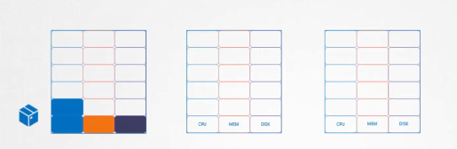

The scheduler takes into consideration, the amount of resources required by a POD

and those available on the Nodes. In this case, the scheduler schedules a new POD on Node 2. If the node has no sufficient resources, the scheduler avoids placing the POD on that node Instead places the POD on one where sufficient resources are available if there is no sufficient resources available on any of the nodes, Kubernetes holds back ( a retine) scheduling the POD, and you will see the POD in a pending state.

If you look at the events, you will see the reason – insufficient cpu.

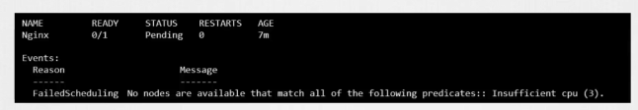

Let us now focus on the resource requirements for each POD. What are these blocks and what are their values?

By default, kubernetes assumes that a POD or a container within a POD requires 0.5 CPU & 256 Mebibyte of memory.

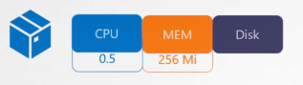

This is known as the resource request for a container the minimum amount of CPU or memory requested by the container when the scheduler tries to place the pod on a node.

It uses these numbers to identify a node which has sufficient amount of resources available.

Now if you know that your application will need more than these you can modify these values by specifying them in your pod or deployment definition files in the simple pod definition file. add a section called resources, under which add requests and specify the new values for memory and cpu usage.

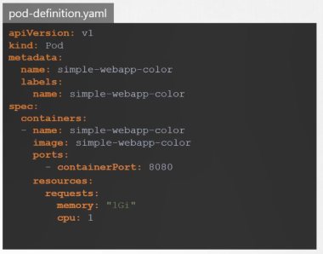

In this case I set it to 1GB of memory and 1 count of vCPU.

So what does 1 count of CPU really mean?

Remember these blocks are used for illustration purposes only.

It doesn't have to be in the increment of point five.

You can specify any value as low as 0.1cpu=100m

CPU can also be expressed as 100m were m stands for milli.

You can go as low as 1m, but not lower than that. 1 count of CPU is equivalent to 1 vCPU.

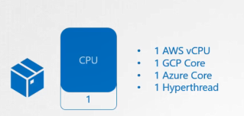

That’s 1 vCPU in AWS, or 1 Core in GCP or Azure or 1 Hyperthread. You could request a higher number of CPUs for the container, provided your Nodes are sufficiently funded. Similarly, with memory you could specify 256 Mebibyte using the Mi suffix. Or specify the same value in Memory like this. Or use the suffix G for a gigabyte.

Note the difference between G and Gi. G is Gigabyte and it refers to a 1000 Megabytes, whereas Gi

Gi refers to Gibibyte and refers to 1024 Mebibyte.

The same applies to megabyte and kilobytes.

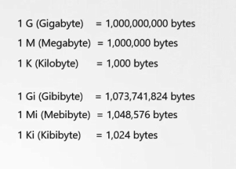

Let's now look at a container running on a node in the docker world a docker container has no limit to the resources it can consume on a Node. Say a container starts with 1 vCPU on a Node, it can go up and consume as much resource as it requires, suffocating the native processes on the node or other containers of resources.

However you can set a limit for the resource usage on these pods by default.

Kubernetes sets a limit of 1vCPU to containers. So if you do not specify explicitly, a container will be limited

to consume only 1 vCPU from the Node.

The same goes with memory. By default, kubernetes sets a limit of 512 Mebibyte on containers.

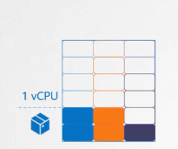

if you don't like the default limit you can change them by adding a limit section under the resources section in your pod definition file. Specify new limits for memory and cpu you like this when the pod is created, kubernetes sets new limits for the container.

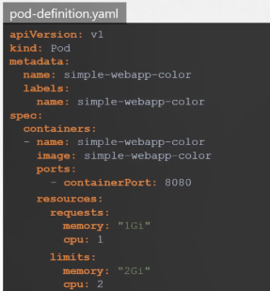

Remember that the limits and requests are set for each container within the pod.

So what happens when a pod tries to exceed resources beyond its specified limit.

In case of the CPU, kubernetes throttles the CPU so that it does not go beyond the specified limit.

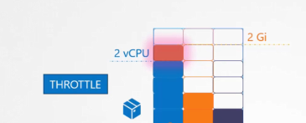

A container cannot use more CPU resources than its limit.

However, this is not the case with memory. A container CAN use more memory resources that its limit.

So if a pod tries to consume more memory than its limit constantly, the POD will be terminated.

## Daemon set

So far we have deployed various pods on different nodes in our cluster. With the help of replica sets and deployments we made sure multiple copies of our applications

applications are made available across various different worker nodes.

Daemon set are like replica sets, as in it helps

you deploy multiple instances of pod. But it runs one copy of your pod on each node in your cluster.

Whenever a new node is added to the cluster a replica of the pod is automatically added to that node and when a node is removed the pod is automatically removed.

The demon set ensures that one copy of the pod is always present in all nodes in the cluster.

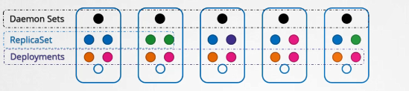

So what are some use cases of daemonsets?

Say you would like to deploy a monitoring agent or log collector on each of your nodes in the cluster

so you can monitor your cluster better.

Demon set is perfect for that as it can deploy your monitoring agent in the form of a pod

in all the nodes in your cluster. Then, you don’t have to worry about adding/removing monitoring agents

from these nodes when there are changes in your cluster.

as the daemon set will take care of that for you.

While discussing the kubernetes architecture we learned that one of the worker node components that

is required on every node in the cluster is a kube-proxy.

That is one good use case of daemon Sets. The kubeproxy component can be deployed as a daemon set in the cluster.

Another use case is for networking. Networking solutions like weave net requires an agent to be deployed on each node in the cluster.

We will discuss about networking concepts in much more detail later during this course but I just wanted to point it out here for now.

Creating a DaemonSet is similar to the ReplicaSet creation process.

It has nested pod specification under the template section and selectors to link the daemon set to the PODs. A daemonSet definition file has a similar structure.

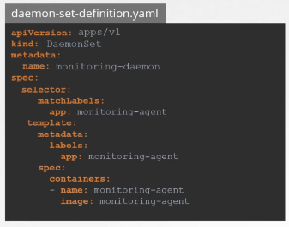

We start with apiVersion, kind,

metadata and spec. The api version is apps/v1. Kind is DaemonSet instead of ReplicaSet.

We will set the name to monitoring daemon. Under spec you have a selector and a pod specification

template.

It's almost exactly like ReplicaSet definition except that the kind is a demon set. Ensure the labels

in the selector matches the ones in the pod template. Once ready create the daemonset using the kubectl create daemonset command. To view the created daemonset run the kubectl get daemonset command.

And of course to view more details run the kubectl describe demonSet command.

So how does a demon set work.

How does it schedule pods on each node? and How does it ensure that every node has a pod? if you were asked to schedule a pod on each node in the cluster.

how would you do it? In one of the previous lectures in this section.

we discussed that we could set the nodeName property on the pod to bypass the scheduler and get the pod placed on a node directly. So that’s one approach. On each pod, set the nodeName property in its specification before it is created and when they are created, they automatically land on the respective nodes.

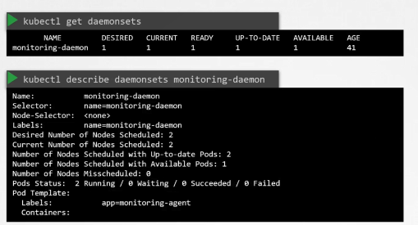

So that’s how it used to be until kubernetes version v1.12. From v1.12 onwards

the Daemon set uses the default scheduler and node affinity rules that we learned in one of the previous lectures to schedule pods on nodes.

## Static Pods

Earlier,in this course we talked about the Architecture and how the kubelet functions as one of the many control plane components in Kubernetes.

The kubelet relies on the kube-apiserver for instructions on what PODs to load on its node,

which was based on a decision made by the kube-scheduler which was stored in the ETCD datastore.

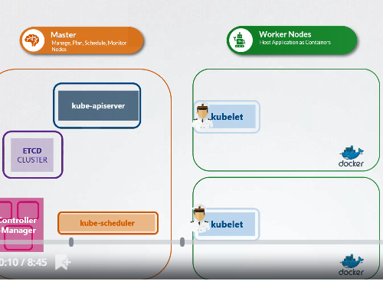

What if there was no kube-apiserver, and kube-scheduler and no controllers and no ETCD cluster.

What if there was no master at all. What if there were no other nodes.

What if you're all alone in the sea by yourself.

Not part of any cluster.

Is there anything that the kubelet can do as the captain on the ship?

Can it operate as an independent node?

If so who would provide the instructions required to create PODs?

Well, the kubelet can manage a node independently. On this ship…err..host,

we have the kubelet installed. And of course we have Docker as well to run containers.

There is no Kubernetes cluster. So there are no Kube API server or anything like that.

The one thing that the kubelet knows to do is create PODs. But we don’t have an API server here to provide

POD details.

By now we know that to create a POD you need the details of the POD in a POD definition file. But how

do you provide a pod definition file to the kubelet without a kube-api server?

You can configure the kubelet to read the pod definition files from a directory on the server designated to store information about pods.

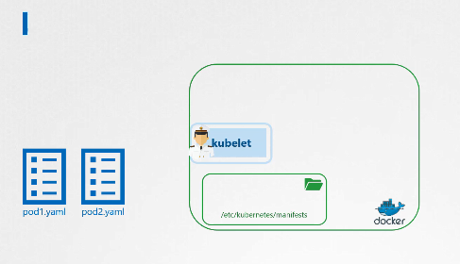

/etc/kubernetes/manifest

The pods definition files in this directory the Kubelet periodically checks this directory for files reads these files and creates pods on the host.

Not only does it create the pod it can ensure that the pod stays alive.

If the application crashes, the kubelet attempts to restart it.

If you make a change to any of the file within this directory, the kubelet recreates the pod for those changes to take effect.

If you remove a file from this directory the pod is deleted automatically.

So these PODs that are created by the kubelet on its own without the intervention from the API server or rest of the kuberentes cluster components are known as Static PODs. Remember you can only create PODs this way.

You cannot create replicasets or deployments or services by placing a definition file in the designated directory.

They are all concepts part of the whole Kubernetes architecture, that requires other control plane componentslike the replication and deployment controllers etc. The kubelet works at a POD level and can only understand PODs. Which is why it is able to create static pods

this way.

So what is that designated folder and how do you configure it.

It could be any directory on the host. And the location of that directory is passed in to the kubelet as a option while running the service.

The option is named pod manifest path

and here it is set to /etc/Kubernetes/manifests.

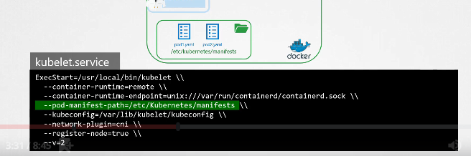

There is also another way to configure this. Instead of specifying the option directly in the kubelet.service file, you could provide a path to another config file using the config option, and define the directory path as staticPodPath in that file.

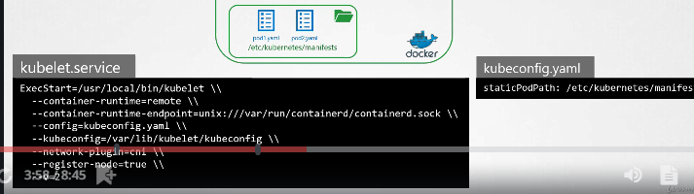

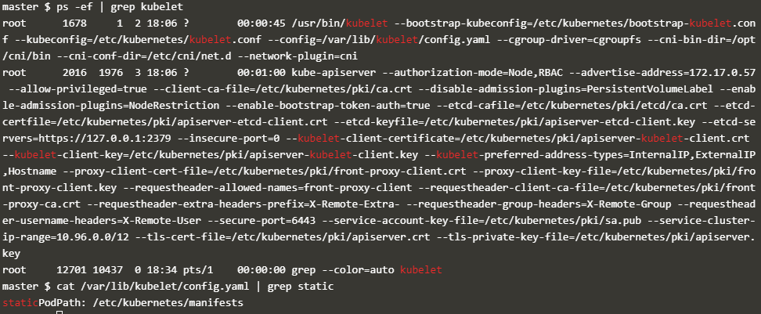

Clusters setup by the kubeadmin tool uses this approach. If you are inspecting an existing cluster, you should inspect this option of the kubelet to identify the path to the directory.

You will then know where to place the definition file for your static pods.

So keep this in mind when you go through the labs. You should know to view and configure this option irrespective of (indifferent de )the method used to set up the cluster first check the option pod manifest path in the

Kubelet service file if it's not there then look for the config option and identify the file used as

the config file and then within the config file look for these static pod path option.

Either of these should give you the right path once the static ports are created.

you can view them by running the Docker ps command. So why not the kubectl command as we have

been doing so far.

Remember we don’t have the rest of the Kubernetes cluster. Kubectl utility works with the

kube-apiserver.

Since we don’t have an API server now, no kubectl utility. which is why we're using the docker command.

So then how does it work when the node is part of a cluster.

When there is an API server requesting the Kubelet to create pods.

Can the kubelet create both kinds of PODs at the same time? Well, the way the kubelet works is it can take in requests for creating parts from different inputs.

The first is through the POD definition files from the static pods folder, as we just saw. The second, is through an HTTP API endpoint. And that is how the kube-apiserver provides

input to kubelet. The kubelet can create both kinds of PODs – the staticpods and the ones from the api server - at the same time.

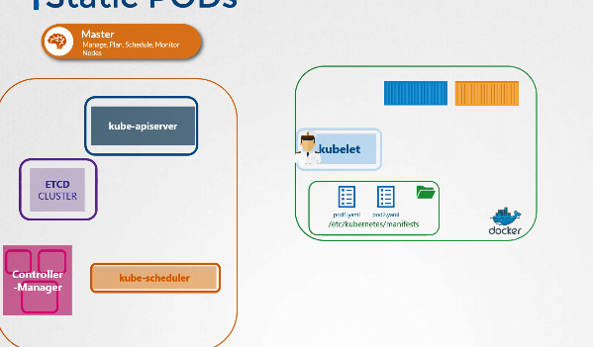

Well, in that case is the API server aware of the static pods created by the kubelet?

Yes it is.

If you run the kubectl get pods command on the master node, the static pods will be listed as any other pod.

Well how is that happening? When the kubelet creates a static pod,

if it is part of a cluster, it also creates a mirror object in the kubeapi server.

What you see from the kube-apiserver is just a read only mirror of the pod. You can view details about the pod but you cannot edit or delete it like the usual parts.

You can only delete them by modifying the files from the nodes manifest folder.

Note that the name of the part is automatically appended with the node name.

In this case node01. So then why would you want to use Static PODs?

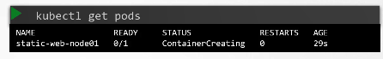

Since static pods are not dependent on the Kubernetes control plane, you can use static pods to deploy the control plane components itself as pods on a node. Start by installing kubelet on all the master nodes.

Then create pod definition files that uses Docker images of the various control plane components such as the api server, controller, etcd etc.

Place the definition files in the designated manifests folder. And kubelet takes care of deploying the control plane components themselves as PODs on the cluster.

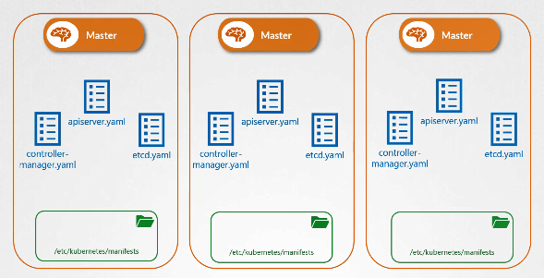

This way you don't have to download the binaries configure services or worry about so the service is crashing.

If any of these services were to crash since it's a static pod it will automatically be restarted by the kubelet. Neat and simple.

That’s how the kubeadmin tool set’s up a Kubernetes cluster.

Which is why when you list the pods in the kube-system namespace, you see the control plane components as PODs in a cluster setup by the kubeadmin tool.

We will explore that setup in the upcoming practice test. Before I let you go,

one question that I get often is about the different between Static PODs and DaemonSets.

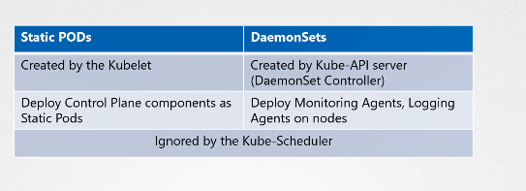

DaemonSets as we saw earlier are used to ensure one instance of an application is available on all nodes in the cluster. It is handled by a daemonset controller through the kube-api server. Whereas static pods, as we saw in this lecture, are created directly by the kubelet without any interference from the

kube-api server or rest of the Kubernetes control plane components. Static pods can be used to deploy

the Kubernetes control plane components itself. Both static pods and pods created by daemonsets are ignored by the kube-scheduler. The kube-scheduler has no affect on these pods.

## Multiple Schedulers

We have seen how the default-scheduler works in a kubernetes environment in the previous lectures.

It has an algorithm that distributes pods across nodes evenly as well as takes into consideration the various conditions we specify through taints & tolerations and node affinity etc. But what if none of these satisfies your needs?

Say you have a specific application that requires its components to be placed on nodes after performing some additional checks. So you decide to have your own scheduling algorithm to place pods on nodes? So that you can add your own custom conditions and checks in it. Kubernetes is highly extensible.

You can write your own kubernetes scheduler program, package it and deploy it as the default scheduler or as an additional scheduler in the kubernetes cluster.

That way all of the other applications can go through the default scheduler,

however one specific application can use your custom scheduler. Your kubernetes cluster can have multiple schedulers at the same time.

When creating a POD or a Deployment you can instruct kubernetes to have the POD

scheduled by a specific scheduler.

Earlier we saw how to deploy the kube-scheduler.

We download the kube-scheduler binary and run it as a service with a set of options.

One of the option is scheduler name. If not specified

It assumes in name of default scheduler.

This kube-scheduler is the default scheduler. To deploy an additional scheduler,

You can use the same kube-scheduler binary or use one that you might have built for yourself, which makes more sense.

In this case we are going to use the same binary to deploy the additional scheduler.

This time we set the scheduler name to a custom name.

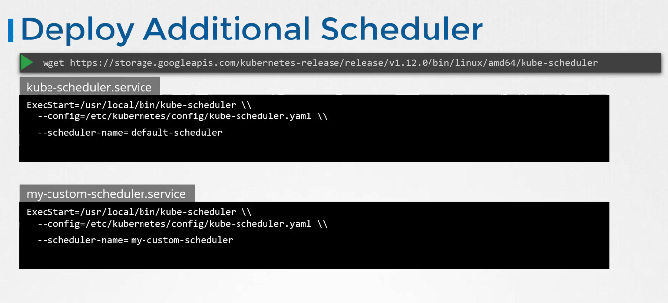

This is important to differentiate the two schedulers and this is the name that we will be specifying in the pod definition file later on.

Let’s take a look at how it works with the kubeadm tool. The kubeadm tool deploys the scheduler as a POD.

You can find the definition file it uses under the manifests folder. I have removed all the other details from the file so we can focus on the key parts.

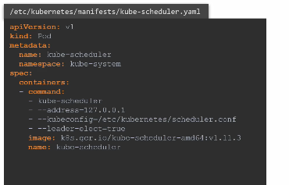

The command section has the command and associated options to start the scheduler.

We can create a custom scheduler by making a copy of the same file, and by changing the name of the scheduler.

We set the name of the pod to my-custom-scheduler and we add a new option to the scheduler command to set a custom name for the scheduler.

Finally an important option to look here is the leader-elect option. The leader-elect

option is used when you have multiple copies of the scheduler running on different master nodes, in a High Availability setup where you have multiple master nodes with the kube-scheduler process running on both of them.

If multiple copies of the same scheduler are running on different nodes only one can be active at a time.

That’s where the leader-elect option helps in choosing a leader who will lead scheduling activities. We will discuss more about HA setup in another section, but for now I wanted

to point out that, to get multiple schedulers working you must either set the leader-elect option to false, in case where you don’t have multiple masters.

In case you do have multiple masters, you can pass in an additional parameter to set a lock object name.

This is to differentiate the new custom scheduler from the default during the leader election process.

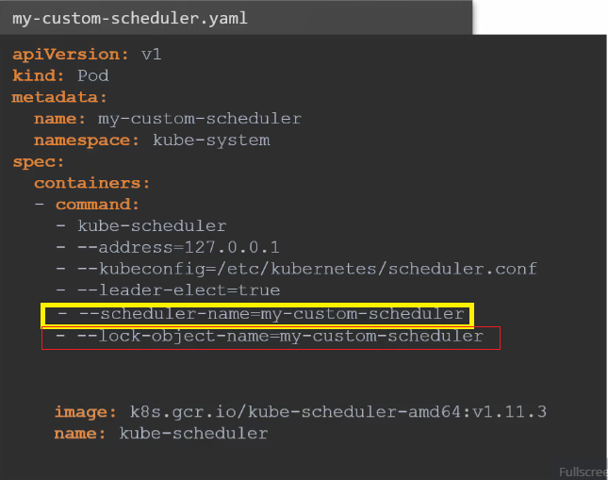

Once done, create the pod using the kubectl create command. Run the get pods command in the kube-system namespace and look for the new custom scheduler.

Make sure its in a running state. The next step is to configure a new POD or a deployment to use the new scheduler.

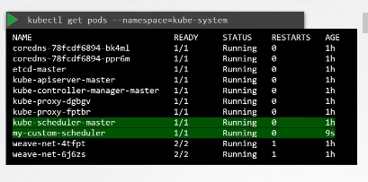

In the Pod specification file.

add a new field called schedulerName and specify the name of the new scheduler.

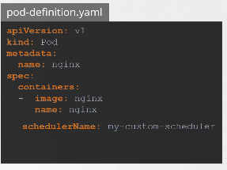

This way when the pod is created, the right scheduler picks it up to schedule. Create the pod using the kubectl create command. If the scheduler was not configured correctly, then the pod will continue to remain in a Pending state. If everything is good, then the pod will be in a Running state.

So how do you know which scheduler picked it up? View the events using the kubectl get events command.

This lists all the events in the current namespace.

Look for the Scheduled events. As you can see the source of the event is the custom scheduler we created.

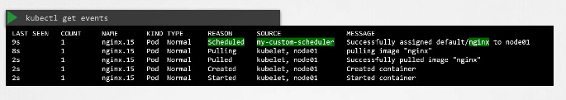

And the message says successfully assigned default/nginx image. To view the logs of the scheduler, view the logs of the pod using the kubectl logs command. Specify the name of the scheduler the correct namespace.

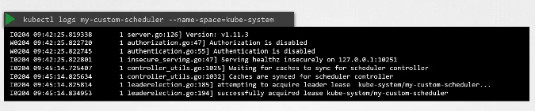

* --leader-elect=false
* --port=10282
* --scheduler-name=my-scheduler

## Logging monitoring

Hello and welcome to this lecture. In this lecture

we talk about Monitoring a Kubernetes cluster.

So how do you monitor resource consumption on Kubernetes? Or more importantly what would you like to monitor?

I’d like to know Node level metrics such as the number of nodes in the cluster,

how many of them are healthy as well as performance metrics such as CPU. Memory, network and disk utilization.

As well as POD level metrics such as the number of PODs, and performance metrics of each POD such

as the CPU and Memory consumption on them.

So we need a solution that will monitor these metrics store them and provide analytics around this data

As of this recording, Kubernetes does not come with a full featured built-in monitoring solution.

However, there are a number of open-source solutions available today, such as the Metrics-Server, Prometheus,

Elastic Stack, and proprietary solutions like Datadog and Dynatrace.

Heapster was one of the original projects that enabled monitoring and analysis features for kubernetes

You will see a lot of reference online when you look for reference architectures on monitoring Kubernetes.

However, Heapster is now Deprecated and a slimmed down version was formed known as the Metrics Server.

You can have one metrics server per kubernetes cluster the metric server retrieves metrics from each

of the kubernetes nodes and pods, aggregates them and stores them in memory.

Note that the metric server is only an in memory monitoring solution and does not store the metrics

on the desk and as a result you cannot see historical performance data.

For that you must rely on one of the advanced monitoring solutions we talked about earlier in this lecture.

So how are the metrics generated for the PODs on these nodes? Kubernetes

runs an agent on each node known as the kubelet, which is responsible for receiving instructions

from the kubernetes API master server and running PODs on the nodes.

The kubelet also contains a subcomponent known as as cAdvisor or Container Advisor. cAdvisor is

responsible for retrieving performance metrics from pods, and exposing them through the kubelet API

to make the metrics available for the Metrics Server. If you are using minikube for your local cluster,

run the command minikube addons enable metrics-server. For all other environments deploy the metrics server by cloning the metrics-server deployment files from the github repository. And then deploying the required components using the kubectl create command. This command deploys a set of pods, services and roles to enable metrics server to poll for performance metrics from the nodes in the cluster.

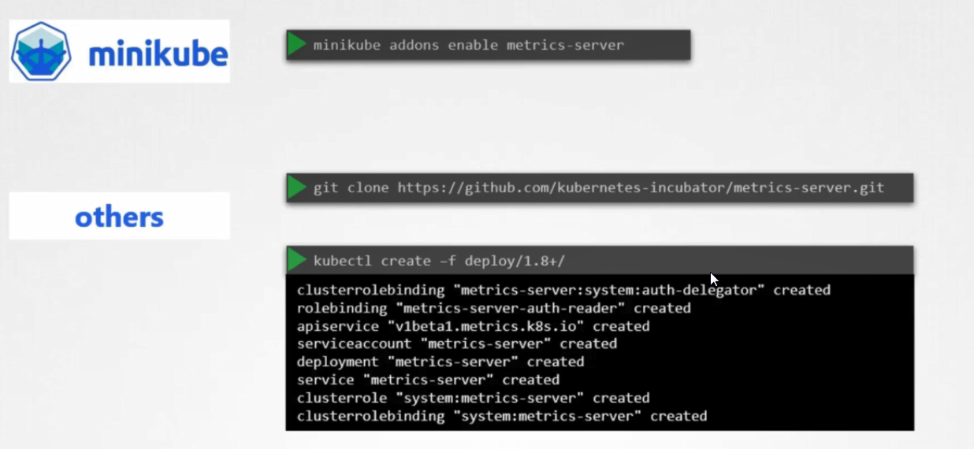

Once deployed, give the metrics-server some time to collect and process data. Once processed, cluster performance

can be viewed by running the command kubectl top node.

This provides the CPU and Memory consumption of each of the nodes. As you can see 8% of the CPU on my master node is consumed, which is about 166 milli cores.

## Checking logs

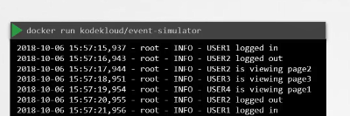

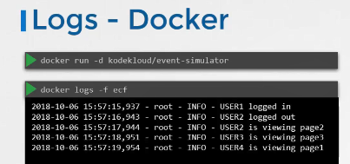

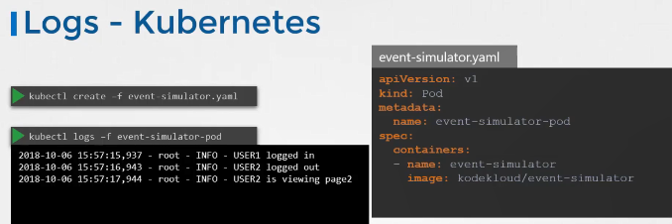

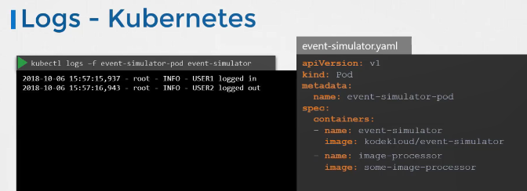

## Rollout & versioning

Let's trying to understand rollouts and versioning in a deployment when you first create a deployment it triggers a rollout a new rollout creates a new deployment revision let's call it revision 1 in the future when the application is upgraded meaning when the container version is updated to a new one a new rollout is triggered and a new deployment revision is created named revision 2.

This helps us keep track of the changes made to our deployment and enables us to roll back to a previous version of deployment if necessary.

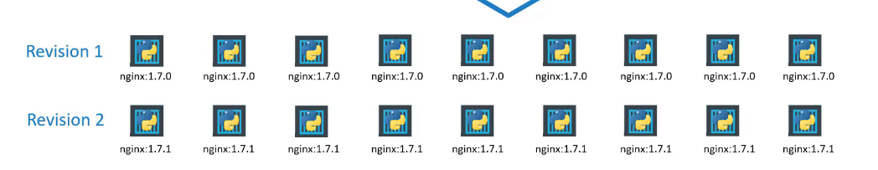

You can see the status of your rollout by running the command: kubectl rollout status followed by the name of the deployment to see the revisions and history of rollout. 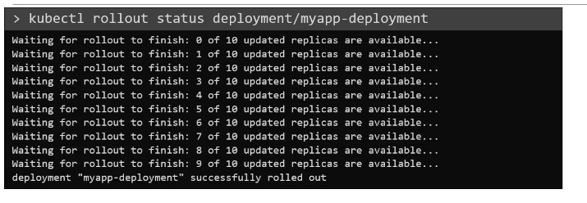

run the command kubectl rollout history followed by the deployment name

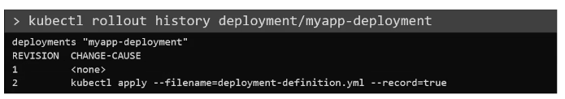

And this will show you the revisions and history of our deployment there are two types of deployment strategies.

Say for example you have five replicas of your web application instance deployed.

One way to upgrade these to a newer version is to destroy all of these and then create newer versions of application instances meaning first destroy the five running instances and then deploy five new instances of the new application version.

The problem with this as you can imagine is that during the period after the older versions are down and before any newer version is up the application is down and inaccessible to users this strategy is known as the Recreate strategy,

And thankfully this is not the default deployment strategy.

The second strategy is where we did not destroy all of them at once.

Instead we take down the older version and bring up a newer version one by one.

This way the application never goes down and the upgrade is seamless.

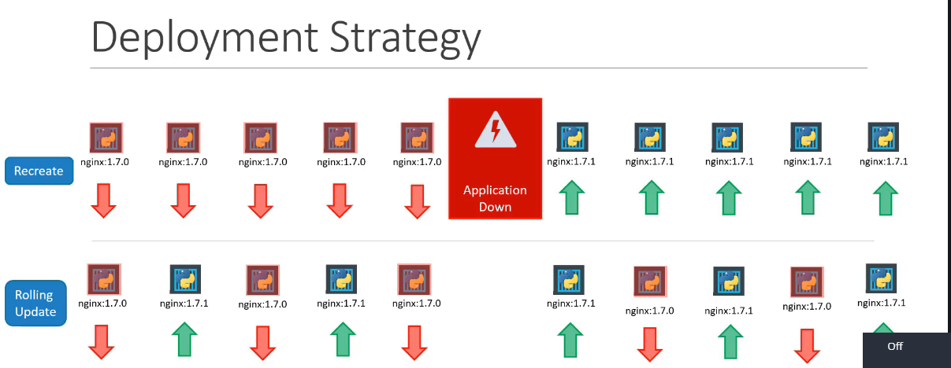

Remember if you do not specify a strategy while creating the deployment it will assume it to be rolling update. In other words rolling update is the default deployment strategy so we talked about upgrades.

How exactly do you update your deployment when you say update.

It could be different things such as updating your application version by updating the version of docker containers used, updating their labels or updating the number of replicas etc

Since we already have a deployment definition file it is easy for us to modify this file once we make the necessary changes.

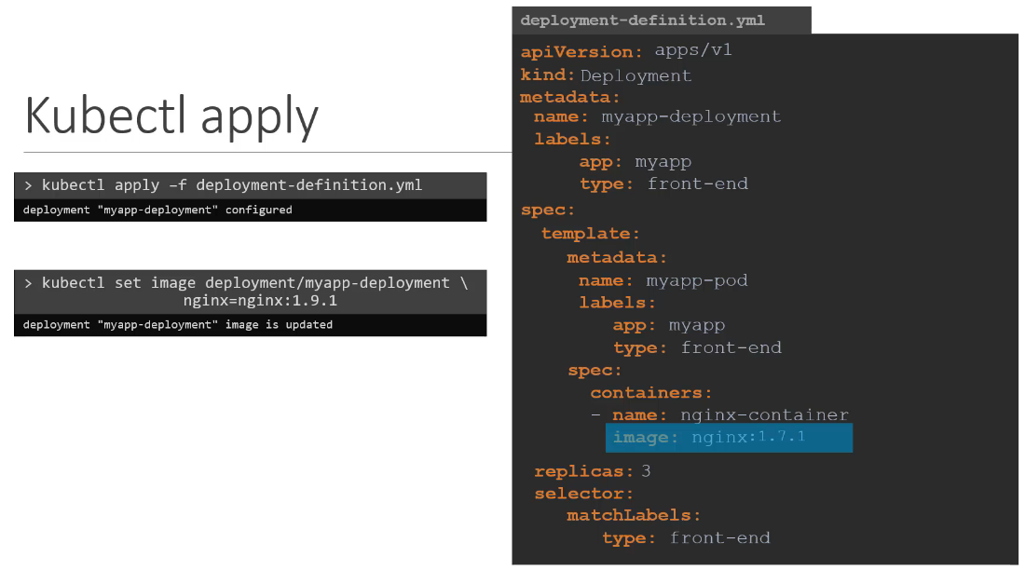

(eroare Nginx-container=nginx:1.9.1)

we run the kubectl apply command to apply the changes. A new rollout is triggered and a new revision after deployment is created.

But there is another way to do the same thing.

You could use the kubectl set image command to update the image of your application.

But remember doing it this way will result in the deployment definition file having a different configuration so you must be careful when using the same definition file to make changes in the future the difference

between the recreate and rolling update strategies can also be seen when you view the deployments in detail.

Run the kubectl describe deployment command to see detailed information regarding the deployments.

You will notice when the recreate strategy was used.

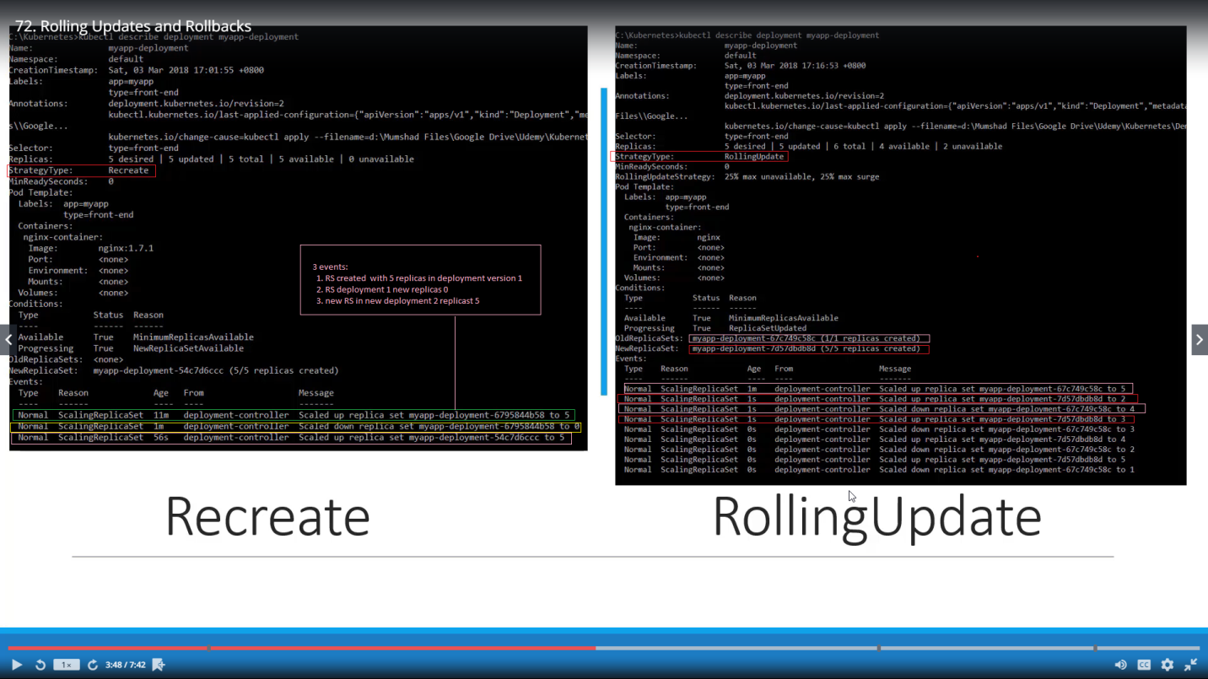

Recreate: The events indicate that the old replica set was scaled down to zero first and then the new replica sets scaled up to five.

However when the Rolling update strategy was used the old replicas set was scaled down one at a time simultaneously scaling up the new replica set one at a time.

Let's look at how a deployment performs an upgrade under the hood when a new deployment is created say to deploy five replicas.

it first creates a Replicaset automatically, which in turn creates the number of PODs required to meet the number of replicas.

When you upgrade your application as we saw in the previous slide, the kubernetes deployment object creates a new replica set under the hood and starts deploying the containers there at the same time

taking down the parts in the old replica set following a rolling update strategy.

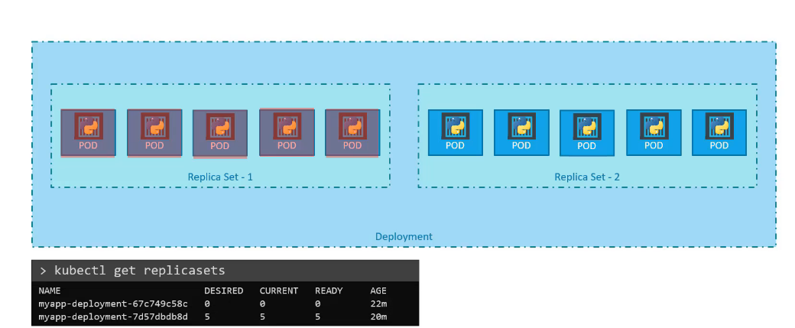

This can be seen when you try to list the replicasets using the kubectl get replicasets command.

Here we see the old replicaset with 0 PODs and the new replicaset with 5 PODs.

Say for instance once you upgrade your application you realize something is inferior right.

Something's wrong with the new version of build.

You used to upgrade so you would like to roll back your update kubernetes deployments allow you to roll back to a previous revision to undo a change.

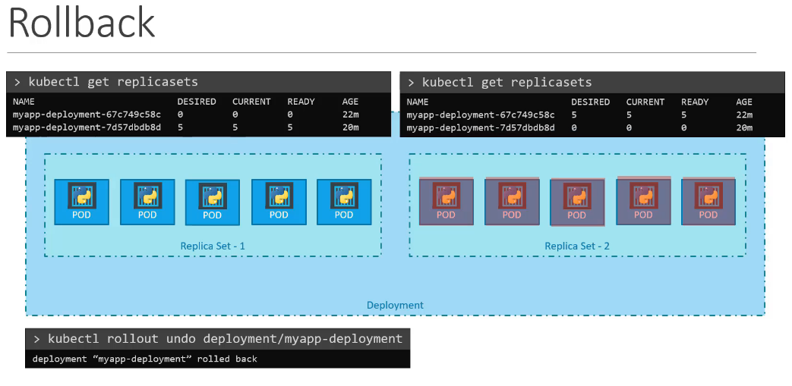

run the command kubectl rollout undo followed by the name of the deployment.

The deployment will then destroy the PODs in the new replicaset and bring the older ones up in the old replicaset. And your application is back to its older format.

When you compare the output of the kubectl get replicasets command, before and after the rollback,

You will be able to notice this difference before the rollback.

the first replicaset had 0 PODs and the new replicaset had 5 PODs

and this is reversed after the rollback is finished.

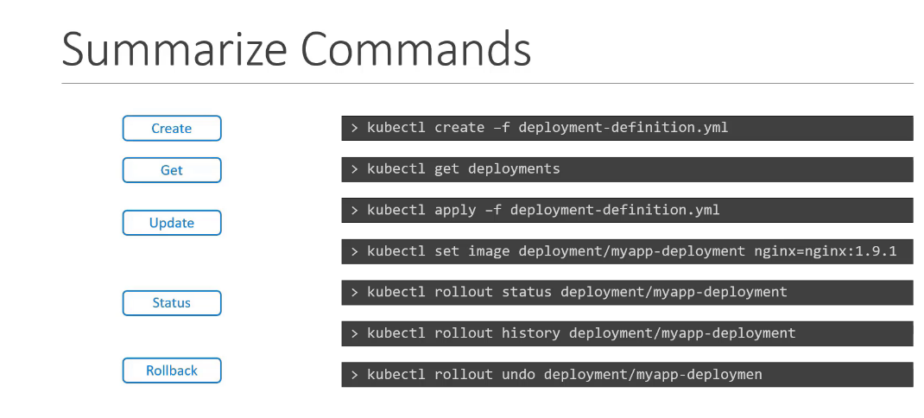

master $ kubectl describe deployments.apps frontend

Name: frontend

Namespace: default

CreationTimestamp: Tue, 29 Oct 2019 10:08:16 +0000

Labels: <none>

Annotations: deployment.kubernetes.io/revision=2

Selector: name=webapp

Replicas: 4 desired | 4 updated | 4 total | 4 available | 0 unavailable

StrategyType: RollingUpdate

MinReadySeconds: 20

RollingUpdateStrategy: 25% max unavailable, 25% max surge

Pod Template:

Labels: name=webapp

Containers:

simple-webapp:

Image: kodekloud/webapp-color:v2

Port: 8080/TCP

Host Port: 0/TCP

Environment: <none>

Mounts: <none>

Volumes: <none>

Conditions:

Type Status Reason

---- ------ ------

Available True MinimumReplicasAvailable

Progressing True NewReplicaSetAvailable

OldReplicaSets: <none>

NewReplicaSet: frontend-65998dcfd8 (4/4 replicas created)

Events:

Type Reason Age From Message

---- ------ ---- ---- -------

Normal ScalingReplicaSet 21m deployment-controller Scaled up replica set frontend-7965b86db7 to 4

Normal ScalingReplicaSet 1m deployment-controller Scaled up replica set frontend-65998dcfd8 to 1

Normal ScalingReplicaSet 1m deployment-controller Scaled down replica set frontend-7965b86db7 to 3

Normal ScalingReplicaSet 1m deployment-controller Scaled up replica set frontend-65998dcfd8 to 2

Normal ScalingReplicaSet 1m deployment-controller Scaled down replica set frontend-7965b86db7 to 1

Normal ScalingReplicaSet 1m deployment-controller Scaled up replica set frontend-65998dcfd8 to 4

Normal ScalingReplicaSet 41s deployment-controller Scaled down replica set frontend-7965b86db7 to 0

## Configure Applications

In this section we will talk about Command and Arguments in a Pod Definition file.

This is not listed as a required topic in the certification curriculum but I think it's important to

explain as it is a topic that is usually overlooked.

Let us first refresh our memory on commands in containers and docker.

We will then translate this into pods in the next lecture.

In this lecture we will look at commands arguments and entry points in Docker.

Let's start with a simple scenario.

Say you were to run a docker container from an Ubuntu image.

When you run the “docker run ubuntu” command, it runs an instance of Ubuntu image and exits immediately.

If you were to list the running containers you wouldn't see the container running.

If you list all containers including those that are stopped you will see that the new container you ran is in an exited state.

Now why is that unlike virtual machines.

Containers are not meant to host an operating system.

Containers are meant to run a specific task or process such as to host an instance of a web server or application server or a database or simply to carry out some kind of computation or analysis once the task is complete.

The container exits a container only lives as long as the process inside it is alive.

If the web service inside the container is stopped or crashes the container exits.

So who defines what process is run within the container.

If you look at the docker file for popular Docker images like NGINX you will see an instruction called CMD which stands for command that defines the program that will be run within the container when it starts. For the NGINX image

it is the nginx command, for the mysql image it is the mysqld command.

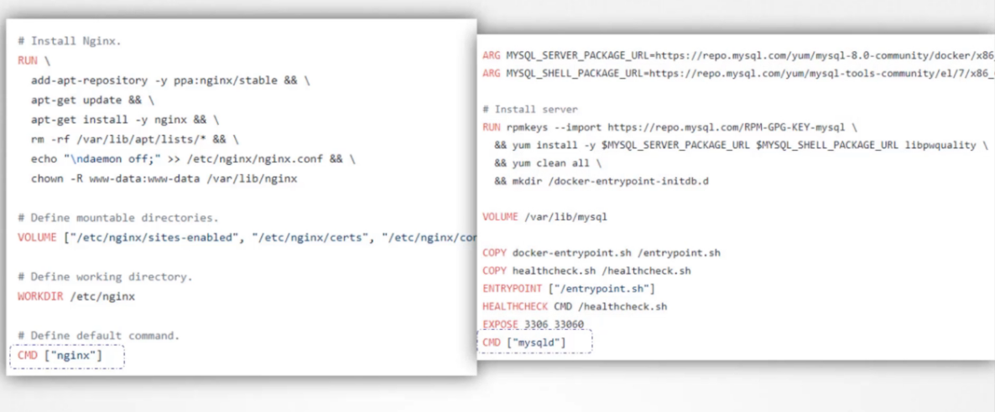

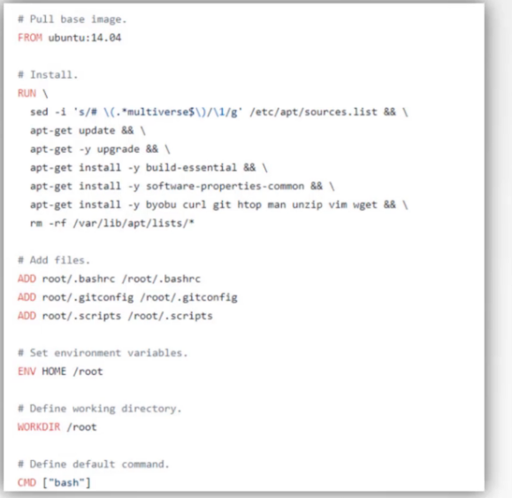

What we tried to do earlier was to run a container with a plain Ubuntu Operating System

Let us look at the docker file for this image you will see that it uses bash as the default command.

Now bash is not really a process like a web server or database server.

It is a shell that listens for inputs from a terminal if it cannot find a terminal it exits.

When we ran the Ubuntu container earlier Docker created a container from the Ubuntu image and launched the bash program by default Docker does not attach a terminal to a container when it is run.

And so the bash program does not find the terminal and so it exits since the process that was started when the container was created finished the container exits as well.

So how do you specify a different command to start the container.

One option is to append a command to the docker run command and that way it overrides the default command specified within the image.

In this case I run the docker run ubuntu command with the “sleep 5” command as the added option.

This way when the container starts it runs the sleep program, waits for 5 seconds and then exits.

But how do you make that change permanent.

Say you want the image to always run the sleep command when it starts.

You would then create your own image from the base Ubuntu image and specify a new command.

There are different ways of specifying the command either the command simply as is in a shell form or Or in a JSON array format like this.

But remember, when you specify in a JSON array format, the first element in the array should be the executable.

In this case the sleep program do not specify the command and parameters together like this the command and its parameters should be separate elements in the list.

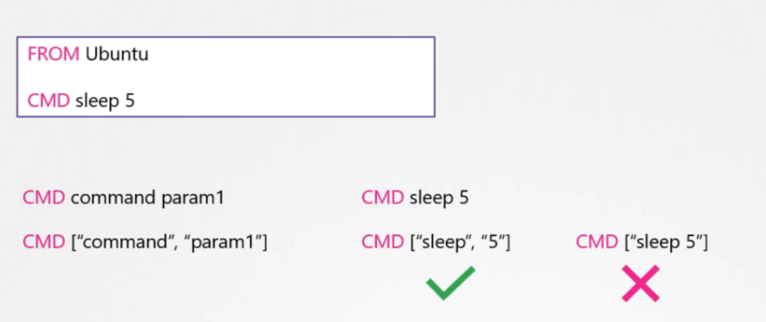

So I now build by new image using the docker build command, and name it as ubuntu-sleeper. 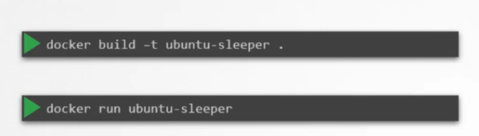

I could now simply run the docker Ubuntu sleeper command and get the same results.

It always sleeps for five seconds and exits.

But what if I wish to change the number of seconds it sleeps currently.

It is hard coded to five seconds as we learned before.

One option is to run the docker run command with the new command appended to it.

In this case sleep 10 and so the command that will be run at startup will be sleep 10 but it doesn't look very good.

The name of the image Ubuntu sleeper in itself implies that the container will sleep.

So we shouldn't have to specify the sleep command again.

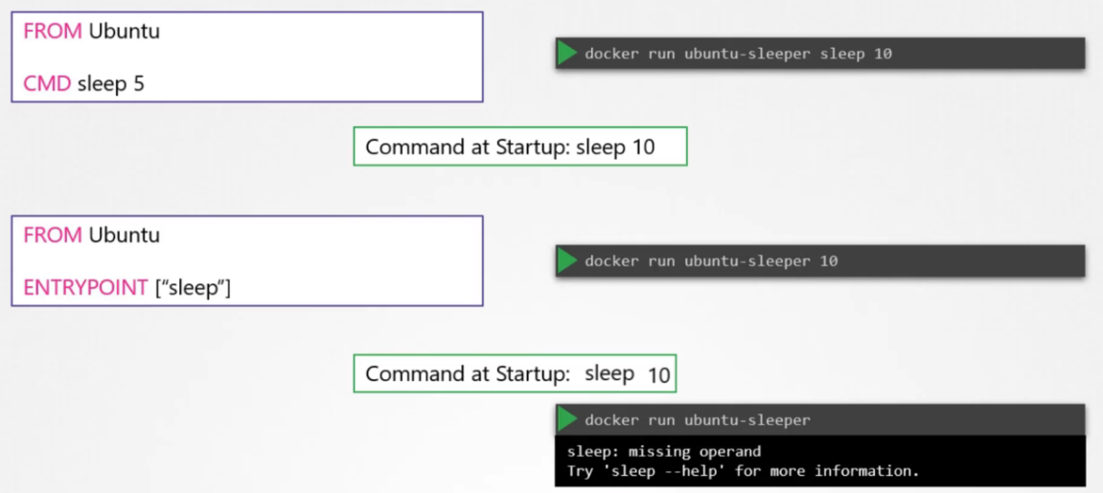

Instead we would like it to be something like this Docker run Ubuntu sleeper 10 we only want to pass in the number of seconds the containers should sleep and sleep command should be invoked automatically and that is where the entry point instruction comes into play.

The entry point instruction is like the command instruction as in you can specify the program that will be run when the container starts and whatever you specify on the command line.

In this case 10 will get appended to the entry point so the command that will be run when the container starts is sleep 10.

So that's the difference between the two.

In case of the CMD instruction the command line parameters passed will get replaced entirely, whereas in case of entry point the command line parameters will get appended.

Now, in the second case what if I run the ubuntu-sleeper without appending the number of

seconds then the command at startup will be just sleep and you get the error that the operant is missing.

So how do you configure a default value for the command.

If one was not specified in the command line that's where you would use both entry point as well as

the command instruction.

In this case the command instruction will be appended to the entry point instruction so at startup the

command would be sleep 5.

If you didn't specify any parameters in the command line if you did then that will override the command instruction.

And remember for this to happen you should always specify the entry point and command instructions in a JSON format.

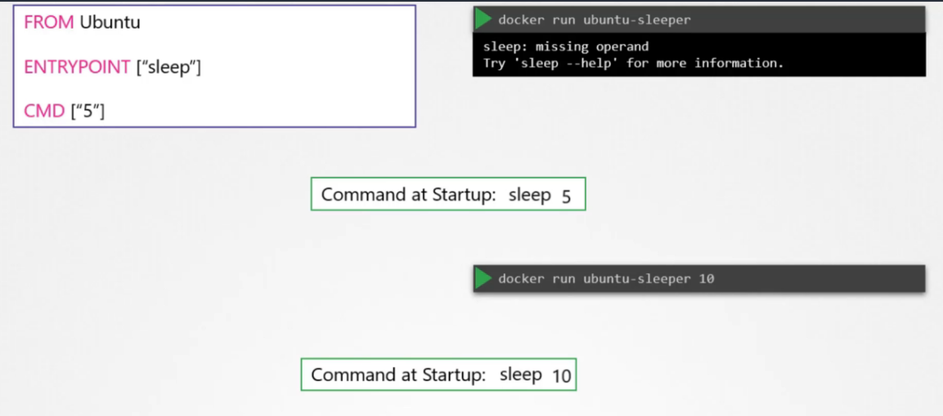Finally, What if you really really want to modify the entry point during runtime say from sleep to an imaginary sleep 2.0 command.

Well in that case you can override it by using the entry point option in the docker run command.

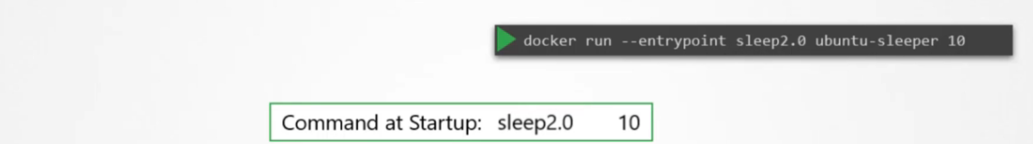

The final command at startup would then be sleep 2.0 10.

Well that's it for this lecture and I will see you in the next.

## Commands and arguments

Docker image that sleeps for a given number of seconds.

We named it ubuntu-sleeper and we ran it using the docker command docker run ubuntu-sleeper. By default It sleeps for five seconds but you can override it by passing a command line argument.

We will now create a pod using this image. We start with a blank pod definition template,

input the name of the pod and specify the image name.

When the pod is created, it creates a container from the specified image, and the container sleeps for five seconds before exiting.

Now if you need the container to sleep for 10 seconds as in the second command how do you specify the additional argument in the pod definition file.

Anything that is appended to the docker run command will go into the “args” property of the pod definition file in the form of an array like this.

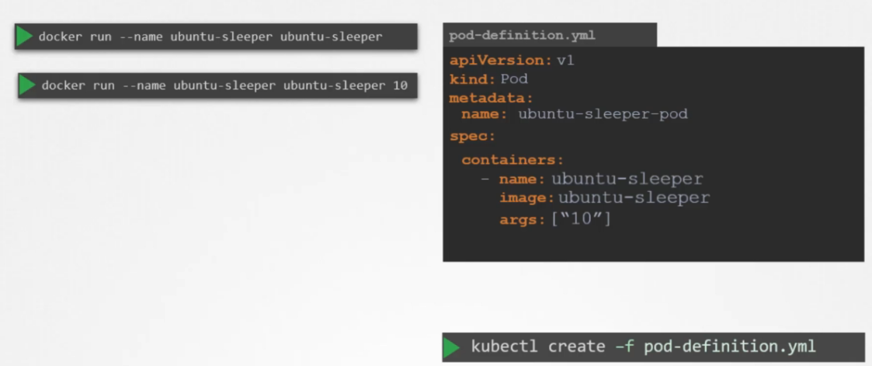

Let us try to relate that to the docker file we created earlier.

The Dockerfile has an Entrypoint as well as a CMD instruction specified. The entrypoint is the command that is run at startup, and the CMD is the default parameter passed to the command. With the args option in the pod definition file we override the CMD instruction in the Dockerfile.

But what if you need to override the entrypoint? Say from sleep to a hypothetical sleep2.0 command? In the docker world.

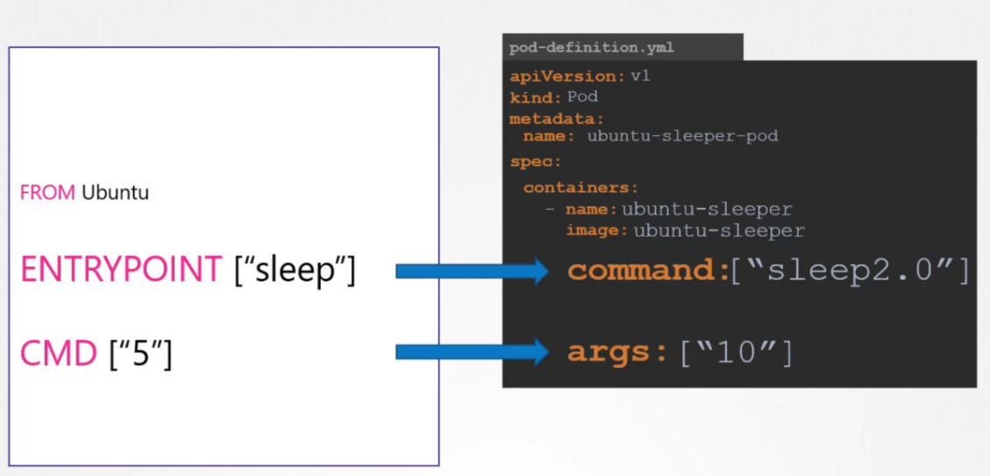

Exp1:

master $ cat /var/answers/answer-ubuntu-sleeper-2.yaml

apiVersion: v1

kind: Pod

metadata:

name: ubuntu-sleeper-2

spec:

containers:

- name: ubuntu

image: ubuntu

command:

- "sleep"

- "5000"

Exp 2:

Dockerfile2 webapp-color-pod-2.yaml

master $ cat webapp-color-pod-2.yaml

apiVersion: v1

kind: Pod

metadata:

name: webapp-green

labels:

name: webapp-green

spec:

containers:

- name: simple-webapp

image: kodekloud/webapp-color

command: ["python", "app.py"]

args: ["--color", "pink"]

We would run the docker run command with the entry point option set to the new command the corresponding

entry in the pod definition file would be using a command field the command field corresponds to entry

point instruction in the docker file so to summarize there are two fields that correspond to two instructions

in the docker file.

The command field overrides the entry point instruction and the args field overrides the command instruction

in the docker file.

Remember it is not the command field that overrides the CMD instruction in the docker file.

Well that's it about commands and arguments in Kubernetes head over to the coding exercises section

and practice viewing configuring and troubleshooting commands and arguments in kubernetes.

## Environment variables

We ran in the last lecture to set an environment variable, use the ENV property. ENV is an array. So every

item under the env property starts with a dash, indicating an item in the array.

Each item has a name and a value property.

The name is the name of the environment variable made available with the container and the value is its value.

What we just saw was a direct way of specifying the environment variables using a plain key value pair format.

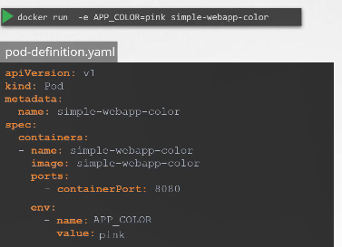

However there are other ways of setting the environment variables such as using config maps and secrets.

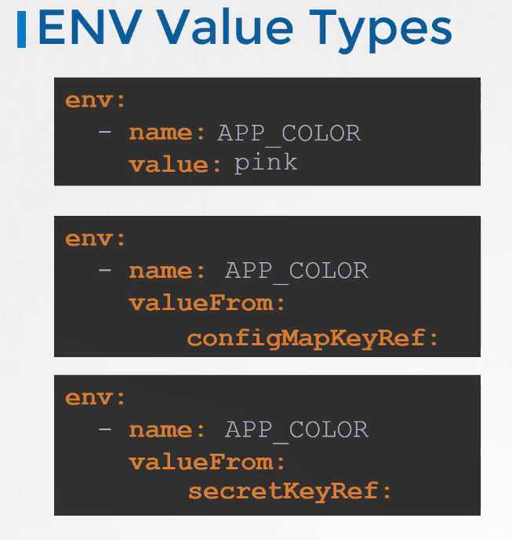

## ConfigMap

When you have a lot of pod definition files it will become difficult to manage the environment data stored within the query files.

We can take this information out of the pod definition file and manage it centrally using ConfigurationMaps.

ConfigMaps are used to pass configuration data in the form of key value pairs in Kubernetes. 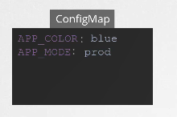

When it pod is created inject the config map into the pod.

So the key value pairs that are available as environment variables for the application hosted inside the container in the pod.

There are two phases involved in configuring ConfigMaps.

First create the ConfigMaps and second Inject them into the POD.

Just like any other Kubernetes object.

There are two ways of creating a configmap.

The imperative way - without using a ConfigMap definition file and the Declarative way by using a Config map definition file.

If you do not wish to create a configmap definition, you could simply use the kubectl create

configmap command and specify the required arguments.

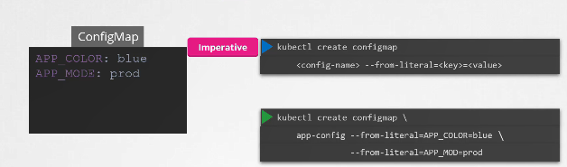

Let's take a look at that first with this method.

you can directly specify the key value pairs in the command line. To create a configMap of the given values, run the kubectl create configmap command.

The command is followed by the config name and the option –from-literal. The from literal option is used to specify the key value pairs in the command itself.

In this example, we are creating a configmap by the name app-config, with a key value pair APP_COLOR equals blue.

If you wish to add additional key value pairs simply specify the from literal options multiple times.

However this will get complicated when you have too many configuration items.

Another way to input configuration data is through a file.

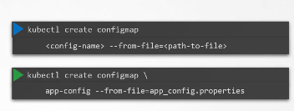

Use the from file option to specify a path to the file that contains the required data.

The data from this file is read and stored under the name of the file let us now look at the declarative approach.

For this we create a definition file just like how we did for the pod.

The file has apiVersion, kind, metadata and instead of spec, here we have “data”.

The apiVersion is v1, kind is ConfigMap. Under metadata specify the name of the config

map.

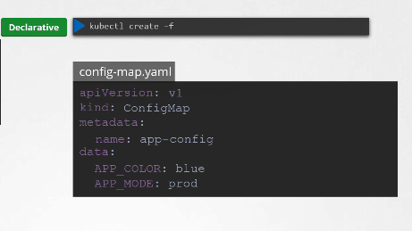

We will call it app-config. Under data add the configuration data in a key-value format. Run the kubectl create command and specify the configuration file name. So that creates the app-config config map with the values we specified.

You can create as many configmaps as you need in the same way for various different purposes.

Here I have one for my application, other for mysql and another one for redis.

So it is important to name the config maps appropriately as you will be using these names later while associating it with PODs. To view the configmaps, run the kubectl get configmaps command.

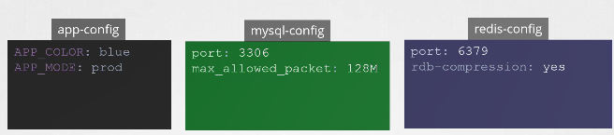

This lists the newly created configmap named app-config. The describe configmaps command List the configuration data as well under the data section.

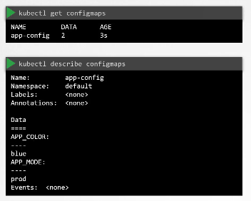

Now that we have the config map created let us proceed with step 2 configuring it with a pod here I have a simple pod definition file that runs my simple web application to inject an environment variable add a new property to the container called envFrom. The envFrom property is a list, so we can pass as many environment variables as required.

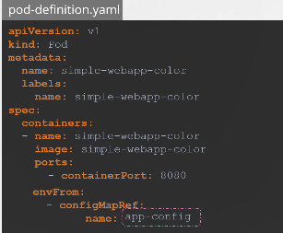

Each

item in the list corresponds to a configMap item. Specify the name of the configmap we created earlier.

This is how we inject a specific configmap from the ones we created before. Creating the pod definition

file now creates a web application with a blue background.

What we just saw was using configMaps to inject environment variables.

There are other ways to inject configuration data into pods you can inject it as a single environment variable or you can inject the whole the data as files in a volume.



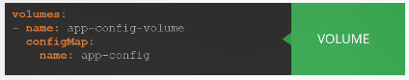

## Secrets

Hello and welcome to this lecture on secrets in Kubernetes. Here we have a simple python web application

that connects to a mysql database. On success the application displays a successful message.

If you look closely into the code you will see the hostname username and password hardcoded.

This is of course not a good idea.

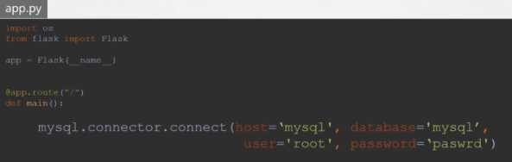

As we learned in the previous lecture, one option would be to move these values into a configMap. The configMap stores configuration data in plain text format.

So while it would be okay to move the hostname and username into a configMap it is definitely not the right place to store a password.

This is where secrets coming secrets are used to store sensitive information like passwords or keys.

They're similar to configMap except that they're stored in an encoded or hashed format as with configmaps.

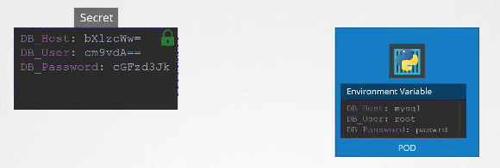

There are two steps involved in working with secrets.

First create the secret and second injected into pod.

There are two ways of creating a secret.

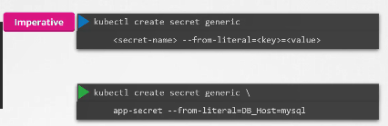

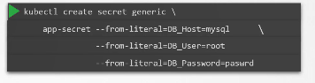

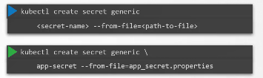

Exp:

The imperative way - without using a Secret definition file and the Declarative way by using a Secret

definition file with the imperative method.

You can directly specify the key value pairs in the command line itself to create a secret of the given values, run the kubectl create secret generic command.

The command is followed by the secret name and the option –from-literal. The from literal option is used to specify the key value pairs in the command itself.

In this example, we are creating a secret by the name app-secret, with a key value pair

DB_Host=mysql. If you wish to add additional key value pairs, simply specify the from literal

options multiple times however this could get complicated when you have too many secrets to pass in

another way to input the secret data is through a file.

Use the –from-file option to specify a path to the file that contains the required data.

The data from this file is read and stored under the name of the file let us now look at the declarative approach.

For this we create a definition file, just like how we did for the ConfigMap.

The file has apiVersion, kind, metadata and data. The apiVersion is v1, kind is Secret. Under metadata specify the name of the secret.

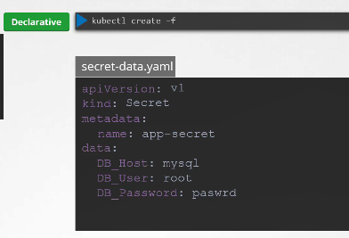

We will call it app-secret. Under data add the secret data in a key-value format.

However one thing we discussed about secrets was that there used to store sensitive data and are stored in an encoded format.

Here we have specified the data in plain text which is not very safe.

So while creating a secret with a declarative approach you must specify the secret values in a hashed

format.

So you must specify the data in an encoded form like this.

But how do you convert the data from plain text to an encoded format on a linux host from the command.

echo –n followed by the text you are trying to convert, which is mysql in this case and pipe

that to the base64 utility. To view secrets run the kubectl get secrets command. This lists

the newly created secret along with another secret previously created by kubernetes for its internal

purposes to view more information on the newly created secret.

run the kubectl describe secret command.

This shows the attributes in the secret but hides the value themselves to view the values as well.

run the kubectl get secret command with the output displayed in a YAML format using the

–o option.

You can now see the hashed values as well.

Now how do you decode these hashed values.

Use the same base64 Command used earlier to encode it but this time add a decode option to it.

Now that we have secret created let us proceed with step 2 configuring it with a pod.

Here I have a simple pod definition file that runs my application.

To inject an environment variable, add a new property to the container called envFrom. The envFrom

property is a list so we can pass as many environment variables as required each item in the list corresponds to a secret item.

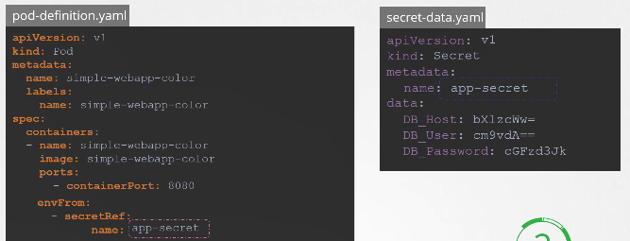

Specify the name of the secret we created earlier.

Creating the pod definition file now makes the data in the secret available as environment variables for the application.

What we just saw was injecting secrets as environment variables into the PODs.

There are other ways to inject secret into PODs.

You can inject as single environment variables or inject the whole secret as files in a volume if you were to mount the secret as a volume in the pod.

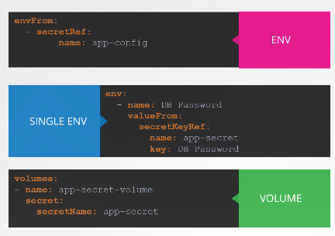

Each attribute in the secret is created as a file with the value of the secret as its content.

In this case since we have three attributes in our secret three files are created and if we look at the contents of the D.B. password file we see the password in it.

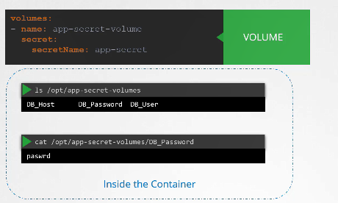

Exp:

master $ kubectl get secrets

NAME TYPE DATA AGE

default-token-fst9j kubernetes.io/service-account-token 3 4m

kubectl create secret generic db-secret --from-literal=DB_Host=sql01 --from-literal=DB_User=root --from-literal=DB_Password=password123

/opt/webapp-mysql # env | grep DB

DB_Host=sql01

DB_User=root

DB_Password=password123

kubectl exec webapp-pod -it sh

exp1

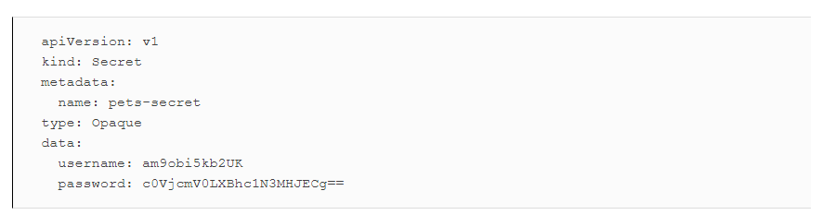

kubectl create -f pets-secret.yaml

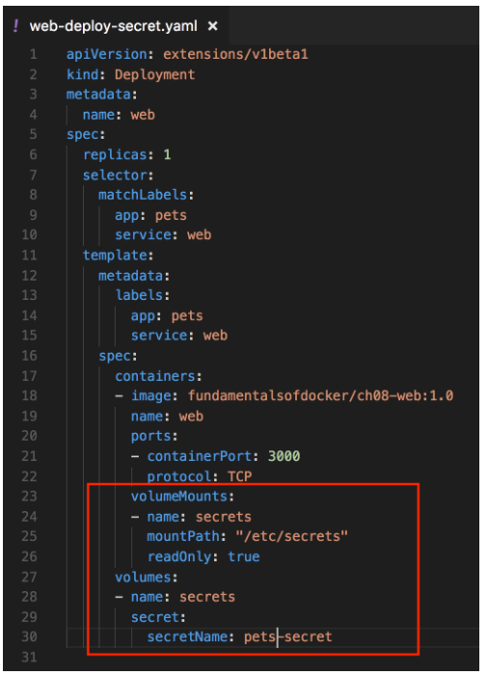

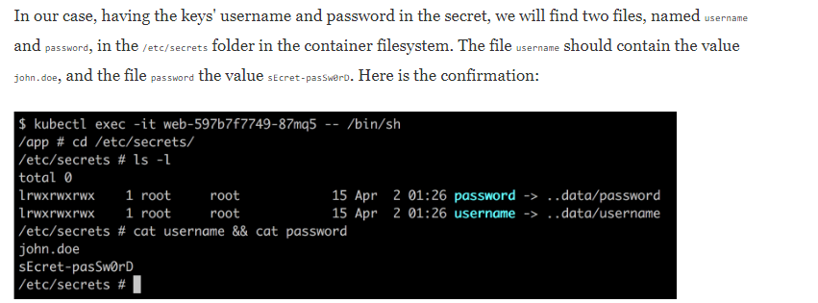

Exp 2

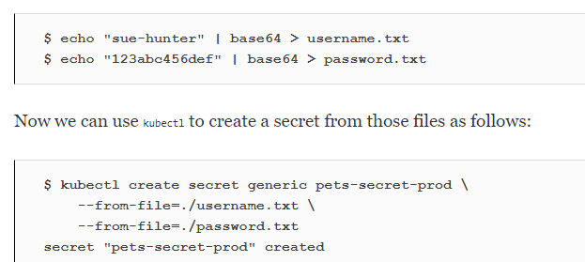

Exp 3

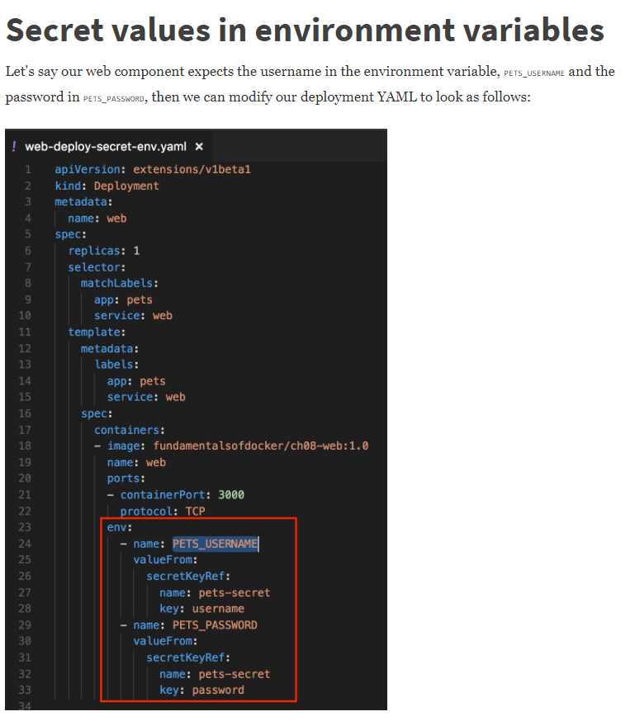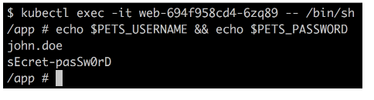

## MultiContainer Pod

The idea of decoupling a large monolithic application into sub-components known as microservices enables us to develop and deploy a set of independent small and reusable code this architecture can then help us scale up down as well as modify each service as required as opposed to modifying the entire application.

However at times you may need two services to work together such as a web server and a logging service.

You need one agent instance per web server instance paired together.

You don't want to march and bloat the code of the two services as each of them target different functionalities and you'd still like them to be developed and deployed separately you only need the two functionality to work together.

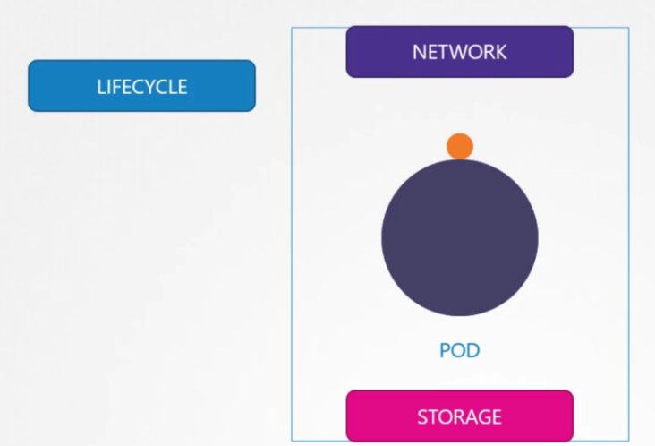

You need one agent per web server instance paired together that can scale up and down together and that is why you have multi-container pods that share the same lifecycle which means they are created together and destroyed together they share the same network space which means they can refer to each other as local host and they have access to the same storage volumes.

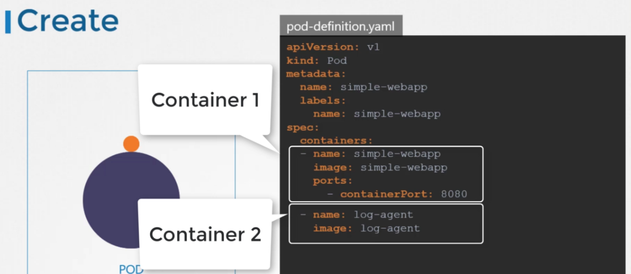

This way you do not have to establish volume sharing or services between the pods to enable communication between them to create a multi container pod.

Add the new container information to the pod definition file.

Remember the container section under the spec section in a pod definition file is an array.

And the reason it is an array is to allow multiple containers in a single pod.

In this case we add a new container named log agent to our existing pod.

Well that's it for this lecture.

Head over to the coding exercises section and practice configuring multi container pods.

See you in the next lecture.

Exp1:

apiVersion: v1

kind: Pod

metadata:

name: yellow

spec:

containers:

- name: lemon

image: busybox

- name: gold

image: redismaster

exp2

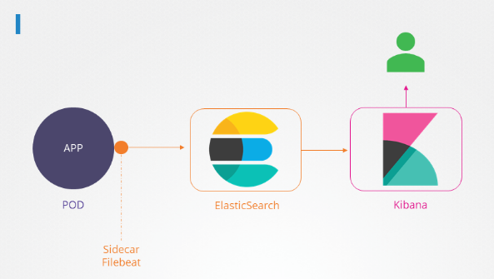

master $ cat /var/answers/answer-app.yaml

apiVersion: v1

kind: Pod

metadata:

name: app

namespace: elastic-stack

labels:

name: app

spec:

containers:

- name: app

image: kodekloud/event-simulator

volumeMounts:

- mountPath: /log

name: log-volume

- name: sidecar

image: kodekloud/filebeat-configured

volumeMounts:

- mountPath: /var/log/event-simulator/

name: log-volume

volumes:

- name: log-volume

hostPath:

# directory location on host

path: /var/log/webapp

# this field is optional

type: DirectoryOrCreatemaster $

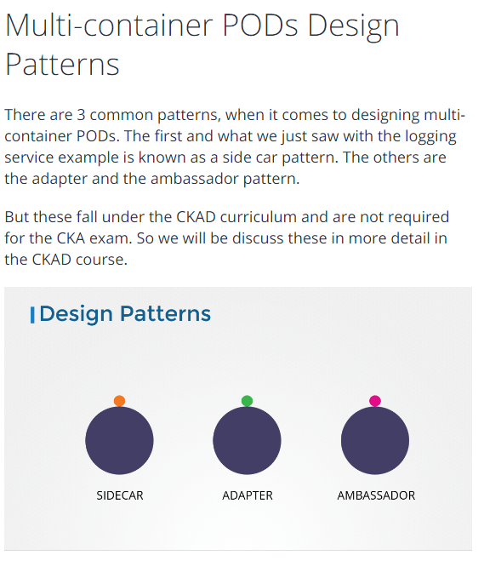

## InitContainers

In a multi-container pod, each container is expected to run a process that stays alive as long as the POD's lifecycle. For example in the multi-container pod that we talked about earlier that has a web application and logging agent, both the containers are expected to stay alive at all times. The process running in the log agent container is expected to stay alive as long as the web application is running. If any of them fails, the POD restarts.

But at times you may want to run a process that runs to completion in a container. For example a process that pulls a code or binary from a repository that will be used by the main web application. That is a task that will be run only  one time when the pod is first created. Or a process that waits  for an external service or database to be up before the actual application starts. That's where **initContainers**comes in.

An **initContainer**is configured in a pod like all other containers, except that it is specified inside a initContainers section,  like this:

1. apiVersion: v1
2. kind: Pod
3. metadata:
4. name: myapp-pod
5. labels:
6. app: myapp
7. spec:
8. containers:
9. - name: myapp-container
10. image: busybox:1.28
11. command: ['sh', '-c', 'echo The app is running! && sleep 3600']
12. initContainers:
13. - name: init-myservice
14. image: busybox
15. command: ['sh', '-c', 'git clone <some-repository-that-will-be-used-by-application> ; done;']

When a POD is first created the initContainer is run, and the process in the initContainer must run to a completion before the real container hosting the application starts.

You can configure multiple such initContainers as well, like how we did for multi-pod containers. In that case each init container is run **one at a time in sequential order**.

If any of the initContainers fail to complete, Kubernetes restarts the Pod repeatedly until the Init Container succeeds.

1. apiVersion: v1
2. kind: Pod
3. metadata:
4. name: myapp-pod
5. labels:
6. app: myapp
7. spec:
8. containers:
9. - name: myapp-container
10. image: busybox:1.28
11. command: ['sh', '-c', 'echo The app is running! && sleep 3600']
12. initContainers:
13. - name: init-myservice
14. image: busybox:1.28
15. command: ['sh', '-c', 'until nslookup myservice; do echo waiting for myservice; sleep 2; done;']
16. - name: init-mydb
17. image: busybox:1.28
18. command: ['sh', '-c', 'until nslookup mydb; do echo waiting for mydb; sleep 2; done;']

## OS upgrades

Hello and welcome to this lecture. In this lecture

we will discuss about scenarios where you might have to take down node as part of your cluster say for maintenance purposes like upgrading a base software or applying patches like security patches etc on your cluster.

So you have a cluster with a few nodes and pods serving applications.

What happens when one of these nodes go down.

Of course the pods on them are not accessible. Now depending upon how you deployed those PODs your users may be impacted.

For example, since you have multiple replicas of the blue pod, the users accessing the blue application are not impacted as they are being served through the other blue pod that's on line.

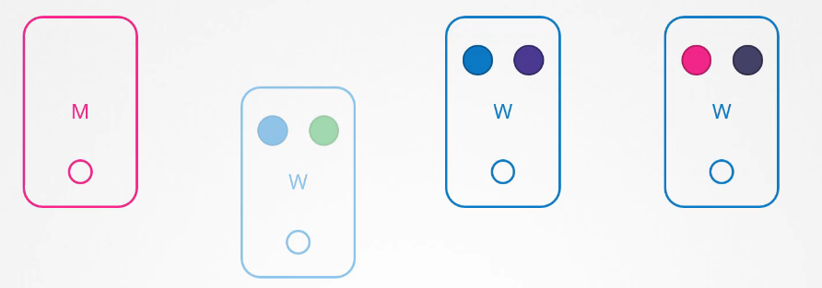

However users accessing the green pod, are impacted as that was the only pod running the green application.

Now what does kubernetes do in this case?

If the node came back online immediately, then the kubectl process starts and the pods come back online.

However, if the node was down for more than 5 minutes, then the pods are terminated from that node.

Well, kubernetes considers them as dead.

If the PODs where part of a replicaset then they are recreated on other nodes.

The time it waits for a pod to come back online is known as the pod eviction timeout and is set on the controller manager with a default value of five minutes.



So whenever a node goes offline, the master node waits for up to 5 minutes before considering the node dead.

When the node comes back on line after the pod eviction timeout it comes up blank without any pods scheduled on it.

Since the blue pod was part of a replicaset, it had a new pod created

On another node. However since the green pod was not part of the replica set it's just gone.

Thus if you have maintenance tasks to be performed on a node if you know that the workloads running on the Node have other replicas and if it's okay that they go down for a short period of time.

And if you're sure the node will come back on line within five minutes you can make a quick upgrade and reboot.

However you do not for sure know if a node is going to be back on line in five minutes.

Well you cannot for sure say it is going to be back at all.

So there is a safer way to do it.

You can purposefully drain the node of all the workloads so that the workloads are moved to other nodes in the cluster.

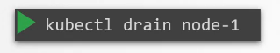

kubectl drain node01 --ignore-daemonsets

Well technically they are not moved. When you drain the node

the pods are gracefully terminated from the node that they're on and recreated on another.

The node is also cordoned (blocat) or marked as unschedulable. Meaning no pods can be scheduled on this node until you specifically remove the restriction.

Now that the pods are safe on the others nodes, you can reboot the first node. When it comes back online

it is still unschedulable.

You then need to uncordon it, so that pods can be scheduled on it again.



Now, remember the pods that were moved to the other nodes, don’t automatically fall back. If any of those pods where deleted or if new pods were created in the cluster,

Then they would be createdon this node. Apart from drain and uncordon, there is also another command called cordon.

Cordon simply marks a node unschedulable.

Unlike drain it does not terminate or move the pods on an existing node.

It simply makes sure that new pods are not scheduled on that node.

## Kubernetes Releases

Hello and welcome to this lecture. In this lecture

we will discuss about the various Kubernetes releases and versions.

So what do we know about API versions in Kubernetes

so far? We know that when we install a kubernetes cluster, we install a specific version of kubernetes.

We can see that when we run the kubectl get nodes command.

In this case its v1.11.3.

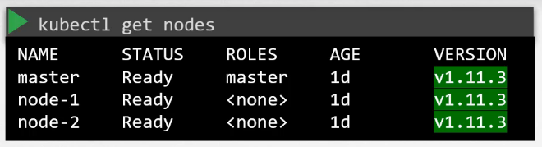

In this lecture we will see how kubernetes project manages software releases.

Let's take a closer look at that version number.

The kubernetes release versions consists of 3 parts.

The first is the major version, followed by the minor version and then the Patch version. While minor versions are released every few months with new features and functionalities,

patches are released more often with critical bug fixes. Just like many other popular applications out there, kubernetes follows a standard software release versioning procedure.

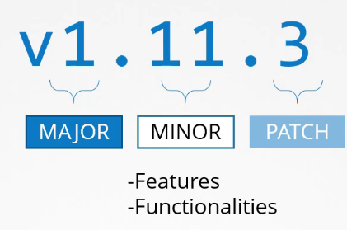

Every few month It comes out with new features and functionalities through a minor release.

The first major version 1.0 was released in July of 2015.

As of this recording the latest stable version is 1.13.0. Whatever we have seen here are stable releases of kubernetes.

Apart from this you will also see alpha and beta releases all the bug fixes and improvements first go into an alpha release tagged alpha in this release.

The features are disabled by default and maybe buggy.

Then from there they make their way to beta release where the code is well tested.

The new features are enabled by default.

And finally they make their way to the main stable release.

You can find all the releases in the releases page of the Kubernetes Github repository.

Download the kubernetes.tar.gz file and extract it to find executables for all the kubernetes

components. The downloaded package when extracted has all the control plane components in it.All of them of the same version.

Remember that there are other components within the control plane that do not have the same version numbers.

The ETCD cluster and CoreDNS servers have their own versions as they are separate projects.

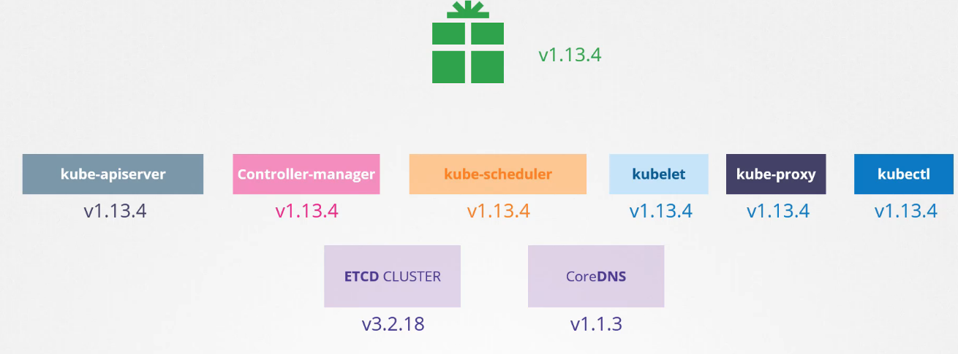The release notes of each release provides information about the supported versions of externally dependent applications like ETCD and CoreDNS etc.

Check out the links for some references.

That was a quick overview of the release versions. In the upcoming lecture

we will discuss how to upgrade from one version to another.

## Cluster upgrades

In the previous lecture, we saw how Kubernetes manages its software releases and how different components have their versions.

We will keep dependency on external components like ETCD and CoreDNS aside for now and focus on the core control plane components.

Is it mandatory for all of these to have the same version?

No, the components can be at different release versions. Since the kube-api server is the primary component in the control plane and that is the component that all other components talked to.

none of the other components should ever be at a version higher than the kube-api server. The controller manager and scheduler can be at one version lower, so if kube-apiserver was at x, controller managers

and kube-schedulers can be at X-1, and the kubelet and kube-proxy components can be at versions lower X-2.

So if kube-api server was at 1.10, the controller-manager and scheduler could be at 1.9

and the kubelet and kube-proxy could be at 1.8. None of them could be at a version higher than the kube api server – like 1.11.

Now this is not the case with kubectl though. The kubectl utility could b at 1.11

a version higher than the API server, 1.10 the same version as the api server or at 1.9 a version lower than the API server.

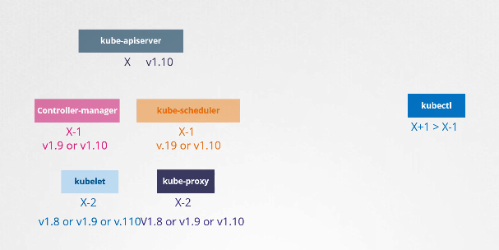

Now this permissible skew in versions allows us to carry out live upgrades. We can upgrade component by component if required.

So when should you upgrade? Say you were at 1.10. And kubernetes releases version 1.11 & 1.12.

at any time kubernetes supports only up to the recent 3 minor versions.

So with 1.12 being the latest release kubernetes supports 1.12,

1.11 and 1.10.

So when 1.13 is released, only versions 1.13, 1.12 and 1.11 are supported.

Before the release of 1.13 would be a good time to upgrade your cluster to the next release.

So how do we upgrade? Do we upgrade directly from 1.10 to 1.13?

No.

The recommended approach is to upgrade one minor version at a time.

v1.10 to v1.11. Then 1.11 to 1.12, and then 1.12 to

1.13. The upgrade process depends on how your cluster is setup.

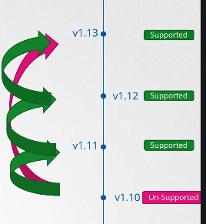

For example if your cluster is a managed kubernetes cluster deployed on cloud service providers, like Google for instance, Google Kubernetes Engine lets you upgrade your cluster easily with just a few clicks.

If you deployed your cluster using tools like kubeadm, then the tool can help you plan and upgrade the cluster.

If you deployed your cluster from scratch, then you manually upgrade the different components of the cluster yourself.

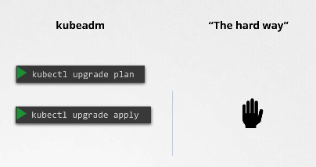

In this lecture we will look at the options by kubeadm. So you have a cluster with master and worker nodes, running in production hosting PODs, serving users. The nodes and components are at version 1.10.

upgrading a cluster involves two major steps.

First you upgrade your master nodes, and then upgrade the worker nodes. While the master is being upgraded,

the control plane components such as the api-server,

scheduler and controller-managers go down briefly. The master going down does not mean your worker nodes and applications on the cluster are impacted. All workloads hosted on the worker nodes continue to serve users as normal.

Since the master is down, all management functions are down. You cannot access the cluster using kubectl

or the kubernetes API. You cannot deploy new applications or delete or modify existing ones.

The controller managers don't function either.

If a POD was to fail, a new POD won’t be automatically created.

But as long as the nodes and the pods are up your applications should be up and users will not be impacted.

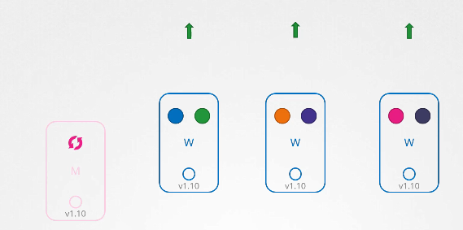

Once the upgrade is complete and the cluster is back up it should function normally.

We now have the master and the master components at v1.11. And the worker nodes at version 1.10.

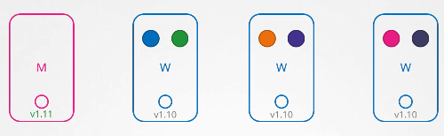

As we saw earlier this is a supported configuration.

It is now time to upgrade the worker nodes.

There are different strategies available to upgrade the worker nodes.

One, is to upgrade all of them at once. But then your PODs are down and users are no longer able to access

the applications. Once the upgrade is complete,

the nodes are back up, new PODs are scheduled and users can resume access.

That's one strategy that requires downtime.

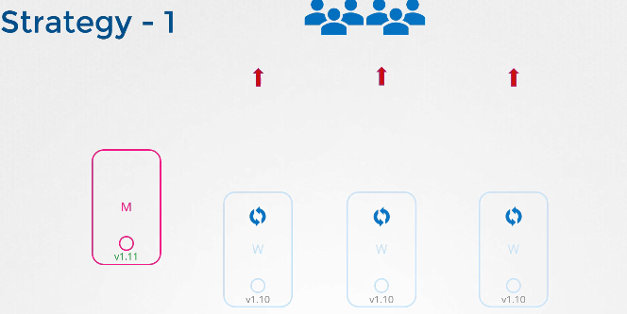

The second strategy is to upgrade one node as a time.

So going back to the state where we have our master upgraded and nodes waiting to be upgraded. We first upgrade the first node, where the workloads move to the second and third node and users are served from there.

Once the first note is upgraded and back up with an update the second node where the workloads move

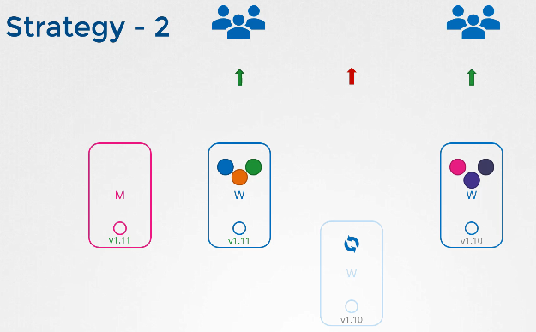

to first and third nodes. And finally the third node, where the workloads are shared between the first

two. Until we have all nodes upgraded to a newer version.

We then follow the same procedure to upgrade the nodes from 1.11 to 1.12 and then

1.13.

A third strategy would be to add new nodes to the cluster. Nodes with the newer software version.

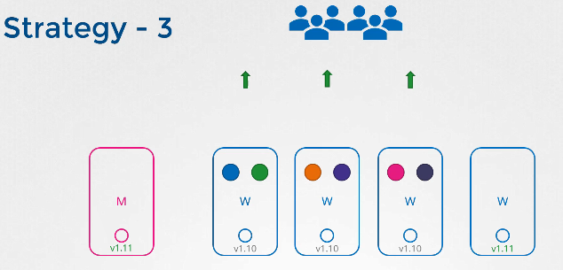

This is especially convenient if you are on a cloud environment where you can easily provision new nodes and decommission old nodes. Nodes with the newer software version can be added to the cluster. Move the workload over to the new and remove the old node until you finally have all new nodes with the new software version. let us now see how it is done.

Say we where to upgrade this cluster from 1.11 to 1.13.

Kubeadm has an upgrade command that helps in upgrading clusters. With kubeadm

run the kubeadm upgrade plan command and it will give you a lot of good information.

The current cluster version, the kubeadm tool version, the latest stable version of kubernetes.

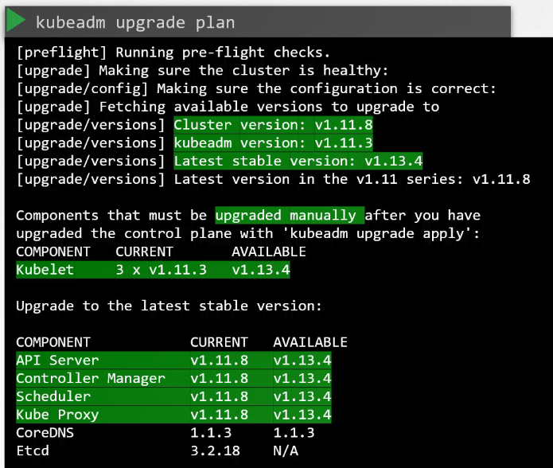

Then it lists all the control plane components and their versions

and what version these can be upgraded to.

It also tells you that after we upgrade the control plane components, you must manually upgrade the kubelet versions on each node. Remember kubeadm does not install or upgrade kubelets.

Finally it gives you the command to upgrade the cluster.

Also note that you must upgrade the kubeadm tool itself before you can upgrade the cluster.

The kubeadm tool also follows the same software version as kubernetes.

So we are at 1.11, and we want to go to 1.13, but remember we can only go one minor version at a time. So we first go to 1.12. First upgrade the kubeadm tool itself to

version 1.12. Then upgrade the cluster using the command from the upgrade plan output – kubeadm upgrade

apply.

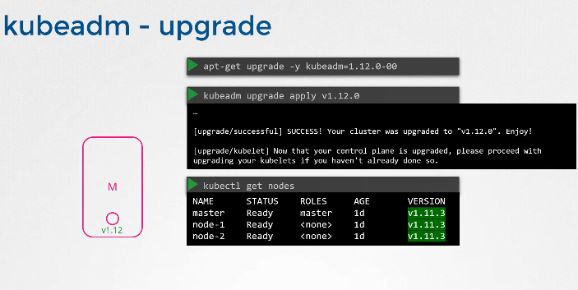

It pulls the necessary images and upgrades the cluster components. Once complete your control plane plane components are now at 1.12.

If you run the kubectl get nodes, you will still see the master node at 1.11.

This is because in the output of this command, it is showing the versions of kubelets on each of these nodes registered with the API server and not the version of the API server itself.

So the next step is to upgrade the kubelets. Remember,

depending on your setup, you may or may not have kubelets running on the master node.

In this case, the cluster deployed with kubeadm has kubelets on the master nodes which are used to run the control plane components as pods on the master

Node. When we set up a Kubernetes cluster from scratch later during this course we do not install kublet on the master nodes. You will not see the master node in the output of this command.

In that case so the next step is to upgrade Kubelet on the master node.

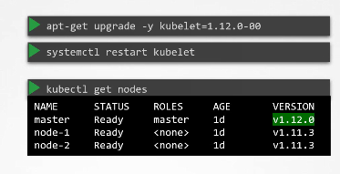

If you have kubletslets on them Run the apt-get upgrade kubelet command for this.

Once the package is upgrade restart the kubelet service. Run the kubectl get nodes command now shows that the master has been upgraded to 1.12. The worker nodes are still at 1.11. Next the worker nodes. Let us start one at a time.

We need to first move the workloads from the first worker node to the other nodes. The kubectl drain drain command lets you safely terminate all the pods from a node and reschedules them on other nodes.

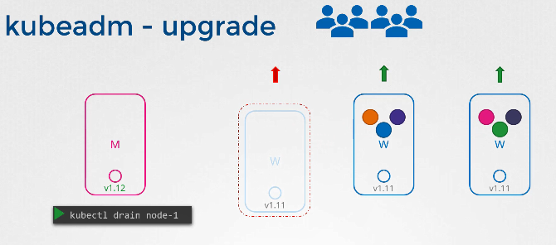

It also cordons the node and marks in unschedulable.

That way no new pods are scheduled on it. The upgrade kubeadm and kubelet packages on the worker nodes as we did on the master node. Then using kubeadm tool upgrade command update node

config for the new kubelet version. Then restart the kubelet.

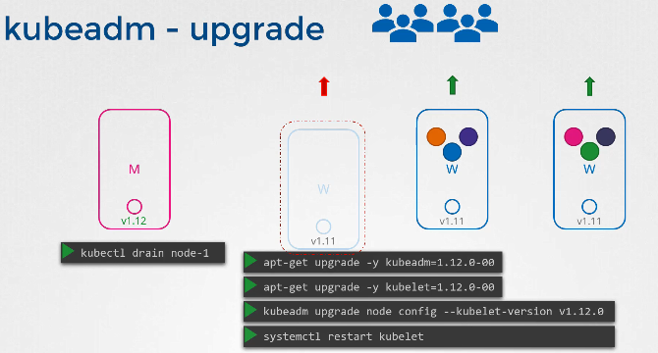

service. The node should now be up with the new software version.

However, when we drained the node, we actually marked it unschedulable. So we need to unmark it by running the

command kubectl uncordon node-1. The node is now schedulable.

But remember, that it is not necessary that the pods come right back to this node.

It is only marked as schedulable. Only when the PODs are deleted from the other nodes, or when new

pods are scheduled do they really come back to this first

node. Well, it will soon come when we take down the second node. To perform the same steps to upgrade it.

And finally the third node. We now have all nodes upgraded.

Well that's it for this lecture.

Head over to the practice test where you will practice upgrading and live cluster with applications

running on it without taking the applications down.

Good luck.

EXP:

Master

 apt install kubeadm=1.12.0-00

master $ kubectl get nodes

NAME STATUS ROLES AGE VERSION

master Ready,SchedulingDisabled master 13m v1.11.3

node01 Ready <none> 13m v1.11.0

master $ apt install kubeadm=1.12.0-00

Reading package lists... Done

Building dependency tree

Reading state information... Done

The following packages will be upgraded:

kubeadm

1 upgraded, 0 newly installed, 0 to remove and 186 not upgraded.

Need to get 8,988 kB of archives.

After this operation, 3,365 kB disk space will be freed.

Get:1 https://packages.cloud.google.com/apt kubernetes-xenial/main amd64 kubeadm amd64 1.12.0-00 [8,988 kB]

Fetched 8,988 kB in 0s (14.0 MB/s)

(Reading database ... 70340 files and directories currently installed.)

Preparing to unpack .../kubeadm_1.12.0-00_amd64.deb ...

Unpacking kubeadm (1.12.0-00) over (1.11.3-00) ...

Setting up kubeadm (1.12.0-00) ...

master $ kubeadm upgrade apply v1.12.0

[preflight] Running pre-flight checks.

[upgrade] Making sure the cluster is healthy:

[upgrade/config] Making sure the configuration is correct:

[upgrade/config] Reading configuration from the cluster...

[upgrade/config] FYI: You can look at this config file with 'kubectl -n kube-system get cm kubeadm-config -oyaml'

[upgrade/apply] Respecting the --cri-socket flag that is set with higher priority than the config file.

[upgrade/version] You have chosen to change the cluster version to "v1.12.0"

[upgrade/versions] Cluster version: v1.11.3

[upgrade/versions] kubeadm version: v1.12.0

[upgrade/confirm] Are you sure you want to proceed with the upgrade? [y/N]: y

[upgrade/prepull] Will prepull images for components [kube-apiserver kube-controller-manager kube-scheduler etcd]

[upgrade/prepull] Prepulling image for component etcd.

[upgrade/prepull] Prepulling image for component kube-scheduler.

[upgrade/prepull] Prepulling image for component kube-controller-manager.

[upgrade/prepull] Prepulling image for component kube-apiserver.

[apiclient] Found 0 Pods for label selector k8s-app=upgrade-prepull-kube-controller-manager

[apiclient] Found 0 Pods for label selector k8s-app=upgrade-prepull-etcd

[apiclient] Found 0 Pods for label selector k8s-app=upgrade-prepull-kube-apiserver

[apiclient] Found 0 Pods for label selector k8s-app=upgrade-prepull-kube-scheduler

[apiclient] Found 1 Pods for label selector k8s-app=upgrade-prepull-etcd

[apiclient] Found 1 Pods for label selector k8s-app=upgrade-prepull-kube-controller-manager

[apiclient] Found 1 Pods for label selector k8s-app=upgrade-prepull-kube-apiserver

[apiclient] Found 1 Pods for label selector k8s-app=upgrade-prepull-kube-scheduler

[upgrade/prepull] Prepulled image for component etcd.

[upgrade/prepull] Prepulled image for component kube-controller-manager.

[upgrade/prepull] Prepulled image for component kube-apiserver.

[upgrade/prepull] Prepulled image for component kube-scheduler.

[upgrade/prepull] Successfully prepulled the images for all the control plane components

[upgrade/apply] Upgrading your Static Pod-hosted control plane to version "v1.12.0"...

Static pod: kube-apiserver-master hash: 7513b07d4bdb75ea2e126c5acecf70ac

Static pod: kube-controller-manager-master hash: 9895fd2d792e30f56ff26d3c070017c9

Static pod: kube-scheduler-master hash: 009228e74aef4d7babd7968782118d5e

Static pod: etcd-master hash: 2cc1c8a24b68ab9b46bca47e153e74c6

[etcd] Wrote Static Pod manifest for a local etcd instance to "/etc/kubernetes/tmp/kubeadm-upgraded-manifests060961687/etcd.yaml"

[upgrade/staticpods] Moved new manifest to "/etc/kubernetes/manifests/etcd.yaml" and backed up old manifest to "/etc/kubernetes/tmp/kubeadm-backup-manifests-2019-10-30-19-46-52/etcd.yaml"

[upgrade/staticpods] Waiting for the kubelet to restart the component

[upgrade/staticpods] This might take a minute or longer depending on the component/version gap (timeout 5m0s

Static pod: etcd-master hash: 2cc1c8a24b68ab9b46bca47e153e74c6

Static pod: kube-controller-manager-master hash: 15ad8f6ae82cef95952b27c0f92a0d5d

[apiclient] Found 1 Pods for label selector component=kube-controller-manager

[upgrade/staticpods] Component "kube-controller-manager" upgraded successfully!

[upgrade/staticpods] Moved new manifest to "/etc/kubernetes/manifests/kube-scheduler.yaml" and backed up old manifest to "/etc/kubernetes/tmp/kubeadm-backup-manifests-2019-10-30-19-46-52/kube-scheduler.yaml"

[upgrade/staticpods] Waiting for the kubelet to restart the component

[upgrade/staticpods] This might take a minute or longer depending on the component/version gap (timeout 5m0s

Static pod: kube-scheduler-master hash: 009228e74aef4d7babd7968782118d5e

Static pod: kube-scheduler-master hash: 1b5ec5be325bf29f60be62789416a99e

[apiclient] Found 1 Pods for label selector component=kube-scheduler

[upgrade/staticpods] Component "kube-scheduler" upgraded successfully!

[uploadconfig] storing the configuration used in ConfigMap "kubeadm-config" in the "kube-system" Namespace

[kubelet] Creating a ConfigMap "kubelet-config-1.12" in namespace kube-system with the configuration for the kubelets in the cluster

[kubelet] Downloading configuration for the kubelet from the "kubelet-config-1.12" ConfigMap in the kube-system namespace

[kubelet] Writing kubelet configuration to file "/var/lib/kubelet/config.yaml"

[patchnode] Uploading the CRI Socket information "/var/run/dockershim.sock" to the Node API object "master" as an annotation

[bootstraptoken] configured RBAC rules to allow Node Bootstrap tokens to post CSRs in order for nodes to get long term certificate credentials

[bootstraptoken] configured RBAC rules to allow the csrapprover controller automatically approve CSRs from a Node Bootstrap Token

[bootstraptoken] configured RBAC rules to allow certificate rotation for all node client certificates in the cluster

[addons] Applied essential addon: CoreDNS

[addons] Applied essential addon: kube-proxy

[upgrade/successful] SUCCESS! Your cluster was upgraded to "v1.12.0". Enjoy!

[upgrade/kubelet] Now that your control plane is upgraded, please proceed with upgrading your kubelets if you haven't already done so.

master $ apt install kubelet=1.12.0-00

Reading package lists... Done

Building dependency tree

Reading state information... Done

The following packages will be upgraded:

kubelet

1 upgraded, 0 newly installed, 0 to remove and 186 not upgraded.

Need to get 24.7 MB of archives.

After this operation, 13.7 MB of additional disk space will be used.

Get:1 https://packages.cloud.google.com/apt kubernetes-xenial/main amd64 kubelet amd64 1.12.0-00 [24.7 MB]

Fetched 24.7 MB in 1s (15.8 MB/s)

(Reading database ... 70340 files and directories currently installed.)

Preparing to unpack .../kubelet_1.12.0-00_amd64.deb ...

Unpacking kubelet (1.12.0-00) over (1.11.3-00) ...

Setting up kubelet (1.12.0-00) ...

master $

master $ kubectl drain node01 --ignore-daemonsets

node/node01 already cordoned

WARNING: Ignoring DaemonSet-managed pods: kube-proxy-94dsl, weave-net-qzhxl

pod/coredns-576cbf47c7-dkcwl evicted

pod/red-67465685c-tfwvg evicted

pod/red-67465685c-fsl8d evicted

pod/coredns-576cbf47c7-tg77m evicted

master $ kubectl get pods -o wide

NAME READY STATUS RESTARTS AGE IP NODE NOMINATED NODE

red-67465685c-dpqsq 1/1 Running 0 18s 10.40.0.2 master <none>

red-67465685c-tgfwc 1/1 Running 0 18s 10.40.0.1 master <none>

master $ kubectl get nodes

NAME STATUS ROLES AGE VERSION

master Ready master 23m v1.12.0

node01 Ready,SchedulingDisabled <none> 23m v1.11.0

Worker

node01 $ apt install kubeadm=1.12.0-00

Reading package lists... Done

Building dependency tree

Reading state information... Done

The following package was automatically installed and is no longer required:

libuv1

Use 'apt autoremove' to remove it.

The following packages will be upgraded:

kubeadm

1 to upgrade, 0 to newly install, 0 to remove and 153 not to upgrade.

Need to get 8,988 kB of archives.

After this operation, 3,352 kB disk space will be freed.

Get:1 https://packages.cloud.google.com/apt kubernetes-xenial/main amd64 kubeadm amd64 1.12.0-00 [8,988 kB]

Fetched 8,988 kB in 0s (13.6 MB/s)

(Reading database ... 109101 files and directories currently installed.)

Preparing to unpack .../kubeadm_1.12.0-00_amd64.deb ...

Unpacking kubeadm (1.12.0-00) over (1.11.0-00) ...

Setting up kubeadm (1.12.0-00) ...

node01 $ kubeadm upgrade node config --kubelet-version v1.12.0

[kubelet] Downloading configuration for the kubelet from the "kubelet-config-1.12" ConfigMap in the kube-system namespace

[kubelet] Writing kubelet configuration to file "/var/lib/kubelet/config.yaml"

[upgrade] The configuration for this node was successfully updated!

[upgrade] Now you should go ahead and upgrade the kubelet package using your package manager.

Short version

###sumarizat##

###Master###

kubectl drain master --ignore-daemonsets

apt install kubeadm=1.12.0-00

kubeadm upgrade -y apply v1.12.0

apt install kubelet=1.12.0-00

kubectl uncordon master

####Worker#####

kubectl drain node01 --ignore-daemonsets

apt install kubeadm=1.12.0-00

apt install kubelet=1.12.0-00

kubeadm upgrade node config --kubelet-version v1.12.0

#Master

kubectl uncordon node01

version 1.13

###Master###

kubectl drain master --ignore-daemonsets

apt-get update

apt install kubeadm=1.13.0-00

kubeadm upgrade apply v1.13.0

apt install kubelet=1.13.0-00

kubectl uncordon master

####Worker#####

kubectl drain node01 --ignore-daemonsets

apt install kubeadm=1.13.0-00

apt install kubelet=1.13.0-00

kubeadm upgrade node config --kubelet-version v1.13.0

#Master

kubectl uncordon node01

###################################

#Master

kubectl uncordon node01

version 1.14

###Master###

kubectl drain master --ignore-daemonsets

apt-get update

apt install kubeadm=1.14.8-00

kubeadm upgrade apply v1.14.8

apt install kubelet=1.14.8-00

kubectl uncordon master

####Worker#####

kubectl drain node01 --ignore-daemonsets

apt install kubeadm=1.14.8-00

apt install kubelet=1.14.8-00

kubeadm upgrade node config --kubelet-version v1.14.8

#Master

kubectl uncordon node01

#Master

kubectl uncordon node01

version 1.15

###Master###

kubectl drain master --ignore-daemonsets

apt-get update

apt-cache policy kubeadm

apt install kubeadm=1.15.5-00

kubeadm upgrade apply v1.15.0

apt install kubelet=1.15.5-00

kubectl uncordon master

####Worker#####

kubectl drain node01 --ignore-daemonsets

apt install kubeadm=1.15.5-00

apt install kubelet=1.15.5-00

kubeadm upgrade node config --kubelet-version v1.15.5

#Master

kubectl uncordon node01

## Backup

Let’s start by looking at what you should consider backing up in a Kubernetes cluster. So far in this course,

we have deployed a number of different applications on our Kubernetes cluster using deployment, pod and Service definition files.

We know that the ETCD cluster is where all cluster related information is stored.

And if your applications are configured with persistent storage then that is another candidate for backups.

With respect to resources that we created in the cluster,

at times we used the imperative way of creating an object by executing a command. Such as while creating a namespace or a secret or config map or at times for exposing applications. And at times we used the declarative approach by first creating a definition file and then running the kubectl apply command on that file.

This is the preferred approach if you want to save your configuration. Because now you have all the objects required for a single application in the form of object definition files in a single folder.

This can easily be reused at a later time or shared with others of course you must have a copy of these files saved at all times.

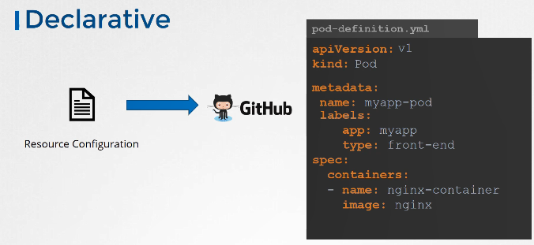

A good practice is to store these on source code repositories.

That way it can be maintained by a team the source code repository should be configured with the right backup solutions. With managed/public source code repositories like Github

You don't have to worry about this.

With that even when you lose your entire cluster you can redeploy your application on the cluster by simply applying this configuration files on them. While the declarative approach is the preferred approach it is not necessary that all of your team members stick to those standards.

What if someone created an object the imperative way without documenting that information anywhere.

So a better approach to backing up resource configuration is to use query the kube-api server. . Query the kube-api server using kubectl or by accessing the API server directly and save all resource configurations

for all objects created on the cluster has a copy.

For example one of the commands that can be used in a backup script is to get all pods, deployments and services in all namespaces using the kubectl utility’s get all command and extract the output

in a YAML format. Then save that file. And that’s just for a few resources groups.

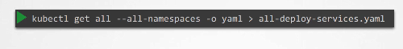

There are many other resource groups that must be considered.

Of course you don't have to develop that solutions yourself.

There are tools like ARK or now called Velero by Heptio that can do this for you.



It can help in taking backups of your Kubernetes cluster using the Kubernetes API. Let us now move on to ETCD.

The ETCD cluster stores information about the state of our cluster. So information about the cluster itself, The nodes and every other resource as created within the cluster are stored here.

So instead of backing up resource as before, you may chose to backup the ETCD server itself. As we have seen the ETCD cluster is hosted on the master nodes. While configuring ETCD we specified a location where all the data would be stored.

The data directory. That is the directory that can be configured to be backup by your backup tool.

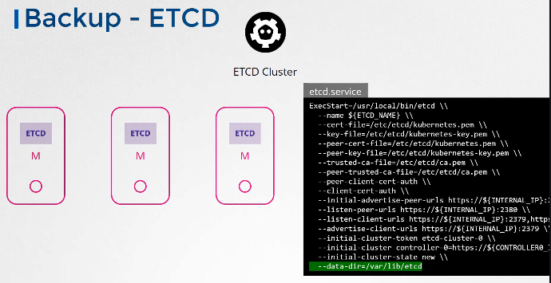

ETCD

also comes with a built in snapshot solution.

You can take a snapshot of the ETCD database by using the etdctl utilities snapshot save command.

Give the snapshot a name snapshot.db. A snapshot file is created by the name in the current directory.

If you wanted to be created in another location specified the full path.

You can view the status of the backup using the snapshot status command.

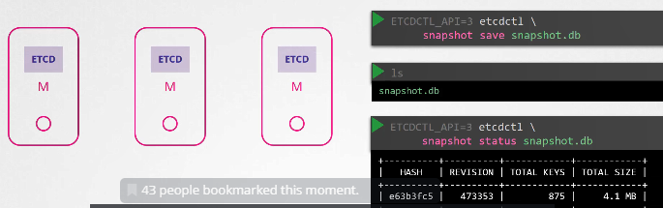

To restore the cluster from

this backup at a later point in time.

first stop the kube-api server service, as the restore process will require you to restart the ETCD

cluster and the kube-api server depends on it. Then run the etcdctl’s snapshot restore command

with the path set to the path of the backup file which is the snapshot.db file. When ETCD restores from a backup, it initializes a new cluster configuration and configures the members of ETCD as new members to a new cluster.

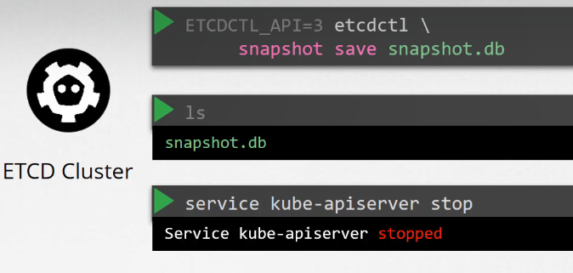

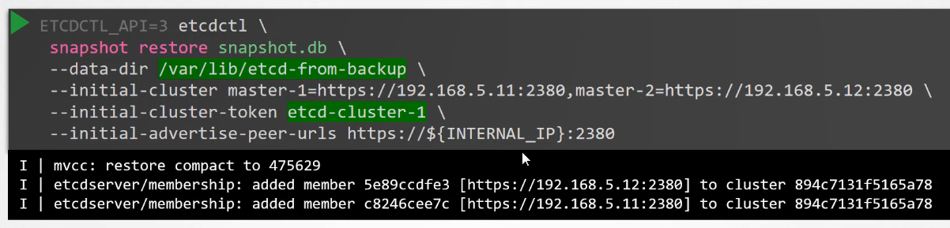

This is to prevent a new member from accidentally joining an existing cluster.

Say for example, you use this backup snapshot to provision a new etcd-cluster for testing purposes.

You don’t want the members in the new test cluster to accidentally join the production cluster.

So during a restore you must specify a new cluster token and the same initial cluster configuration

options specified in the original configuration file. On running this command a new data directory is

created. in this example at location /var/lib/etcd-from-backup.

Before:  
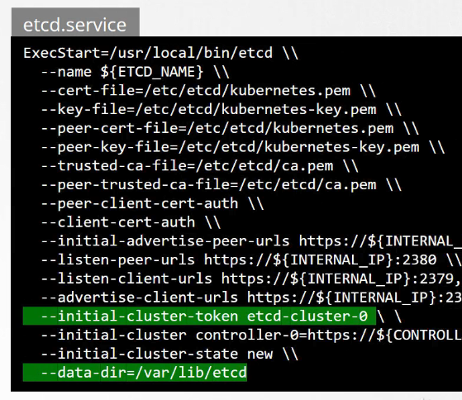

After:

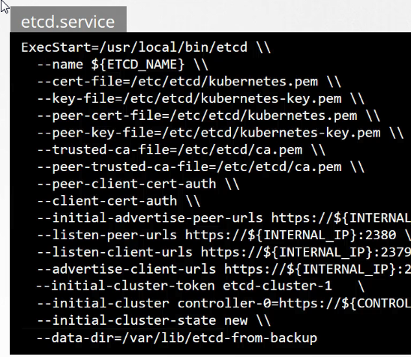

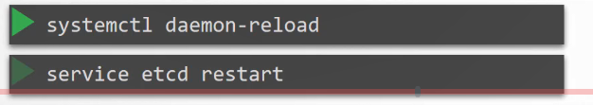

We then configure the ETCD configuration file to use the new cluster-token and data directory.

The reload the service daemon and restart etcd service.

Finally start the kube-apiserver service. Your cluster should now be back in the original state. A quick note before I let you go With all the ETCD commands

remember to specify the certificate files for authentication.

Specify the endpoint to the ETCD cluster and the ca certificate, the etcd-server certificate and the key, So we have seen two options and backup using ETCD and backup by querying the kube-apiserver .

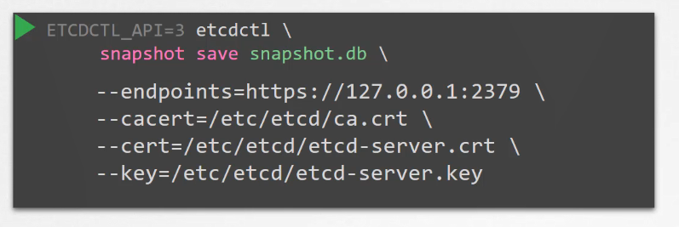Well if you're using a managed Kubernetes environment then at times you may not even have access to

the ETCD cluster in that case

Backup by querying the kube-apiserver probably the better way.

Well that's it for this demo.

Head over to the practice test and practice backing up ETCD in a cluster and then restoring from backups.

EXERCISE:

<https://github.com/mmumshad/kubernetes-the-hard-way/blob/master/practice-questions-answers/cluster-maintenance/backup-etcd/etcd-backup-and-restore.md>

master $ kubectl describe pod etcd-master -n kube-system | more

Name: etcd-master

Namespace: kube-system

Priority: 2000000000

PriorityClassName: system-cluster-critical

Node: master/172.17.0.41

Start Time: Wed, 30 Oct 2019 21:50:44 +0000

Labels: component=etcd

tier=control-plane

Annotations: kubernetes.io/config.hash=2cc1c8a24b68ab9b46bca47e153e74c6

kubernetes.io/config.mirror=2cc1c8a24b68ab9b46bca47e153e74c6

kubernetes.io/config.seen=2019-10-30T21:50:44.823017516Z

kubernetes.io/config.source=file

scheduler.alpha.kubernetes.io/critical-pod=

Status: Running

IP: 172.17.0.41

Containers:

etcd:

Container ID: docker://5d2976f1d743927abea8c3de0d4ac3241cb5af795f72ea32f23a252cdbeb364a

Image: k8s.gcr.io/etcd-amd64:3.2.18

ontainers:

etcd:

Container ID: docker://5d2976f1d743927abea8c3de0d4ac3241cb5af795f72ea32f23a252cdbeb364a

Image: k8s.gcr.io/etcd-amd64:3.2.18

Image ID: docker-pullable://k8s.gcr.io/etcd-amd64@sha256:b960569ade5f37205a033dcdc3191fe99dc95b15c6795a6282859070ec2c6124

Port: <none>

Host Port: <none>

Command:

etcd

--advertise-client-urls=https://127.0.0.1:2379

--cert-file=/etc/kubernetes/pki/etcd/server.crt

--client-cert-auth=true

--data-dir=/var/lib/etcd

--initial-advertise-peer-urls=https://127.0.0.1:2380

--initial-cluster=master=https://127.0.0.1:2380

--key-file=/etc/kubernetes/pki/etcd/server.key

--listen-client-urls=https://127.0.0.1:2379

--listen-peer-urls=https://127.0.0.1:2380

--name=master

--peer-cert-file=/etc/kubernetes/pki/etcd/peer.crt

--peer-client-cert-auth=true

--peer-key-file=/etc/kubernetes/pki/etcd/peer.key

--peer-trusted-ca-file=/etc/kubernetes/pki/etcd/ca.crt

--snapshot-count=10000

--trusted-ca-file=/etc/kubernetes/pki/etcd/ca.crt

TCDCTL_API=3 etcdctl --endpoints=https://[127.0.0.1]:2379 --cacert=/etc/kubernetes/pki/etcd/ca.crt --cert=/etc/kubernetes/pki/etcd/server.crt --key=/etc/kubernetes/pki/etcd/server.key snapshot save /tmp/snapshot-pre-boot.db

ETCDCTL_API=3 etcdctl --endpoints=https://[127.0.0.1]:2379 --cacert=/etc/kubernetes/pki/etcd/ca.crt \

--name=master \

--cert=/etc/kubernetes/pki/etcd/server.crt --key=/etc/kubernetes/pki/etcd/server.key \

--data-dir /var/lib/etcd-from-backup \

--initial-cluster=master=https://127.0.0.1:2380 \

--initial-cluster-token etcd-cluster-1 \

--initial-advertise-peer-urls=https://127.0.0.1:2380 \

snapshot restore /tmp/snapshot-pre-boot.db